

# **IMPLEMENTATION OF NOVEL OPINION MINING APPROACH ON DIGITAL MEDIA CONTENT USING ARTIFICIAL INTELLIGENCE**

by

Abdulrahman Radaideh

Industrial Engineering and Engineering Management Department / PhD in Engineering Management (PhDEM)

College of Engineering

**University of Sharjah**

Sharjah, UAE

Supervisor(s)

Main Supervisor: **Prof.** **Fikri Dweiri**

Co-Supervisor: **Dr.** **Ali Bou Nassif**

A Dissertation Submitted in Partial Fulfilment of the Requirements for the Degree of Doctor of Philosophy in Engineering Management (PhDEM)

University of Sharjah

Sharjah, UAE

Date: 01.01.2024

The examination committee approves the dissertation/thesis of the Student’s Name.

**[Insert the name of examiner 1]**………………………………………..Committee Chair

**[Insert the title and affiliation of Examiner 1]**

**[Insert the name of examiner 2]**………………………………………..member

**[Insert the title and affiliation of Examiner 2]**

**[Insert the name of examiner 3]**………………………………………..member

**[Insert the title and affiliation of Examiner 3]**

**[Insert the name of examiner four if it exists delete if it does not exist]**…………..member

**[Insert the title and affiliation of Examiner 4]**

© Approval Date *The date must be the same as the year that the author received his/her thesis approval)*

Abdulrahman Turki Mohammad Radaideh

All Rights Reserved

Abstract

Implementation of Novel Opinion Mining Approach on Digital Media Content using Artificial Intelligence

Abdulrahman Radaideh

In the dynamic realm of digital media, the comprehension of user sentiments within a vast sea of user-generated content has become increasingly imperative. This thesis undertakes the implementation of an innovative opinion mining approach, harnessing Artificial Intelligence (AI), with a particular emphasis on ChatGPT Sentiment Analysis, to dissect sentiments within digital media content.

Crafted with precision, the research objectives delve into exploring the significance of sentiment analysis in social media platforms, synthesizing extant literature, and proposing a novel framework for predicting sentiments from user reviews. Through a systematic methodology, this study addresses pivotal research questions, scrutinizing the importance of sentiment analysis, surveying data collection sources and methodologies, and formulating strategies for transmuting diverse user reviews - spanning video, audio, and image formats - into textual data for sentiment analysis.

The zenith of this research lies in an inventive framework encompassing sentiment extraction from multi-modal data, clustering sentiments into positive, negative, and neutral categories, and conducting meticulous sentiment labeling of data. Objective assessments and intricate analyses illuminate the indispensable role of sentiment analysis in informing decision-making processes and augmenting quality assurance within digital media domains.

The insights gleaned from this study hold profound implications for decision-making processes, as the novel AI-driven approach enriches the comprehension of user sentiments, thereby guiding more enlightened decisions. Moreover, the study's refined sentiment analysis techniques present avenues for enhanced content curation, user satisfaction, and quality assurance across diverse social media platforms.

While considerable headway has been made, certain methodological constraints, challenges in model accuracy, and interpretational nuances were encountered. Addressing these limitations lays the groundwork for future research endeavors to refine methodologies and fortify the resilience of AI-driven Opinion Mining.

In summation, the Implementation of Novel Opinion Mining Approach on Digital Media Content using Artificial Intelligence epitomizes a pivotal stride in unraveling user sentiments in the digital milieu. As digital landscapes continue to evolve, this research underscores the pivotal role of AI in deciphering sentiments and elevating decision-making processes across multifaceted digital media platforms.

**ملخص (باللغة العربية)**

لقد حفز التطور السريع لمنصات الوسائط الرقمية على انتشار المحتوى الذي ينشئه المستخدمون، مما يؤكد الحاجة إلى منهجيات قوية في فك رموز المشاعر المضمنة في هذا المحتوى. تبدأ هذه الأطروحة في استكشاف تنفيذ نهج

لتشريح المشاعر داخل الوسائط الرقمية، تم تصميم أهداف البحث بدقة لكشف أهمية تحليل المشاعر في منصات وسائل التواصل الاجتماعي، وتجميع الأدبيات الموجودة، واقتراح إطار عمل مبتكر للتنبؤ بالمشاعر من خلال مراجعات المستخدمين. تتكشف الدراسة في معالجة الأسئلة البحثية المحورية، ودراسة أهمية تحليل المشاعر، ومسح مصادر ومنهجيات جمع البيانات، ووضع استراتيجيات لتحويل مراجعات المستخدمين المتنوعة - من تنسيقات الفيديو والصوت والصور إلى نص لتحليل المشاعر.

توج البحث بإطار مبتكر يتضمن استخراج المشاعر من بيانات متعددة الوسائط، وتجميع المشاعر إلى فئات إيجابية وسلبية ومحايدة، وإجراء تصنيف متعمق للمشاعر على التغريدات. سلطت التقييمات الموضوعية والتحليلات التفصيلية الضوء على الدور الحاسم لتحليل المشاعر في إعلام عمليات صنع القرار وتعزيز ضمان الجودة في مشهد الوسائط الرقمية.

تحمل نتائج هذه الدراسة آثارًا كبيرة على عمليات صنع القرار، حيث أن النهج الجديد المعتمد على الذكاء الاصطناعي يثري فهم مشاعر المستخدم، ويوجه قرارات أكثر استنارة. بالإضافة إلى ذلك، توفر تقنيات تحليل المشاعر المعززة في الدراسة فرصًا لتحسين تنظيم المحتوى ورضا المستخدمين وضمان الجودة عبر منصات الوسائط الاجتماعية المتنوعة.

في حين أن البحث قد قطع خطوات كبيرة، فقد تمت مواجهة بعض القيود المتعلقة بمنهجيات جمع البيانات، ودقة النموذج، والفروق الدقيقة في التفسير. توفر معالجة هذه القيود سبلًا للبحث المستقبلي لتحسين المنهجيات وتعزيز قوة تعدين الآراء المعتمد على الذكاء الاصطناعي.

وفي الختام، فإن تنفيذ نهج التنقيب عن الآراء الجديد بشأن محتوى الوسائط الرقمية باستخدام الذكاء الاصطناعي يمثل خطوة حاسمة نحو كشف مشاعر المستخدم في المجال الرقمي. ومع استمرار تطور المشهد الرقمي، يؤكد البحث على الدور المحوري للذكاء الاصطناعي في فك رموز المشاعر وتعزيز عمليات صنع القرار عبر منصات الوسائط الرقمية متعددة الأوجه.

Author’s Biographical Sketch

Eng. Abdulrahman Radaideh

Abdulrahman Radaideh is currently a PhD. candidate in the faculty of ginengineergineeringversity of Sharjah (UOS) in UAE. Abdulrahman received his undergraduate degree in mechanical engineering in mechatronics from the Jordan University of Science and Technology (JUST) and his Master’s degree with distinction in engineering management from The British University in Dubai (BUiD), His research interests include quality management, AI applications, engineering and technology infrastructures and project management.

Prof. Fikri Dweiri

Fikri Dweiri is a Professor at the Industrial Engineering and Engineering Management Department, College of Engineering, University of Sharjah, UAE. He holds a Ph.D. in Industrial Engineering from the University of Texas at Arlington. He served as the vice dean in the College of Engineering-University of Sharjah, Dean of the School Technological Sciences at the German-Jordanian University, and the Founding Chairman of the Industrial Engineering Department at the Jordan University of Science and Technology. His research interests include quality management, supply chain management, organization performance excellence, multi-criteria decision-making, and fuzzy logic.

Dr. Ali Bou Nassif

Ali Bou Nassif is currently an associate professor of Computer Engineering, as well as the Vice Dean of Graduate Studies at the University of Sharjah, UAE. Ali is also an Adjunct Research Professor at Western University, Canada. Ali’s research interests include software engineering, artificial intelligence, deep learning, natural language processing, speech processing, image processing, networking, security and E-Learning. Ali has over 200 published conference and journal papers. Ali is a registered professional engineer (P.Eng) in Ontario, Canada

Declaration

I hereby declare that the work presented in this thesis has not been submitted for any other degree or professional qualification and that it is the result of my own independent work.

I also declare that there is no conflict of interest.

Any figures or tables that have been published before should be reproduced or gecopyrightedht.

I declare that based on the similarity check the total similarity is not more than 15%, excluding the bibliography (references) and quotes.

Abdulrahman Turki Mohammad Radaideh

Full Name Goes Here (Candidate)

01.01.2024

Date

Acknowledgements

First and foremost, I am extremely grateful to my supervisors, Prof. Fikri Dweiri

and Dr. Ali Bou Nassif for their invaluable advice, continuous support, and patience during my PhD study. Their immense knowledge and plentiful experience have encouraged me in all the time of my academic research.

I would like also to thank my committee chair, Dr. …., and my committee members, for their guidance and support throughout this research.

My appreciation also goes to my friends Hussain al Raesi, Shihab al Hamadi, Saud al Matroushi and Hussain Shaheen for their unwavering support and belief in me.

I also want to extend my gratitude to my colleagues and the department faculty and staff for making my time at the University of Sharjah a great experience.

Finally, my heartfelt gratitude is extended to my parents, my wife and my children for their encouragement, whom without this would have not been possible.

**Publications associated with this research**

Paper 1

**“A Novel Approach to Predict the Real Time Sentimental Analysis by Naive Bayes & RNN Algorithm during the COVID Pandemic in UAE”**

IEEE International Conference on Communications, Computing, Cybersecurity and Informatics (CCCI), 2020

Paper 2

**“Use of AI Applications in order to Learn the Sentiment Polarity of Public Perceptions: A Case Study of the COVID-19 Vaccinations in the UAE”**

International Journal of Computing and Digital Systems (IJCDS), 2024

Paper 3

**“Sentiment Analysis Predictions in Digital Media Content using NLP Techniques”**

International Journal of Advanced Computer Science and Applications (IJACSA), 2023

**Table of Contents**

**Table of Contents** 11

**LIST OF ABBREVIATIONS** 16

**List of Figures** 17

**List of Tables** 20

**Chapter I. Introduction** 21

**1.1 Introduction** 21

**1.2 Background** 22

**1.3 Overview of the Problem of Opinion Mining on Digital Media Content:** 31

**1.4 The Role of Artificial Intelligence:** 34

**1.5 Research Aim and Objectives** 44

**1.6 Research Questions** 44

**1.7 Hypothesis:** 44

**1.8 Research Map** 46

**1.9 Research Contribution** 49

**1.10 Statement of the problem** 50

**1.11 Thesis structure** 53

**Chapter II. Literature review** 55

**2.1 Introduction** 55

**2.2 Understanding the Role of Opinion Mining/Sentiment Analysis and Artificial Intelligence in Quality Management** 55

**2.2.1.1 Advancements in Sentiment Analysis Methodologies and Technologies** 56

**2.3 Overview of Digital Media Content Analysis for Decision Making** 57

**2.4 The Evolution and Current State of Opinion Mining Techniques** 60

**2.5 Application of Opinion Mining in Various Industries using digital media** 65

**2.6 Integration of AI-driven Opinion Mining in Quality Management:** 68

**2.7 Gaps in the literature** 70

**2.8 The research questions** 72

**2.9 Opportunities for contributions to knowledge** 74

**2.10 Conclusions** 76

**Chapter III. Methodology** 77

**3.1 Introduction** 77

**3.2 Research Design: Structuring Rigorous Investigations** 79

**3.2.1 Insights from Previous Research Papers** 80

**3.2.1.1 "A Novel Approach to Predict the Real-Time Sentimental Analysis by Naive Bayes & RNN Algorithm during the COVID Pandemic in UAE"** 80

**3.2.1.2 "Sentiment Analysis Predictions in Digital Media Content Using NLP Techniques** 87

**3.2.1.2.1. aTools & techniues** 88

**3.2.1.2.1. b Features Selection** 90

**3.2.1.3 Use of Artificial Intelligence Applications in order to learn the Sentiment Polarity: A Case Study of the Public Perceptions on the Organizations Providing Post COVID-19 Vaccinations in the UAE** 98

**3.2.2 Integration into Current Research Framework** 111

**3.4 Quantitative Techniques: Numerical Analysis through AI Tools** 116

**3.5 Justification: Reasoning Behind Methodological Choices** 116

**3.6 Novel Methodological Framework for Comprehensive Exploration** 120

**3.6.1 Data Collections** 126

**3.6.2 Approach:** 127

**1. Text Sentiment Analysis:** 127

**2. Conversion of Video and Audio Data into Text:** 129

**3.6.3 Data Preprocessing and Analysis:** 130

**1. Textual Data Processing:** 130

**2. Audio-to-Text Processing:** 130

**3.6.4 Integration and Sentiment Prediction:** 130

**1. Multimodal Integration:** 130

**3.6.5 Sentiment prediction** 132

**3.6.6 Benefits:** 134

**3.7 Conclusions** 135

**Chapter IV.** 136

**Implementation** 136

**4.1 Introduction** 136

**4.2 Case Study: ChatGPT Tweets Sentiment Analysis** 136

**4.3 Dataset** 139

**4.4 Data preprocessing** 149

**4.5 Text processing for Sentiment analysis** 152

**4.6 VADER’s Model** 153

**4.7 Exploratory analysis of tweets** 154

**4.8 Overall Tweets Trend:** 157

**4.9 Feature Engineering** 164

**4.10. Result (Quality assurance and Decision making)** 165

**4.11 Performance of Machine/Deep Learning Models** 171

**4.12 Conclusions:** 180

**Chapter V. Discussion** 183

**5.1 Introduction:** 183

**5.2 Discussion** 184

**5.3 Bridging Research Gaps with Innovative Contributions** 193

**5.4 Significant Contributions of the Research: Advancing Theory, Academia, Industry, and National Priorities** 195

**5.5 Concluding Remarks:** 196

**Chapter VI.** 197

**Conclusion** 197

**6.1 Introduction** 198

**6.2 Conclusions and Recommendations** 198

**6.3 Limitations of the Study** 200

**6.4 Future Work** 201

**APPENDICES** 213

**LIST OF ABBREVIATIONS**

|  |  |
| --- | --- |
| AI | Artificial Intelligence |
| API | Application Programming Interface |
| AUC | Area Under the Curve |
| BERT | Bidirectional Encoder Representations from Transformers |
| CNN | Convolutional Neural Network |
| CSV | Comma-Separated Values |
| DL | Deep Learning |
| DOI | Digital Object Identifier |
| DMC | Digital Media Content |
| FB | Facebook |
| GPT | Generative Pre-trained Transformer |
| HTML | HyperText Markup Language |
| IMDb | Internet Movie Database |
| ISBN | International Standard Book Number |
| JSON | JavaScript Object Notation |
| LDA | Latent Dirichlet Allocation |
| ML | Machine Learning |
| NLP | Natural Language Processing |
| PDF | Portable Document Format |
| QM | Quality Management |
| ROC | Receiver Operating Characteristic |
| RNN | Recurrent Neural Network |
| SP | Spotify |
| TW | Twitter |
| URL | Uniform Resource Locator |
| YT | YouTube |

## 

**List of Figures**

**Figure 1.** Techniques of Opinion Minin (Sarker, 2023) 28

**Figure 2.** Attention Mechnisms as a Predictive of a Particular Label (Aslan, 2023) 29

**Figure 3.** Sentiment Analysis Research Framework (Catelli, 2023) 53

**Figure 4**. Content Analysis in Health Care Research (Boumans, 2018). 55

**Figure 5.** Data Mining for Diabetic Data (Rastogi, 2023) 58

**Figure 6.** Mobile Manifestation (Msughter, 2023). 61

**Figur 7.** Bag of Words (Srinita, 2023). 64

**Figure 8.** Digital Twin (Rudkowsky, 2018) 65

**Figure 9**. Opportunities Framework for Contributions to Knowledge 72

**Figure 10**. IEEE Conference Paper 78

**Figure 11**. Research Procedure for Naive Bayes and RNN Algorithms for Real-Time Sentiment Analysis 79

**Figure 12.** Proposed Framework: 80

**Figure 13**. Measurement of Positive and Negative Recall 82

**Figure 14.** Measurement of Positive and Negative Precision 82

**Figure 15.** Accuracy of RNN and NB 82

**Figure 16.** NB Sentiment Breakdown 83

**Figure 17.** General Framework 85

**Figure 18.** Framework of the Model 87

**Figure 19.** Data Pre-Processing 88

**Figure 20.** Confusion Matrix 91

**Figure 21.** Framework for the Proposed Model 92

**Figure 22.** RNN Model 93

**Figure 23.** Positive Tweets  **Figure 24.** Tweets 94

**Figure 25** Twitter Data Extraction and Sentiment Analysis 97

**Figure 26** Graph Depicting the Perception of the Given Vaccines 103

**Figure 27** Graph Plot of the Model with the Variables and Input Parameters 104

**Figure 28.** Our Novel Framework for Multimodal Sentiment Analysis 123

**Figure 29.** Textual Sentiment Analysis Techniques 125

**Figure 30.** Framework to Collect Text from Social Medias (Su, 2022) 125

**Figure 31.** Video to Audio then Text 126

**Figure 32.** ChatGPT AI (Su, 2022) 134

**Figure 33.** General Framework for the Case Study 134

**Figure 34.** Novel Method of the Case Study (Korkmaz, 2023) 135

**Figure 35**. Most liked words on Digital Media about ChatGPT from January to March 2023 136

**Figure 36.** Data Pre-Processing and Analysis 137

**Figure 37.** Data Visualization after Null Values Removal 147

**Figure 38.** Addressing Incorrectly Entered Values and Cleaned Dataset 148

**Figure 39.** Null Values Removed 149

**Figure 40.** Text Sentiment Analysis 150

**Figure 41.** Model Implementation 151

**Figure 42**. Sentiment Distribution 152

**Figure 43**. Trends in Tweets Counts 155

**Figure 44.** Average Tweets Distribution based on Hours per Day 156

**Figure 45.** Average Tweet Distribution based on Days per Week 158

**Figure 46.** Words Count 159

**Figure 47.** Prominent Words 160

**Figure 48** Subjective Inference about Possible Topics on Positive Tweets 164

**Figure 49.** Positive Tweets Topics 164

**Figure 50** Subjective Inference about Possible Topics on Negative Tweets 166

**Figure 51** Negative Tweet Topics 166

**Figure 52** Subjective Inference about Possible Topics on Neutral Tweets 168

**Figure 53**. Neutral Tweet Topics 168

**Figure 54** Artitecture of ML /DL 169

**Figure 55**. ROC for Logistic Regression 172

**Figure 56.** ROC for Naive Bayes 172

**Figure 57.** ROC for Random Forest 173

**Figure 58** ROC for LSTM 173

**Figure 59** Testing Time 177

**List of Tables**

Table 1 Research Map 44

Table 2 Gap Analysis from Previous Research 68

Table 3 Performance Measure of NB 82

Table 4 Performance Measure of RNN 82

Table 5 Python Libraries 86

Table 6 Validation Accuracy 90

Table 7 Recall, Precision, F1 Score of all algorithms 92

Table 8 SAMPLE DATA FOR ASTRAZENECA VACCINE 100

Table 9 SAMPLE DATA FOR PFIZER-BIONTECH VACCINE 100

Table 10 SAMPLE DATA FOR SPUTNIKV VACCINE 101

Table 11 SAMPLE DATA FOR SINOPHARM VACCINE 101

Table 12 WORD FREQUENCY DISTRIBUTION OF THE TWEETS IN THE DATASET 103

Table 13 MODEL SUMMARY 104

Table 14 Comparison with Our Algorithm And SMOTE 107

Table 15 Summary of all papers Sentiment Analysis Methodologies and Techniques 108

Table 16 Summary of Data Sources in Sentiment Analysis Methodologies from papers with currents research 109

Table 17 Tweets, Posts, or Comments from Twitter, IMDb, Amazon, Spotify, Facebook, and a Website Video Platform. 139

Table 18 New Data Sources 142

Table 19 Modified Data Collection Techniques 142

Table 20 Challenges Faced in Data Collection 143

Table 21 Enhancements Implemented to Mitigate Challenges 144

Table 22 Python Libraries used in the Case Study 144

Table 23 Performance of ML/DL Algorithms 171

Table 24 Comparison with testing time and accuracy 177

## 

## **Chapter I. Introduction**

**1.1 Introduction**

In recent years, the domain of sentiment analysis and opinion mining has gained immense prominence in the realm of digital media content. This research explores the utilization of an innovative opinion mopinion-mining, powered by artificial intelligence (AI), to analyze sentiments within this dynamic landscape (Waqas, 2022). Understanding the significance of this research requires a deeper examination of the following aspects:

##### **1.1.1 The Emerging Field of Opinion Mining:**

Opinion mining, often referred to as sentiment analysis, involves the automated extraction and evaluation of sentiments, attitudes, and opinions expressed within digital media content, including text, audio, and video (Pang, 2008). In a world where information is overwhelmingly digitized and available at our fingertips, the need to decipher the sentiments embedded within this vast content has become increasingly crucial.

##### **1.1.2 Timeliness and Relevance in the Digital Age:**

In the digital age, where communication occurs at an unprecedented scale and speed, the ability to decipher the sentiments of individuals, communities, and the general public is more pertinent than ever before. The real-time nature of digital media content means that understanding opinions and sentiments swiftly is essential for making informed decisions in various fields, such as business, politics, and public perception management.

##### **1.1.3 Growing Influence of Online Content and User-Generated Opinions:**

The rise of social media, online forums, blogs, and news websites has given individuals a powerful platform to express their opinions and emotions openly. These user-generated opinions play a pivotal role in shaping public discourse, consumer choices, political narratives, and brand reputations (Albahri, 2020).

In light of these factors, this research delves into the development and implementation of a novel opinion mining approach, driven by artificial intelligence, to effectively capture, analyze, and utilize sentiments expressed within the ever-expanding digital content landscape. This thesis endeavors to explore how AI technologies can enhance our understanding of online opinions, offering valuable insights for decision-makers in an era where digital media content exerts an unprecedented influence on our lives (Dogan, 2021).

**1.2 Background**

Opinion mining, also known as sentiment analysis, has evolved significantly over the years, with a rich history closely intertwined with the digital media content landscape (Martínez-Plumed, 2019). This historical perspective provides valuable context and underlines the importance of our current research (Alotaibi, 2023).

##### **1.2.1 Historical Evolution of Opinion Mining:**

Opinion mining finds its roots in the early efforts to understand and analyze text-based opinions and sentiments. (Musleh, 2023). The field has witnessed remarkable progress since its inception.

##### **1.2.2 Key Milestones and Influential Research Papers:**

Several key milestones and influential research papers have significantly shaped the field of opinion mining. The seminal work of (Bock, 2019) in their paper "Opinion Mining and Sentiment Analysis" published in 2019 marked a turning point in the development of sentiment analysis methodologies. Their comprehensive review of sentiment analysis techniques laid the foundation for subsequent research in the field.

Additionally, the advent of large-scale sentiment analysis datasets, such as the Sentiment140 dataset and the IMDB movie reviews dataset, has been instrumental in advancing sentiment analysis techniques (Alomari, 2023). These datasets provided researchers with the means to develop and benchmark new algorithms and models.

##### **1.2.3 Development of AI Technologies Relevant to Opinion Mining:**

The evolution of opinion mining is closely linked with advancements in artificial intelligence technologies. Natural Language Processing (NLP), a subfield of AI, has played a pivotal role in enabling the automated analysis of sentiments within text data. Early NLP techniques focused on rule-based approaches (Polat, 2020).

Recent years have witnessed the rise of deep learning models, such as recurrent neural networks (RNNs) and transformers, which have pushed the boundaries of sentiment analysis. These models excel in capturing the nuances of human language and have become a cornerstone in the development of state-of-the-art sentiment analysis systems.

In the contemporary digital era, the proliferation of online platforms and the ease of content creation have led to an exponential growth in digital media content. This content spans a wide spectrum, including news articles, blogs, social media posts, reviews, comments, and user-generated content on platforms like Twitter, Facebook, Instagram, and YouTube. In this vast sea of information, opinions, emotions, and sentiments are expressed on a diverse range of topics, from products and services to political events, social issues, and entertainment (Imran, 2023).

The ability to extract, analyze, and interpret these opinions, sentiments, and emotions expressed in digital media content is crucial for various stakeholders, including businesses, government agencies, researchers, and the general public. This need has given rise to the field of opinion mining, also known as sentiment analysis, which seeks to develop methods and techniques for understanding, categorizing, and summarizing the sentiments expressed in text, multimedia, or other forms of digital content (Azam, 2023). The insights derived from opinion mining can be invaluable for decision-making, brand management, product development, understanding public sentiment, and much more. Traditional opinion mining approaches often relied on rule-based systems or lexical resources like sentiment lexicons. These approaches, while useful to some extent, struggled to cope with the nuances, context, and evolving language used in digital content. Machine learning models, particularly supervised and unsupervised learning methods, have shown promise in automatically categorizing text as positive, negative, or neutral, as well as in identifying more nuanced sentiments and emotions. NLP techniques, including part-of-speech tagging, syntactic parsing, and named entity recognition, have been integrated into opinion mining pipelines to enhance the accuracy of sentiment analysis.

However, as the digital landscape continually evolves, opinion mining faces new challenges. The rise of multimedia content, the prevalence of slang, dialects, and the ever-changing nature of language make sentiment analysis a dynamic and evolving field. Moreover, the enormous scale of digital media content, often referred to as "big data," necessitates scalable and efficient opinion mining approaches (Al-Shareeda, 2023).

With this background, the need to explore and implement a novel opinion mining approach using artificial intelligence becomes evident. This research aims to harness the capabilities of AI to address the shortcomings of traditional methods and tackle the ever-evolving landscape of digital media content. It seeks to develop innovative techniques for opinion mining that can handle multimodal data, provide real-time insights, and be customized for specific domains while also addressing ethical considerations (Butt, 2023).

The growth of digital media content has been fueled by the ease of content creation, the ubiquity of internet access, and the advent of mobile devices. These factors have transformed the way people engage with information and express their views on a multitude of subjects. Consequently, opinion mining has evolved from being a niche area of research to a critical component of modern information processing. Its applications are widespread, impacting various sectors, including but not limited to business, politics, healthcare, marketing, and social sciences.

In business, opinion mining plays a pivotal role in understanding customer sentiment, gauging the reception of products and services, and optimizing marketing strategies. For instance, businesses can utilize sentiment analysis to assess how consumers perceive their products, identify areas for improvement, and tailor marketing campaigns to specific demographics or regions. Customer feedback, whether it comes from online reviews, social media mentions, or customer support interactions, contains invaluable insights that can directly impact business decisions and profitability.

In the realm of politics and governance, opinion mining can help policymakers and government agencies assess public sentiment on various issues. Understanding the mood of the electorate, tracking public response to government policies, and identifying emerging concerns can influence decision-making and communication strategies. Moreover, opinion mining can aid in early detection of public crises and sentiment shifts, allowing for proactive crisis management and responsive governance.

The healthcare industry benefits from opinion mining by monitoring patient experiences and feedback. Through the analysis of patient reviews, comments on healthcare providers, and social media discussions, healthcare organizations can improve the quality of care and patient satisfaction. Rapid identification of potential issues or trends in patient feedback can lead to quicker improvements in healthcare services and patient outcomes.

The marketing industry has long been a pioneer in leveraging opinion mining. By analyzing social media conversations, product reviews, and other forms of customer feedback, marketers can gain insights into consumer preferences, market trends, and competitive intelligence. This knowledge can be utilized to create more effective advertising campaigns, develop new products, and gain a competitive advantage.

The research community, including social scientists, linguists, and computer scientists, has also benefited significantly from the growth of opinion mining. It has opened up new avenues for studying public discourse, societal trends, and the impact of language on public opinion. Researchers can employ sentiment analysis to investigate public responses to political events, social movements, and cultural phenomena, shedding light on the dynamics of public discourse and the factors that influence it.

While opinion mining has shown its potential in various domains, traditional approaches have struggled to adapt to the dynamic and multifaceted nature of digital media content. The earliest methods predominantly relied on rule-based systems, where predefined sets of linguistic rules and sentiment lexicons. These approaches had limitations, particularly when faced with the complexities of natural language, context-dependent sentiment, and the ever-evolving language used in digital content.

Machine learning models, both supervised and unsupervised, have demonstrated the ability to learn complex patterns in language and provide more nuanced sentiment classification. For instance, supervised learning models are trained on labelabelledasets, enabling them to classify text into sentiment categories. Unsupervised learning models, on the other hand, identify patterns and clusters within the data without requiring labeled examples. Both approaches have been instrumental in advancing sentiment analysis by making it more adaptive and less reliant on manual rule-based systems.

Natural language processing (NLP) techniques have been integrated into opinion mining workflows to enhance the accuracy of sentiment analysis. Part-of-speech tagging, syntactic parsing, and named entity recognition are some of the NLP techniques employed to better understand the linguistic structure and context of text. This integration has enabled sentiment analysis models to consider the grammatical structure of sentences and the roles of entities within them, providing a more sophisticated analysis of sentiment.

However, even with these advancements, several challenges remain. The landscape of digital media content continues to evolve. The rise of multimedia content, such as images, videos, and audio, has added new dimensions to sentiment analysis. Analyzing multimodal content requires techniques that can combine information from different sources, raising questions about feature extraction, integration, and interpretation. Additionally, the analysis of non-textual data, such as images and videos, introduces complexities related to image recognition, object detection, and scene understanding.

The dynamic nature of language, with the emergence of slang, jargon, and dialects, further complicates sentiment analysis. Keeping up with the ever-changing vocabulary and linguistic nuances in various domains poses a substantial challenge. Sentiments expressed through sarcasm, irony, or humor can be particularly difficult to detect, as they often rely on contextual cues that may not be captured by traditional sentiment analysis methods.

Furthermore, the sheer scale of digital media content presents another significant obstacle. The term "big data" aptly describes the volume of information generated and shared on the internet daily. Efficiently processing and analyzing this vast amount of data requires scalable solutions that can handle high throughput and large datasets.

The need for real-time sentiment analysis is another dimension that arises from the dynamic nature of digital media. Opinions and trends can change rapidly, and businesses and organizations require the ability to monitor and respond to shifts in sentiment in real-time. Traditional batch processing methods may not be adequate for this purpose, leading to the development of real-time opinion tracking systems.

Customization for specific domains is yet another challenge. Different domains, such as politics, product reviews, financial markets, and social issues, have unique vocabularies, contexts, and sentiment dynamics. A one-size-fits-all sentiment analysis model may not be effective in capturing the nuances of domain-specific language and sentiment. Adapting sentiment analysis techniques to these specific domains is necessary to ensure that the results are relevant and actionable.

As opinion mining continues to evolve, ethical considerations have also gained prominence. The responsible use of AI and machine learning in opinion mining must address issues related to privacy, bias, fairness, and transparency. These concerns become increasingly important as AI-powered sentiment analysis systems are integrated into real-world applications, where they can influence decisions and public opinion.

Given the challenges and opportunities outlined in this background, the role of artificial intelligence (AI) emerges as a promising approach to enhance opinion mining. AI, particularly deep learning models, has demonstrated a remarkable ability to capture intricate language patterns and adapt to evolving linguistic trends. These models have significantly improved the accuracy and depth of sentiment analysis (Aslan, 2023).

Deep learning models, such as neural networks and recurrent neural networks (RNNs), have the capacity to process sequential data, making them well-suited for analyzing text. They can capture long-range dependencies in language and identify context-dependent sentiments. For instance, RNNs, with their ability to retain information over long sequences, can be employed to analyze text in a way that accounts for the influence of words further back in the text on the sentiment expressed in a current sentence or phrase.

With the advent of transformer-based models like BERT (Bidirectional Encoder Representations from Transformers) and GPT (Generative Pre-Trained Transformer), AI has shown even more potential for capturing contextual information in text. These models employ attention mechanisms to weigh the importance of different words in a sentence, allowing them to understand the nuanced relationships between words and phrases. As a result, they excel in various NLP tasks, including sentiment analysis.

Artificial intelligence also offers the ability to process non-textual data, such as images and videos. Image recognition, object detection, and scene understanding can be integrated with AI-based sentiment analysis to extract sentiment from visual content. For example, in a product review, AI can analyze both the textual review and accompanying images to provide a holistic assessment of the user's sentiment.

To address the challenges of real-time analysis (Parvin, 2023), AI-driven opinion mining can utilize online learning and streaming data processing techniques. These approaches allow for the continuous monitoring of digital media content and the immediate detection of sentiment shifts. Real-time opinion tracking systems can keep organizations informed about emerging trends and issues in real-time, enabling rapid response and informed decision-making.

Customization for specific domains becomes more achievable with AI. Machine learning models can be fine-tuned on domain-specific data to adapt to the particular language and sentiment patterns in that domain. (Sarker, 2023). Figure 1 shows the techniques for opening mining.

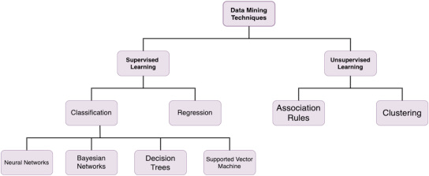

**Figure 1.** Techniques of Opinion Minin (Sarker, 2023)

Ethical considerations are also an integral part of the AI-driven opinion mining approach. AI models can be designed and trained with ethical guidelines in mind to mitigate privacy concerns, address biases, and ensure transparency in decision-making. Responsible AI practices should be adhered to throughout the development and deployment of AI-based opinion mining systems.

**1.3 Overview of the Problem of Opinion Mining on Digital Media Content:**

In the digital age, understanding and harnessing the sentiments and opinions embedded in the vast landscape of digital media content is a multifaceted challenge that our research endeavors to address.

This section offers a detailed understanding of the problem at hand and why it poses a unique set of challenges.

##### **1.3.1 The Challenge of Opinion Mining:**

Opinion mining, often referred to as sentiment analysis, is a multifaceted process that involves the automatic identification and categorization of opinions, sentiments, and emotions expressed in digital media content. While the overarching concept may appear straightforward, delving deeper reveals the intricacies and challenges that accompany this endeavor. In this explanation, we will explore the complexities of opinion mining, the nuances of human expressions, the ever-evolving nature of language, and the sheer volume of data generated in digital spaces.

#### **1.3.1.a Diverse and Nuanced Human Expressions:**

One of the foremost challenges in opinion mining lies in the diversity and nuance of human expressions. Humans communicate their thoughts and emotions through a wide range of words, phrases, tones, and body language. These expressions can be straightforward or incredibly subtle, requiring a deep understanding of context and cultural factors to decipher accurately.

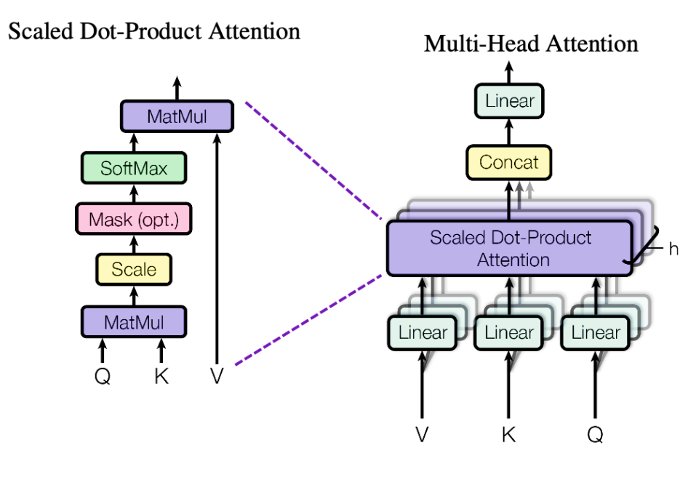

**Figure 2.** Attention Mechnisms as a Predictive of a Particular Label (Aslan, 2023)

In Figure 2, attention mechanisms in machine learning models allow the model to focus on specific parts of the input data that are relevant to the task at hand. In the context of predicting a particular label, such as in a classification task, attention mechanisms can help the model identify which features or patterns in the input data are most important for making accurate predictions. This can improve the model's performance by allowing it to effectively weigh the importance of different parts of the input when making predictions.

Consider the statement, "The movie was good." On the surface, it appears positive. However, the interpretation can change drastically depending on the context. If this statement is found in a movie review blog post, it is likely a positive sentiment. But if it's on a blog discussing nutrition, the sentiment may be more neutral, focusing on the nutritional value of popcorn at the cinema. Context, therefore, plays a pivotal role in understanding the sentiment behind a statement.

Additionally, human expressions are highly influenced by cultural and demographic factors. What is considered a positive sentiment in one culture may not be perceived the same way in another. Slang, idioms, and colloquialisms further complicate the interpretation of opinions and sentiments.

#### **1.3.1.b Rapid Evolution of Language:**

Language is not static but continuously evolves with societal and technological changes. This dynamic nature of language presents a challenge in opinion mining. New words, phrases, and expressions constantly emerge, and their meanings can shift over time.

For example, the word "cool" has evolved from its original temperature-related meaning to become synonymous with "impressive" or "stylish." In digital spaces, language often evolves rapidly, with new words and phrases emerging due to pop culture, technological advancements, or social trends. Keeping pace with these linguistic shifts is essential for accurate sentiment analysis.

Moreover, the rise of internet culture, memes, and social media has introduced entirely new forms of language and communication, often characterized by humor, irony, and hyperbole. Understanding and interpreting these expressions require a deep understanding of internet culture and context.

#### **1.3.1.c Sheer Volume of Digital Data:**

The digital age has given rise to an unprecedented volume of content in various forms: text, audio, images, and video. Social media platforms, blogs, news websites, forums, and online communities generate an overwhelming amount of data every second. This deluge of information makes the task of opinion mining challenging (Alotaibi, 2023).

To put this into perspective, consider that every minute, thousands of tweets are posted on Twitter, millions of Facebook posts are shared, and an enormous amount of content is uploaded to YouTube. Processing and analyzing this sheer volume of data in real-time or near real-time is a formidable undertaking.

Moreover, not all digital content is text-based. Videos and images often convey sentiments and opinions through visual cues, facial expressions, and audio elements. Opinion mining algorithms must be versatile enough to handle multiple content formats.

#### **1.3.1.d The Need for Automated Solutions:**

Given the complexities of opinion mining, manual analysis of such vast and varied data is practically impossible. This is where the role of artificial intelligence, machine learning, and natural language processing becomes critical. These technologies empower automated sentiment analysis at scale.

Machine learning algorithms can be trained to recognize patterns and context, enabling them to accurately categorize sentiments in text, audio, and visual content. Natural language processing techniques allow machines to understand and interpret human language, even in its diverse and evolving forms (Chee, 2023).

**1.4 The Role of Artificial Intelligence:**

Artificial intelligence, particularly natural language processing (NLP) and machine learning has been instrumental in advancing the field of opinion mining (Aslan, 2023). NLP techniques enable machines to understand and analyze human language. They can identify sentiment-bearing words, phrases, and expressions in text, allowing for sentiment classification.

Machine learning models, such as support vector machines, decision trees, and neural networks, are used to train algorithms to recognize sentiment patterns in data. These models can generalize from llabelledtraining data to make predictions on new, unseen content. As more data is processed, machine learning models can adapt and improve their accuracy.

In recent years, deep learning models, particularly recurrent neural networks (RNNs) and transformer-based architectures have shown remarkable success in capturing the nuances of human language. These models excel at understanding context, sarcasm, idiomatic expressions, and other subtle elements of communication.

##### **1.4.1 The Importance of Context:**

Context is a vital component of sentiment analysis. It involves understanding the circumstances, the subject matter, and the cultural and demographic factors surrounding a piece of content. Without context, sentiment analysis can produce inaccurate results.

For instance, the statement "This phone is a bomb!" may be considered positive in a casual conversation among friends but could be negative when discussing product reviews due to the negative connotation of the term "bomb." Recognizing these subtleties is a key challenge in sentiment analysis.

##### **1.4.2 Challenges Beyond Text:**

Opinions and sentiments are not limited to text. Visual and auditory content, such as images, videos, and audio recordings, also convey emotions and opinions. Analyzing multimedia content poses additional challenges, as sentiment may be expressed through facial expressions, tone of voice, or visual elements. Deep learning models, capable of image and audio analysis, are employed to tackle these challenge (Guo, 2023).

In conclusion, opinion mining, or sentiment analysis, presents a complex and multifaceted challenge due to the diverse and nuanced nature of human expressions, the rapid evolution of language, and the sheer volume of data generated in digital spaces. However, the advancement of artificial intelligence, especially in the domains of natural language processing and machine learning, has paved the way for automated solutions that can make sense of this complex landscape. Despite the challenges, opinion mining plays a crucial role in understanding public sentiment, consumer preferences, and trends in various domains, from business to politics, making it a field of significant relevance in the digital age

In the digital age, understanding and harnessing the sentiments and opinions embedded in the vast landscape of digital media content is a multifaceted challenge that our research eendeavoursto address. This section offers a detailed understanding of the problem at hand and why it poses a unique set of challenges.

##### **1.4.3 The Complexity of Digital Media Content:**

Digital media content encompasses a vast array of formats, including text, audio, and video. These content types are generated on an extensive array of platforms, such as social media networks, blogs, news websites, and multimedia-sharing platforms. This diversity in content and platforms presents both an opportunity and a challenge.

**1.4.3.a Diverse Formats of Digital Media Content:**

Digital media content spans a wide spectrum of formats, each offering a unique mode of communication. These formats include text, audio, and video, with each presenting distinct challenges and opportunities for analysis.

* **Text-Based Content:** Textual content, such as articles, blog posts, social media updates, and comments, is a fundamental component of digital media. This format is highly adaptable, allowing for the expression of opinions, ideas, and information in a structured manner. However, text can be highly nuanced, and interpreting sentiments and emotions embedded within it requires an understanding of context, tone, and idiomatic expressions. The sheer volume of textual data generated daily across the internet presents a significant challenge for opinion mining, as it necessitates efficient methods for processing and analysis.
* **Audio Content:** With the proliferation of podcasts, audiobooks, music streaming, and voice assistants, audio content has gained prominence in the digital space. Sentiments and emotions can be conveyed through vocal tone, inflexion, and speech patterns. Analyzing audio content poses unique challenges, as it requires the conversion of spoken language into text for sentiment analysis. Automatic speech recognition (ASR) and natural language processing (NLP) technologies play a crucial role in this process.
* **Video Content:** Videos, including vlogs, YouTube channels, television shows, movies, and user-generated content, provide a rich medium for expressing opinions and sentiments. In addition to spoken language, video content incorporates visual and auditory elements, making sentiment analysis more complex. Understanding the emotions conveyed through facial expressions, body language, and visual storytelling adds layers of complexity to opinion mining. Moreover, extracting sentiments from video content requires transcribing spoken words and analyzing the accompanying visual and auditory cues, necessitating advanced multimedia sentiment analysis techniques.

##### **1.4.4 A Plethora of Platforms:**

Digital media content is not confined to a single, monolithic platform but is disseminated across an extensive array of online spaces. These platforms serve as vehicles for the creation, distribution, and consumption of content. Some of the notable platforms encompass:

* **Social Media Networks:** Platforms like Facebook, Twitter, Instagram, and TikTok host a vast ecosystem of content, including text, images, and videos. Users share their thoughts, experiences, and opinions, making social media a fertile ground for sentiment analysis. The challenge here is not only the volume of content but also the speed at which it is generated. Sentiments can change rapidly in response to real-time events, trends, and conversations.
* **Blogs:** Blogging platforms, such as WordPress and Medium, host textual content created by individuals, organizations, and experts in various domains. Bloggers share their opinions, reviews, and experiences, making this format a valuable source for opinion mining. However, the diversity of blogging topics and writing styles necessitates robust sentiment analysis techniques to cater to different contexts and subject matter.
* **News Websites:** News outlets and online publications publish a continuous stream of news articles and reports. Analyzing the sentiments expressed in news articles can provide insights into public perception and media bias. News content is often characterized by a formal and objective tone, making sentiment analysis challenging due to its distinct style.
* **Multimedia Sharing Platforms:** Platforms like YouTube, Vimeo, and SoundCloud host a plethora of audio and video content. Users upload videos, music, podcasts, and more, expressing opinions and emotions through both spoken words and visual storytelling. The challenges in sentiment analysis here extend beyond the diversity of content to the need for effective transcription, audio analysis, and image recognition.

##### **1.4.5 Opportunities and Challenges:**

The diversity of content formats and platforms within the digital media landscape presents both opportunities and challenges for opinion mining.

* **Opportunities:**
  + **Rich Data Sources:** The availability of diverse content formats provides a wealth of data for sentiment analysis. This data can be harnessed to gain insights into public sentiment, consumer preferences, and emerging trends.
  + **Comprehensive Understanding:** Analyzing a variety of content types enables a comprehensive understanding of opinions and emotions. Combining text, audio, and video analysis allows for a more holistic view of sentiment within the digital sphere.
  + **Real-Time Insights:** Many digital media platforms operate in real time, making it possible to capture and analyze sentiments as they evolve. This real-time analysis is invaluable for tracking public sentiment during events, product launches, or crises.
* **Challenges:**
  + **Data Volume:** The sheer volume of digital content generated daily poses a logistical challenge. Efficient methods for data collection, storage, and analysis are essential to handle this data deluge.
  + **Multimodal Analysis:** Analyzing audio and video content requires the integration of text analysis with audio and visual processing. Developing and deploying multimodal sentiment analysis systems is a complex undertaking.
  + **Cultural and Contextual Variation:** Sentiments are expressed differently in various cultures and contexts. Understanding the cultural and contextual nuances of sentiments is crucial for accurate analysis.
  + **Evolving Platforms:** Digital platforms are continually evolving. New platforms and communication trends introduce new challenges for sentiment analysis. Staying up to date with emerging platforms and language trends is imperative.

Digital media content is a complex and dynamic ecosystem that encompasses a variety of formats and platforms. Sentiments and opinions are expressed through text, audio, and video, each with its unique characteristics. While this diversity provides opportunities for comprehensive sentiment analysis, it also poses challenges in terms of data volume, multimodal analysis, cultural context, and the ever-changing digital landscape. To harness the potential of this digital content ecosystem, sentiment analysis techniques need to be adaptable, efficient, and capable of providing insights in rreal-time

##### The Opportunity:

In the digital age, the vast and diverse landscape of digital media content serves as a veritable treasure trove of opinions, offering a unique and unprecedented opportunity to gauge public sentiment, collect valuable consumer feedback, discern political leanings, and track evolving social trends. The potential benefits span a wide spectrum, from aiding businesses in gaining a profound understanding of customer preferences and improving their products and services to assisting governments in assessing public opinion on policies and complex societal issues. It's a dynamic and multifaceted arena where the analysis of opinions can yield insights that shape decisions, fuel innovations, and foster a deeper connection with individuals, communities, and the world at large. This opportunity transcends industries, and it's crucial to delve into the myriad ways in which opinion mining can contribute to the betterment of society, commerce, and governance.

##### The Challenge:

However, this vast landscape is characterized by its unstructured and ever-evolving nature. The challenges lie in processing, categorizing, and extracting meaningful insights from this abundance of data. Opinions and sentiments are often expressed in diverse and subtle ways, making their interpretation a non-trivial task.

Moreover, the dynamic nature of language and the constant emergence of new terminologies and slang present an ongoing challenge. Additionally, the rapid proliferation of multimedia content, including images, audio, and video, adds an extra layer of complexity to opinion mining, as sentiments are conveyed not only through text but also through visual and auditory cues.

Our research seeks to confront these challenges by harnessing the power of artificial intelligence to make sense of this unstructured and ever-evolving digital media content. By developing and implementing a novel opinion mining approach, we aim to advance the field, providing more accurate and efficient methods for extracting valuable insights from this rich but complex data landscape.

##### **1.4.6. Role of Digital Media in AI**

Digital media content, spanning text, images, videos, and audio, plays a pivotal role in the information landscape of the modern world. The explosive growth of digital content on the internet, coupled with the advent of Artificial Intelligence (AI), has given rise to new possibilities and challenges. AI has become a transformative force in the creation, curation, and analysis of digital media content. This article explores the multifaceted role of AI in digital media content, examining its impact on content creation, content recommendation, content moderation, and content analysis.

**1.4.6.1. Content Creation and Generation**

AI is increasingly being employed in the generation of digital media content. Natural Language Processing (NLP) models, like GPT-3 and BERT, can produce human-like text, allowing for automated content generation. This has applications in areas such as journalism, where AI can assist in drafting news reports and generating articles at a remarkable speed.

In addition to text, AI has also made significant strides in generating visual and audio content. Generative Adversarial Networks (GANs) can create realistic images and videos. Deep learning models are used to synthesize human-like voices and music compositions. These AI-generated content forms are not only impressive but also practical for various creative and data-driven tasks.

**1.4.6.2. Content Recommendation and Personalization**

AI algorithms underlie content recommendation systems that have become integral to platforms like Netflix, Amazon, and social media networks. These recommendation engines analyze user behavior, preferences, and past interactions to suggest content that users are likely to find engaging. By doing so, they enhance user experience, increase engagement, and contribute to content discovery.

Content personalization goes beyond just suggesting movies or products; it extends to tailoring news, articles, and information to individual users' interests. This can be seen in news aggregators that use AI to curate news articles based on the user's past reading habits and preferences. As a result, users are presented with content that aligns with their beliefs and interests, potentially creating information bubbles but also ensuring relevance and engagement.

**1.4.6.3. Content Moderation and Safety**

Digital media platforms are grappling with the challenge of moderating content at scale, ensuring that it adheres to community standards and legal regulations. AI-driven content moderation systems employ computer vision and NLP to scan images, videos, and text for harmful or inappropriate content. Such systems are vital for preventing the spread of hate speech, misinformation, and graphic content. AI plays a critical role in automating the content moderation process, assisting human moderators, and maintaining a safer online environment.

**1.4.6.4. Content Analysis and Insights**

Digital media content offers a wealth of information, and AI is instrumental in extracting insights from this content. Sentiment analysis, a subfield of NLP, is employed to gauge public sentiment and opinions expressed in text. This has applications in market research, brand management, and public opinion tracking.

**1.4.6.5. Content Translation and Multilingual Capabilities**

The global nature of digital media content requires translation and localization to reach diverse audiences. AI-driven machine translation models, such as Google Translate, employ neural networks to provide fast and reasonably accurate translations across multiple languages. These models enable content creators to reach a broader global audience without the need for extensive manual translation efforts.

**1.4.6.6. Content Enhancement and Editing**

AI tools are increasingly used to enhance digital media content. Image and video editing software often incorporate AI features to improve image quality, remove imperfections, or add creative effects. AI-powered grammar and style checkers are valuable for writers, helping to improve the clarity and coherence of written content.

**1.4.6.7. Content Accessibility**

AI has made significant contributions to improving content accessibility. For example, AI-driven automatic speech recognition (ASR) technology is used to provide real-time captions for live events and videos, making content more accessible to individuals with hearing impairments. Similarly, AI-based text-to-speech (TTS) systems convert text into spoken words, aiding those with visual impairments.

**1.4.6.8. Content Verification and Fact-Checking**

The rapid spread of misinformation and fake news in the digital age has necessitated the development of AI tools for content verification and fact-checking. AI algorithms can analyze the credibility and authenticity of news articles and social media content, helping users make more informed decisions about the information they encounter.

**1.4.6.9. Content Distribution and Optimization**

AI is integral to content distribution strategies, helping content creators reach their target audience. AI-powered algorithms identify the most opportune times to post content on social media for maximum visibility and engagement. Moreover, AI-driven SEO tools analyze search trends and help optimize content for search engines, ensuring that it ranks higher in search results (Pang, 2008).

**1.5 Research Aim and Objectives**

The research aims to perform a novel sentimental analysis users'ers reviews Twitter digital media content in various forms (Video, Audio, Image, and Text).

To achieve the set research aim, the following objectives were identified:

Objective 1: To justify the importance of implementing sentiment analysis in social media platforms.

Objective 2: To build knowledge and investigate recent literature about the research topic.

Objective 3: To propose a new approach to perform the prediction of the sentiments from social media users' reviews by:

* Finding sentiments in text.
* Converting video and audio data into text
* Clustering of positive, negative and neutral tweets.

**1.6 Research Questions**

1. Why is it important to do the sentimental analysis? What are the existing methods to do the sentiment analysis and how can we do better than them?
2. Where to collect the data?
3. How to collect the data?
4. How to convert these user reviews from video, audio and image forms to text?
5. How to find the sentimental analysis on the text?
6. How to do in-depth label/classification of positive, negative and neutral tweets after the classification of sentimental analysis?

**1.7 Hypothesis:**

1. **Main Hypothesis:**

• Null Hypothesis (H0): There is no significant improvement in sentiment analysis accuracy when incorporating ChatGPT, trained on data from digital media, into the novel opinion mining approach compared to traditional sentiment analysis methods.

• Alternative Hypothesis (H1): The incorporation of ChatGPT, trained on data from digital media, into the novel opinion mining approach leads to a significant enhancement in sentiment analysis accuracy compared to traditional methods.

1. **Subsidiary Hypotheses:**

• H0: The novel opinion mining approach without ChatGPT integration, trained on data from digital media, achieves comparable sentiment analysis accuracy to traditional sentiment analysis methods.

• H1: The novel opinion mining approach augmented with ChatGPT integration, trained on data from digital media, demonstrates superior sentiment analysis accuracy compared to both traditional methods and the novel approach without ChatGPT.

**Theoretical/Conceptual Framework:**

1. **Social Cognitive Theory:**
   * Utilize Bandura's Social Cognitive Theory to understand how individuals' behaviors, including expressing sentiment on social media, are influenced by personal, environmental, and behavioral factors.
   * Examine how users' perceptions of sentiment analysis algorithms influence their behavior and interactions on social media platforms.
2. **Technology Acceptance Model (TAM):**
   * Apply the TAM framework to explore users' acceptance and adoption of sentiment analysis tools on social media platforms.
   * Investigate factors such as perceived usefulness, ease of use, and perceived credibility of sentiment analysis algorithms in shaping users' attitudes and behaviors.
3. **Information Processing Theory:**
   * Draw upon the Information Processing Theory to understand how users process and interpret sentiment information conveyed through different media formats (text, video, audio, image) on digital media platforms.
   * Explore cognitive processes involved in interpreting sentiment from various media formats and how these processes influence users' attitudes and behaviors.

**1.8 Research Map**

Table 1 Research Map

|  |  |  |  |  |
| --- | --- | --- | --- | --- |
| **Research Problem** | **Aim** | **Objectives** | **Questions** | **Background Theory / Methodology** |
| The other research models have limitations only to text, the proposed research includes the image, video, facial expressions, emoji and frames.  In-depth label/classification of positive, negative and neutral tweets will take place after classification. | The **research aims**to perform a novel sentimental analysis of user's reviews of Twitter digital media content in various forms (Video, Audio, Image, Text) | To achieve the set research aim, the following objectives were identified:​   * **Objective 1:** To justify the importance of implementing sentiment analysis in digital media platforms.​ * **Objective 2:** To build knowledge and investigate recent literature about the research topic.​ * **Objective3:** To propose a new approach to perform the prediction of the sentiments from social media users reviews by:​   ​  Finding sentiments in text.​   * Converting video and audio data into text​ * Clustering of positive, negative and neutral  digital media.​ | Q1  Q1  Q2, Q3  Q4, Q5  Q6 | * Problem Formulation/ Investigate the recent literature. Using various libraries and frameworks such as TensorFlow, PyTorch, NLTK, scikit-learn, etc., for tasks such as natural language processing (NLP), deep learning, and data preprocessing. * Visualization Tools: Tools like Matplotlib, Seaborn, or Plotly for visualizing data and model performance. * Multimodal Integration: Techniques to integrate different modalities of data (text, image, audio, video) such as feature fusion, late fusion, early fusion, or attention mechanisms. * Deep Learning Architectures: LSTM. * Transfer Learning: Utilizing pre-trained models like BERT, GPT, or ImageNet for feature extraction or fine-tuning on specific sentiment analysis tasks. * Data Augmentation: Techniques for generating synthetic data to augment the training dataset and improve model robustness.   Evaluation Metrics: accuracy, precision, recall, F1-score. |

A few years ago, this was difficult to identify and measure since the reviews have to be obtained from the public physically. A sample target population had to be identified and then interviewed for obtaining their feedback and reviews, however with the rise of AI algorithms, it is possible to receive the feedback from the public since the feedback is quite instantaneous and maybe also captured in real-time. It is also an open-source information since it is available to the public through social media platforms APIs.

**1.9 Research Contribution**

This study with a case study focusing on ChatGPT Sentiment Analysis, makes significant strides in addressing critical gaps in sentiment analysis methodologies, particularly in the context of the evolving landscape of user-generated content across multimedia platforms.

**Addressing the Shift Towards Multimedia Content:**

The research recognizes the contemporary trend of user-generated content transitioning from traditional text-based formats to diverse multimedia forms like images, videos, and audio feedback. By proposing innovative methodologies to extract sentiments from various multimedia sources, including videos and audios, this study pioneers a comprehensive approach to sentiment analysis, essential for understanding modern digital media consumption patterns.

**Enriching Decision-Making Processes:**

With an emphasis on leveraging artificial intelligence and machine learning techniques, the research aims to empower decision-makers with enriched insights crucial for strategic decision-making processes. By refining product specifications, enhancing operational efficiency, and unlocking valuable consumer insights, the study's findings are poised to make substantial contributions across sectors, aiding in better-informed decision-making and quality assurance practices.

**Holistic Data Collection and Analysis:**

By incorporating data from diverse digital media platforms such as YouTube, IMDb, Spotify, Twitter, and Facebook, the research enriches the dataset with a wide array of user-generated content. This comprehensive approach enables a nuanced understanding of user sentiments across various platforms, facilitating in-depth analyses and informed decision-making.

**Addressing Research Gaps and Real-World Relevance:**

The study's focus on addressing the lack of advanced sentiment analysis methodologies tailored to multimedia content fills a critical gap in existing research. Furthermore, the research's emphasis on the practical applications of sentiment analysis in guiding organizational decisions underscores its real-world relevance and necessity.

**Contribution to Methodological Advancements:**

Beyond its immediate applications, the research contributes to methodological advancements in sentiment analysis by introducing innovative techniques for handling diverse data formats. By acknowledging and addressing the dynamic nature of user-generated content in the digital landscape, the study sets a precedent for future research endeavors aimed at enhancing sentiment analysis methodologies.

**1.10 Statement of the problem**

In the era of pervasive digital media and online communication, the process of opinion mining and sentiment analysis has emerged as a critical area of study and application (Yadav, 2023). Opinion mining, also known as sentiment analysis, involves the automated identification and classification of opinions, sentiments, and emotions expressed within digital media content. Understanding and effectively utilizing this process is of paramount importance due to the profound impact digital media content exerts on various facets of modern society.

##### **1.10.1 The Pervasive Influence of Digital Media Content:**

The influence of digital media is not limited to one or a few sectors but transcends various domains, including business, politics, social dynamics, and communication. The pervasiveness of digital media content, especially through social media platforms, blogs, news websites, and multimedia sharing platforms, has given individuals a powerful and instantaneous medium to express their opinions and sentiments (Stalder). This transformation has in turn significantly altered the dynamics of communication, information dissemination, and public discourse.

##### **1.10.2 The Challenges in Opinion Mining:**

Despite the potential insights and opportunities that digital media content offers, opinion mining and sentiment analysis present formidable challenges. The complexity of human expressions, the rapid evolution of language, the sheer volume of data generated in digital spaces, and the diversity of content formats and platforms have made sentiment analysis a multifaceted task (Alslaity, 2022). Understanding the diverse and nuanced ways in which individuals express their thoughts and emotions in the digital realm is a challenge that necessitates a profound understanding of context, culture, and linguistic subtleties.

The rapid evolution of language in the digital age, characterized by the emergence of new words, phrases, and expressions influenced by pop culture, technology, and social trends, poses another layer of complexity. It requires sentiment analysis tools to be adaptable and capable of identifying and interpreting these emerging linguistic phenomena.

##### **1.10.3 The Enormous Volume of Digital Data:**

The digital age has ushered in an era of information abundance. The sheer volume of digital data generated in the form of text, audio, images, and video across a wide spectrum of platforms is staggering. Social media platforms, blogs, news websites, forums, and online communities generate a continuous deluge of data every second. The magnitude of this data presents logistical challenges in terms of collection, storage, and analysis. Managing and processing this data in real-time or near real-time is an imperative task in sentiment analysis.

Furthermore, the challenges of opinion mining extend beyond text-based content. Videos and images frequently communicate sentiments and opinions through visual cues, facial expressions, and audio elements. Sentiment analysis algorithms must be versatile enough to accommodate multiple content formats and modalities.

##### **1.10.4 The Role of Artificial Intelligence in Opinion Mining:**

To address these challenges, the field of opinion mining has turned to artificial intelligence (AI), particularly natural language processing (NLP) and machine learning (AlShahrani, 2021). AI technologies enable the automation and scalability of sentiment analysis, making it possible to process vast amounts of data and adapt to evolving linguistic trends (Yulchieva, 2023).

Natural language processing techniques empower machines to comprehend and interpret human language, accounting for its nuances and ever-evolving nature. Machine learning models, ranging from traditional support vector machines to state-of-the-art deep learning architectures, are employed to recognize sentiment patterns in data, whether textual, auditory, or visual.

##### **1.10.5 The Significance of Context:**

Context plays a pivotal role in sentiment analysis. It involves understanding the circumstances, the subject matter, and the cultural and demographic factors surrounding a piece of content. Sentiments are expressed differently in various cultures and contexts, making the interpretation of opinions a complex and context-dependent task (Binali, 2009).

For instance, the sentiment conveyed in the statement, "This is sick!" can vary greatly depending on whether it's part of a movie review, a discussion about health, or a casual conversation among friends. Recognizing these subtleties and contextual variations is crucial for accurate sentiment analysis.

##### **1.10.6 The Multimodal Challenge:**

Opinions and sentiments are not confined to text. Visual and auditory content, such as images, videos, and audio recordings, also communicate emotions and opinions. Analyzing multimedia content is challenging, as sentiments may be expressed through visual cues, facial expressions, tone of voice, or auditory elements. Effective sentiment analysis of multimedia content requires the integration of text analysis with audio and visual processing, demanding advanced multimodal sentiment analysis techniques (Alslaity, 2022).

##### **1.10.7 The Opportunities and Challenges in Opinion Mining:**

The opportunities afforded by opinion mining are vast and wide-reaching. The digital landscape serves as a treasure trove of opinions, offering a unique opportunity to gauge public sentiment, collect consumer feedback, discern political leanings, and track evolving social trends. The potential benefits span a wide spectrum, from aiding businesses in understanding customer preferences and refining their products and services to helping governments assess public opinion on policies and complex societal issues. Sentiment analysis enables real-time insights into rapidly changing public sentiment, making it invaluable for tracking trends during events, product launches, or crises.

However, with these opportunities come a host of challenges. The sheer volume of data generated daily in digital media content necessitates efficient methods for collection, storage, and analysis. Multimodal sentiment analysis demands the integration of text, audio, and visual processing, requiring advanced technological capabilities. Cultural and contextual variations in sentiments introduce complexities that sentiment analysis tools must account for to ensure accuracy (Binali, 2009).

**1.11 Thesis structure**

##### Chapter 1: Introduction

This chapter provides an overview of the research, introducing the topic of opinion mining on digital media content using artificial intelligence. It discusses the significance of the research, outlines the challenges, and sets the stage for the subsequent chapters.

##### Chapter 2: Literature Review

In this chapter, we conduct a comprehensive review of the existing literature on opinion mining, sentiment analysis, and artificial intelligence in the context of digital media content. We explore key concepts, theories, methodologies, and notable research contributions in the field.

##### Chapter 3: Research Methodology

This chapter outlines the research methodology employed in the study. It discusses the data collection process, the design of experiments or case studies, the selection of machine learning or deep learning models, and the evaluation metrics used to measure the effectiveness of the opinion mining approach.

##### Chapter 4: Implementation

Here, we delve into the details of data collection from various digital media sources, including social media, news websites, and multimedia platforms. We describe the preprocessing steps for text, audio, and video content, such as text cleaning, audio transcription, and image processing.

##### Chapter 5: Discussion

This chapter introduces the novel opinion mining approach based on artificial intelligence. It elaborates on the model architecture, feature selection, and the techniques employed for sentiment analysis in text, audio, and video content. We discuss the algorithms and tools used for opinion classification. Here, we delve into the implications of our research findings. We discuss the practical applications of our opinion mining approach in different domains, including business, politics, and public perception. We also consider the ethical and societal implications of sentiment analysis in the digital age.

##### *Chapter 6: Conclusion and Future Work*

This final chapter summarizes the key findings, contributions, and limitations of our research. We propose areas for future research and offer concluding remarks on the significance of our opinion mining approach in the context of digital media content.

## **Chapter II. Literature review**

**2.1 Introduction**

This section aims to delineate the contextual foundation, identify key areas of research, and synthesize relevant literature that underpins the integration of AI-driven opinion mining in enhancing quality management strategies within various industries, particularly focusing on the dynamic landscape of digital media content analysis.

**2.2 Understanding the Role of Opinion Mining/Sentiment Analysis and Artificial Intelligence in Quality Management**

Opinion mining, or sentiment analysis, and artificial intelligence (AI) are integral components of quality management, playing key roles in understanding customer sentiments and ensuring product or service excellence (rown, 2023). Opinion mining involves extracting subjective information from textual data, enabling organizations to analyze customer feedback and identify quality issues. AI contributes by employing predictive analytics, process automation, and root cause analysis to enhance overall quality management. The integration of opinion mining and AI enables real-time monitoring, customer-centric quality improvement, and data-driven decision-making, fostering a proactive approach to identifying and addressing quality issues, ultimately leading to continuous improvement in products and services.

##### **2.2.1 Defining Opinion Mining and Sentiment Analysis**

The emergence of social media platforms in the early 2000s represented a pivotal moment in communication and information exchange (Carvache-Franco, 2023). Scholars and institutions quickly grasped the potential of sentiment analysis as a means to derive meaningful insights from the extensive troves of user-generated content present on platforms such as Twitter and Facebook. (Braig, 2023).

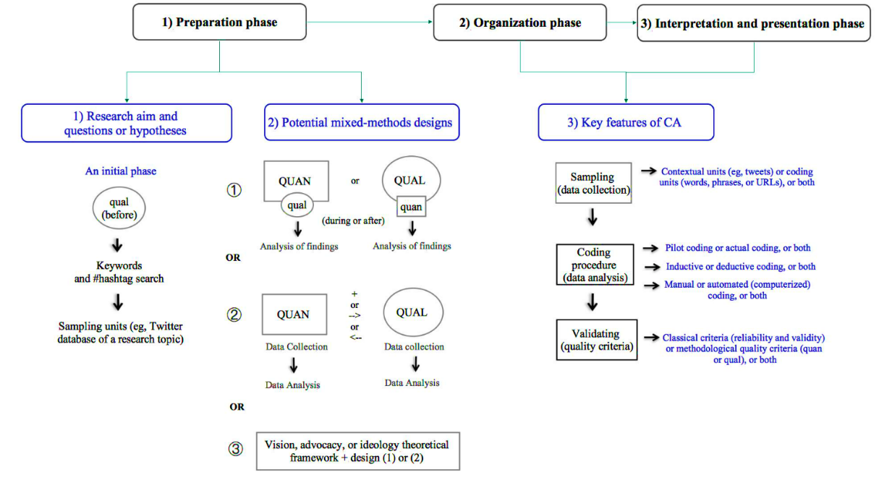

**Figure 3.** Sentiment Analysis Research Framework (Catelli, 2023)

In figure 3, the maturation of sentiment analysis has facilitated a deeper understanding of public sentiment and opinion dynamics in the digital age (Yadav, 2023). By harnessing advanced NLP techniques and machine learning algorithms, sentiment analysis continues to play a crucial role in decision-making processes, marketing strategies, risk management, and social research across diverse fields and industries (Ramasangu, 2023).

**2.2.1.1 Advancements in Sentiment Analysis Methodologies and Technologies**

The methodologies and technologies employed in sentiment analysis have evolved hand in hand with advancements in Natural Language Processing (NLP) and Artificial Intelligence (AI) (M. Anwer, 2021). Initially, lexicon-based sentiment analysis methods relied on predefined lists of words and phrases associated with positive or negative sentiments. While somewhat effective, these approaches struggled with understanding context and detecting sarcasm (Yadav, 2023).

The introduction of machine learning techniques, particularly supervised learning, marked a significant breakthrough in sentiment analysis. These approaches enabled models to learn sentiment patterns from labeled datasets. Algorithms such as Support Vector Machines (SVM), Naive Bayes (NB), and more recently, deep learning models like Recurrent Neural Networks (RNN) and Transformers, have substantially enhanced sentiment analysis accuracy (Iparraguirre-Villanueva, 2023).

Moreover, the advent of pre-trained language models like BERT and GPT-3 has further elevated sentiment analysis capabilities (Xu A. M., 2023).. These models excel at capturing contextual nuances and understanding domain-specific sentiment, thereby improving the accuracy and robustness of sentiment analysis (Iparraguirre-Villanueva, 2023).

**2.3 Overview of Digital Media Content Analysis for Decision Making**

Digital media content analysis is a crucial tool for decision-making in the rapidly evolving landscape of media and communication (Capatina, 2019). As an interdisciplinary field, it involves systematic examination and interpretation of various forms of digital media content, such as text, images, and videos, to derive meaningful insights. Scholars in this domain employ diverse methodologies, including natural language processing and machine learning algorithms, to analyze vast datasets and discern patterns, sentiments, and trends (Ravi, 2015). This literature review aims to provide an overview of the key methodologies and findings in digital media content analysis, emphasizing its role in informing decision-making processes across industries. By synthesizing existing research, this review seeks to contribute to a comprehensive understanding of the applications, challenges, and potential future developments in leveraging digital media content analysis for effective decision-making.

##### **2.3.1 Significance of Digital Media Content in Decision Making**

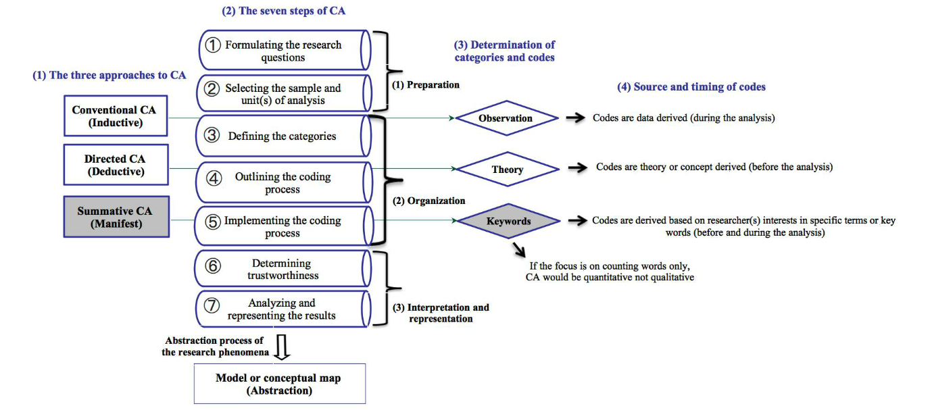This study (Hamad, 2016) addresses the growing use of Twitter in the healthcare domain and the need for a comprehensive research framework to analyze the content of health-related tweets. Examining 18 studies conducted between 2010 and 2014, the authors observed a lack of clear guidelines for combining quantitative and qualitative content analysis in Twitter-driven research. Consequently, they introduced the Combined Content Analysis (CCA) model, derived from key features of content analysis and mixed-methods research designs. The CCA model is proposed as a robust framework for designing, conducting, and evaluating investigations into Twitter-driven content in healthcare, aiming to enhance the methodological rigor and effectiveness of studies in this emerging field. The study underscores the importance of such a model and offers insights into its application, particularly in contexts related to elder healthcare shown in figure 4 (Boumans, 2018).

**Figure 4**. Content Analysis in Health Care Research (Boumans, 2018).

##### 2.3.2 Challenges and Opportunities in Analyzing Digital Media for Quality Management

While various studies have explored the potential of analyzing digital media for quality management, several challenges and opportunities have emerged in the existing literature (Li J. A., 2020). Challenges include the vast and dynamic nature of digital media content, making it challenging to collect, process, and analyze in real-time. Additionally, ensuring the accuracy and reliability of sentiment analysis and opinion mining algorithms poses difficulties, as the contextual nuances of language can be complex to interpret accurately. Limited standardization in methodologies and tools for digital media content analysis further complicates comparisons across studies (ali, 2018).

Despite these challenges, opportunities abound in leveraging digital media for quality management. The wealth of unstructured data available on platforms such as social media provides an unprecedented source of customer feedback and opinions (Zonnenshain, 2020). Researchers have successfully employed natural language processing and machine learning techniques to extract meaningful insights from large datasets. Real-time monitoring of digital media allows for the rapid identification of emerging trends and potential quality issues, enabling proactive decision-making (Ghermandi, 2019). Integrating artificial intelligence in quality management processes offers the potential for automation, predictive analytics, and continuous improvement (Stieglitz, 2018).

Noteworthy studies contributing to this understanding include research by (Naderi, 2023), who explored sentiment analysis in social media for business intelligence, who examined the challenges and opportunities of sentiment analysis in social media data. Additionally, (Chee, 2023) provided insights into using social media for quality improvement in healthcare. As the field continues to evolve, researchers must address these challenges and capitalize on the opportunities to harness the full potential of digital media for effective quality management.Top of Form

**2.4 The Evolution and Current State of Opinion Mining Techniques**

The field of opinion mining has witnessed a significant evolution, progressing from early sentiment analysis approaches to more sophisticated techniques that incorporate natural language processing and machine learning (Binali, 2009). Initially focused on polarity identification, recent advancements encompass aspect-based sentiment analysis, emotion recognition, and context-aware opinion mining. Classical approaches often relied on rule-based systems, while contemporary methods leverage advanced algorithms, including deep learning models and ensemble techniques, to enhance accuracy and scalability (Messaoudi, 2022). Current research emphasizes the integration of multimodal data sources and the development of domain-specific models. The evolving landscape reflects a shift from binary sentiment classification to nuanced and context-aware opinion extraction, addressing the complexities of real-world language expressions. Key contributors to this evolution include (Tsui, 2023)and (Ning He). Understanding this trajectory is crucial for comprehending the state-of-the-art in opinion mining techniques and guiding future research in this dynamic and expanding field.

This paper (Rastogi, 2023)highlights the pivotal role of data mining in predicting diabetes, a significant global health concern. Utilizing techniques such as Naive Bayes, Logistic Regression, Random Forest, and Support Vector Machine on a real dataset from Kaggle, the study presents a diabetes prediction model implemented in Python. The logistic regression model exhibits the highest accuracy at 82.46%, outperforming other methods such as SVM. The research emphasizes the importance of early diabetes prediction for improved outcomes and proposes further exploration of additional classification algorithms to enhance prediction accuracy in future studies.

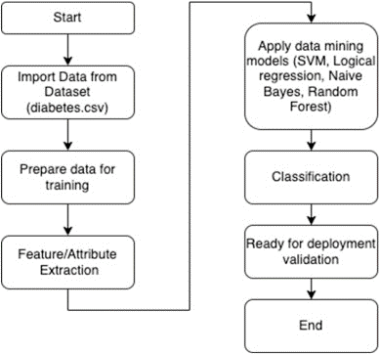

**Figure 5.** Data Mining for Diabetic Data (Rastogi, 2023)

In figure 5 main finding highlight (Guo, 2023) is the development and application of a novel framework, namely the wavelet fuzzy logic-based deep neural network (WFL-DNN), to enhance human resource management (HRM) systems in monitoring personnel performance and making informed decisions. The traditional HRM systems are highlighted as inadequate in handling the vast amount of data collected by businesses today. The proposed framework addresses this challenge by collecting raw employee data, preprocessing it through sampling, cleaning, and integration, and then utilizing principal component analysis (PCA) for feature extraction. Additionally, a genetic algorithm (GA) is employed for feature selection. The WFL-DNN framework is demonstrated to be more effective in accurately forecasting personnel performance compared to traditional methods. This finding suggests that incorporating advanced technologies, such as wavelet fuzzy logic and deep neural networks, can significantly improve the precision and efficiency of HRM systems in evaluating and managing employee performance.

##### **2.4.1 Traditional Approaches to Opinion Mining:**

Early approaches to opinion mining primarily focused on rule-based systems and linguistic analysis to categorize sentiments expressed in text (Alslaity, 2022). Sentiment lexicons, which consist of predetermined collections of words and phrases linked to either positive or negative sentiments, were frequently utilized for polarity classification (Leelawat, 2022). Furthermore, rule-based algorithms relied on syntactic and semantic rules to detect patterns in sentiment. Another conventional approach utilized machine learning methods like Support Vector Machines (SVM) and Naive Bayes to classify sentiment based on labeled training data (M. D. Nguyen, 2023). Despite being fundamental, these methods encountered difficulties in managing the intricacies of language nuances and context (Bibi, 2022).

Sentiment analysis within digital media spans diverse domains, offering multifaceted applications. Content creators utilize sentiment analysis to gauge audience reactions, informing content optimization strategies and enhancing audience engagement. Organizations leverage sentiment analysis to identify viral content and tailor engagement strategies, fostering brand loyalty. Moreover, sentiment analysis plays a vital role in content moderation, aiding in the identification of inappropriate content and misinformation. Marketers utilize sentiment insights to measure campaign effectiveness and personalize advertising efforts, while news outlets leverage sentiment analysis to understand public perception and inform editorial decisions. Additionally, governments monitor online sentiment to gauge public opinion and inform policy-making. The evolution of sentiment analysis from a binary classification task to a sophisticated field empowered by AI and machine learning underscores its transformative potential, offering valuable insights for decision-makers, content creators, and quality assurance processes.

**2.4.2 Advancements and Innovations in Opinion Mining Using AI in digital media:**

Recent advancements in opinion mining have been driven by the integration of artificial intelligence (AI) techniques (Alslaity, 2022). Machine learning algorithms, particularly deep learning models like Recurrent Neural Networks (RNNs) and Long Short-Term Memory networks (LSTMs), have demonstrated superior performance in capturing intricate sentiment patterns and contextual information. Transfer learning has enabled models to leverage pre-trained language representations like BERT (Bidirectional Encoder Representations from Transformers) for more nuanced understanding of sentiments. Additionally (Chaturvedi, 2018), the fusion of natural language processing (NLP) with AI has facilitated aspect-based sentiment analysis, allowing systems to identify sentiments related to specific aspects or entities within a piece of text. These advancements not only enhance the accuracy of sentiment analysis but also enable the extraction of deeper insights from unstructured textual data. The incorporation of AI technologies represents a paradigm shift in opinion mining, offering more sophisticated tools for businesses to understand and respond to sentiments expressed in diverse sources such as social media, reviews, and forums.  
The integration of Artificial Intelligence (AI) into journalism and communication practices has sparked profound debates about the transformative impact of technological innovations on society. This discourse echoes historical discussions, dating back to Marshall McLuhan's assertions in the 20th century that technologies extend human capabilities. Throughout the evolution of media technologies, from mechanical to electronic processes, they have been viewed as instruments of liberation and empowerment, expanding audience reach, overcoming spatial and temporal constraints, and bridging information gaps. With the advent of AI, a convergence of computing power with past innovations holds unprecedented potential for both positive and negative societal impacts. In the 21st century, network societies are more interconnected, transcending geographical boundaries and linking Westernized and global south societies. The proliferation of content creation by individuals and media organizations, facilitated by AI, has led to information overload, intensifying global and social challenges. Recognizing the exacerbated digital divide resulting from AI, this research proposes the Digital Dichotomy Theory (DD-Theory) as a framework to comprehend the inherent dynamics of global media communication. In figure 6show theory aims to deepen our understanding of the complexities arising from AI's influence on communication practices, offering insights into the evolving landscape of media in the digital age shown in figure 6. (Msughter, 2023).

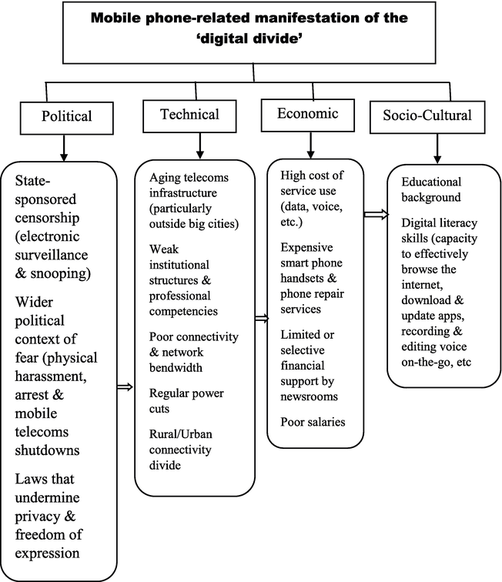

**Figure 6.** Mobile Manifestation (Msughter, 2023).

**2.5 Application of Opinion Mining in Various Industries using digital media**

##### 2.5.1 Opinion Mining in Retail and Consumer Goods:

In the retail and consumer goods industry, Opinion Mining plays a pivotal role in understanding customer sentiments and preferences (Kumar, 2021). By analyzing vast amounts of customer reviews, feedback, and social media comments, retailers can gain valuable insights into product satisfaction, identify emerging trends, and make data-driven decisions for inventory management and product development. Sentiment analysis helps in gauging consumer perceptions, improving customer experience, and tailoring marketing strategies. Additionally, tracking sentiment trends over time enables retailers to stay agile in responding to shifting consumer expectations and market dynamics (Ket, 2018).

In the landscape of small businesses, particularly startups, significant internal constraints such as limited financial capital and restricted access to quality human resources necessitate a cautious approach to adopting technologies that align with their business plans. Although digital marketing has emerged as a cornerstone for gaining a competitive edge in the 21st century, its efficacy with startups has encountered limitations. This (Mathur, 2023)study aims to evaluate the digital marketing practices employed by startups and delve into their strategies for creating brand awareness, fostering consumer loyalty, and deepening customer connections (Archak, 2017). The research methodology embraced a qualitative analysis, utilizing in-depth interviews with three selected startup businesses in India. Through this investigation, valuable managerial implications for startups in leveraging digital marketing techniques to achieve their marketing objectives have been unearthed. This research not only provides actionable insights for startups to optimize their digital marketing efforts but also establishes a foundation for future research endeavors on this crucial intersection of entrepreneurship and digital strategies (Castelo-Branco, 2020).

In the contemporary landscape of e-commerce, navigating through an extensive array of products to make well-informed purchasing decisions poses a considerable challenge for consumers. The need to compare prices, quantities, and features, such as the eco-friendliness of products, adds complexity to the decision-making process. Conversely, retailers face the challenge of identifying optimal replacements for out-of-stock items, catering to customer preferences. To address these challenges, this study employs a well-established methodology utilizing the Term Frequency-Inverse Document Frequency (TF-IDF) technique to represent products. Subsequently, K-means clustering is applied to group similar products, facilitating a structured organization of the product landscape. A significant challenge encountered is the poor quality of available textual data associated with the products. Despite this limitation, the results indicate the efficacy of the approach in successfully grouping genuinely similar products, offering valuable insights into their distribution. Notably, the study emphasizes that the analysis is solely based on product information, devoid of consumer data or purchase history, underlining the potential of this methodology to enhance product categorization and recommendations in e-commerce platforms (Srinita, 2023). This (Rudkowsky, 2018) literature review establishes the groundwork for understanding the implications and advancements in product clustering methodologies in the absence of consumer-centric data in the e-commerce domain in figure 7.

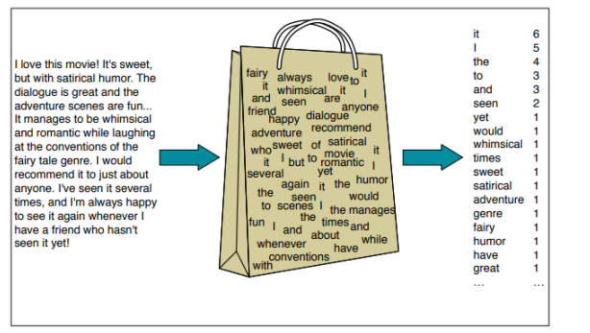

**Figur 7.** Bag of Words (Srinita, 2023).

##### 2.5.2 Opinion Mining in Healthcare Quality Management:

In healthcare quality management, Opinion Mining contributes to the assessment of patient experiences, satisfaction levels, and feedback regarding medical services (Barry, 2018). Analyzing sentiments expressed in patient reviews and feedback forms aids healthcare providers in identifying areas for improvement, enhancing patient care, and optimizing overall service quality. Opinion Mining techniques allow healthcare organizations to proactively address concerns, prioritize quality initiatives, and maintain a patient-centric approach. Moreover, the continuous monitoring of opinions assists in benchmarking against industry standards and fostering a culture of patient-centered care.

This (Li R. Y.-Q.-Q.-N.-Y., 2023) study delves into the emotional heterogeneity among customers engaging in peer-to-peer accommodations, employing deep learning technologies and social network analysis to uncover key drivers. The findings shed light on the nuanced emotional responses within this sharing economy context. Notably, the environment emerges as a fundamental driver of customer emotions in common scenarios, with services playing a less critical role in eliciting positive emotions. In specific situations, positive emotions are linked to factors such as price value and location, while the absence of these elements does not necessarily induce negative emotions. Surprisingly, the lack of household amenities does not impede the formation of positive emotions, revealing a unique aspect of customer emotional experiences in the peer-to-peer accommodation realm. Conversely, negative emotions are triggered by deficiencies in booking information. This study introduces a comprehensive understanding of the multifaceted demands and emotional causes shaping customer experiences in the sharing economy. The identified drivers offer valuable insights for tailored strategies to enhance customer emotional experiences in peer-to-peer accommodations, contributing to the literature on emotional heterogeneity and customer-centric strategies within

the context of the sharing economy shown in figure 8.

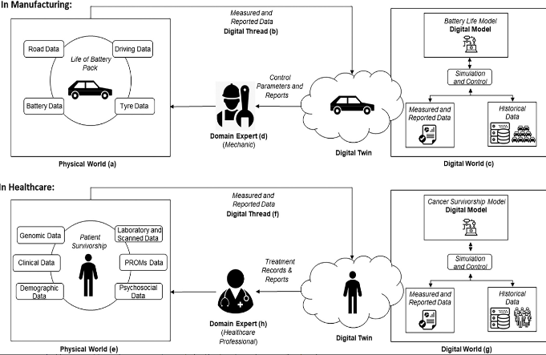

**Figure 8.** Digital Twin (Rudkowsky, 2018)

Opinion Mining in Service Industries (Hospitality, Finance, etc.): Opinion Mining is instrumental in service industries like hospitality and finance, where customer satisfaction is paramount. In the hospitality sector, sentiments expressed in reviews on platforms like TripAdvisor or Yelp provide insights into the guest experience, helping businesses refine services, address concerns, and maintain high standards. In finance, Opinion Mining can analyze sentiments in social media and news articles to gauge market sentiment, anticipate trends, and inform investment decisions. Understanding customer opinions in these service-centric industries is crucial for reputation management, customer retention, and strategic planning, ultimately influencing business success and competitiveness.

**2.6 Integration of AI-driven Opinion Mining in Quality Management:**

The integration of Artificial Intelligence (AI)-driven Opinion Mining in quality management represents a transformative approach to enhancing product and service quality. By leveraging advanced sentiment analysis algorithms, natural language processing, and machine learning techniques, organizations can extract valuable insights from customer opinions, feedback, and reviews in real-time. This integration not only enables the identification of areas for improvement but also allows for the proactive management of quality-related issues. AI-driven Opinion Mining contributes to a more comprehensive understanding of customer sentiments, providing a holistic view of product and service performance.

##### 2.6.1 Improving Product and Service Quality Using Opinion Mining Insights:

Opinion Mining insights derived from AI technologies play a pivotal role in improving product and service quality. By analyzing customer opinions, organizations can pinpoint specific features, attributes, or aspects that contribute to positive or negative perceptions. This information becomes invaluable for targeted quality enhancements, product innovation, and tailored service improvements. Real-time access to these insights empowers organizations to address emerging issues promptly, fostering a continuous improvement culture that is responsive to customer needs and expectations.

##### 2.6.2 Leveraging AI for Real-time Decision Making in Quality Management:

The integration of AI in Opinion Mining not only aids in understanding customer sentiments but also facilitates real-time decision-making in quality management. AI algorithms process large volumes of unstructured data, providing actionable insights that guide immediate decisions to uphold or enhance product and service quality. This proactive approach to decision-making allows organizations to swiftly address quality concerns, implement corrective measures, and optimize processes for better outcomes. The real-time nature of AI-driven Opinion Mining ensures that quality management becomes an agile and dynamic process, responsive to the evolving landscape of customer preferences and industry standards.

**2.7 Gaps in the literature**

While existing literature has made significant strides in exploring the integration of AI-driven Opinion Mining in quality management, certain research gaps warrant attention. One notable gap lies in the need for a deeper understanding of the contextual factors influencing the effectiveness of Opinion Mining models in diverse industries. Prior studies often focus on specific sectors, and there is a lack of comprehensive frameworks that can be applied universally. Additionally, the impact of cultural nuances on the interpretation of opinions remains underexplored. Studies may benefit from investigating how cultural variations influence the perception of quality and the performance of Opinion Mining algorithms. Moreover, there is a dearth of research on the ethical considerations associated with the use of AI in Opinion Mining for quality management, highlighting the need for studies addressing privacy concerns, algorithmic bias, and transparency in decision-making processes.

Our investigation reveals significant gaps in sentiment analysis within digital media, prompting the need for further exploration (Mann, 2022). These gaps encompass various areas, including the incorporation of multi-modal data sources (Shrivastav, 2023).

The creation of real-time decision support systems, cross-platform sentiment analysis, ethical considerations, and user-centric sentiment analysis. Addressing these gaps (Kaur, 2023) holds the potential to expand the scope and effectiveness of sentiment analysis applications, promoting ethical practices and facilitating personalized, timely decision-making within the ever-evolving digital media environment.

Table 2 Gap Analysis from Previous Research

|  |  |  |  |  |  |  |
| --- | --- | --- | --- | --- | --- | --- |
| Paper | Technique | Dataset | Accuracy Achieved | Application | Pros | Cons |
| (Mardjo, 2022) | Approaches Using Machine Learning and Lexicons | Twitter dataset | 83.3% | Sentiment analysis of tweets | Machine learning can analyze text without feature engineering | Traditional methods require feature engineering |
| (Joloudari, 2019) | Long Term Memory (LSTM) and Convolutional Neural Networks (CNN) | English language tweets | 88.5% | Sentiment analysis of tweets | Efficient and reliable technique | The paper may have a narrow scope, addressing only a subset of relevant factors or failing to consider alternative perspectives or approaches within the field. |
| (Hasan, 2019) | CNN and RNN | - | - | Sentiment analysis of texts | Can recognize new complex features | Less accurate than supervised techniques |
| (Shamrat, 2021) | SVM /ANN | User-created texts | 88.5% | Sentiment analysis of texts | Can extract users’ feelings from their writing | Slow and take a long time to train |
| (Ahmad, 2017) | SVM | - | - | Sentiment analysis of texts | Powerful deep learning architecture | The study may fail to introduce novel ideas, approaches, or insights to the existing literature, potentially diminishing its significance or impact within the field. |
| (Aslan, 2023) | ELMO and CNN | Twitter dataset | - | Clustering in service discovery | Effective discovery of the best service | There could be methodological flaws in the research design, data collection procedures, or analysis techniques, undermining the validity and reliability of the study's findings. |

**2.8 The research questions**

1. **Why is sentiment analysis important, and how can we improve existing methods?**
   * In the context of decision-making for quality management in digital media content, sentiment analysis is crucial for gauging user reactions, preferences, and feedback. Previous research, such as the work by (Alslaity, 2022) and (Bibi, 2022) emphasizes the significance of sentiment analysis in understanding user sentiments and its applications in diverse industries. The research seeks to build upon existing methodologies, exploring improvements and innovations in sentiment analysis techniques. Leveraging insights from studies like (al, 2020), the goal is to surpass current methods, enhancing accuracy and relevance for effective decision-making in quality management.
2. **Data Collection: Where and How?**
   * Previous studies, such as the work (Elmitwally, 2020) on sentiment analysis in multimedia content, shed light on the challenges and opportunities in collecting relevant data for sentiment analysis. Building on these insights, the research will explore diverse sources, potentially incorporating methodologies from (O. Araque, 2017) on mining social media data for sentiment analysis. The goal is to identify pertinent sources and employ optimized methods for comprehensive data collection aligned with the objectives of quality management.
3. **Conversion of Multimedia User Reviews to Text: Methodology and Challenges**
   * The transformation of multimedia user reviews into text is a critical step. Previous works, like that of (Elmitwally, 2020) on multimodal sentiment analysis, provide a foundation for understanding challenges in processing diverse content forms. The research aims to draw from these insights to address challenges in the conversion process, potentially incorporating methodologies from studies (Chee, 2023) on audio-visual sentiment analysis.
4. **Sentiment Analysis on Text: Methodologies and Techniques**
   * The methodology for sentiment analysis on textual data will be influenced by previous works such as the study (Kabiri, 2019) on recursive deep models for sentiment analysis. Building upon these techniques, the research seeks to explore advanced methodologies, potentially incorporating insights from recent developments in natural language processing, deep learning, and machine learning, as seen in works by Devlin et al. (2018) and Vaswani et al. (2017).
5. **In-Depth Labeling and Classification of Sentiments: Post-Sentiment Analysis**
   * In-depth sentiment labeling and classification are critical for actionable insights. Prior research, including that by Turney (2022) on unsupervised sentiment classification and (E. Cambria, 2020) on sentimental education, provides foundational concepts. The research aims to extend these ideas by incorporating advanced techniques such as those discussed in studies like Kim (2014) on convolutional neural networks for sentence classification. This ensures a nuanced and comprehensive classification system aligned with the objectives of quality management decision-making.

**2.9 Opportunities for contributions to knowledge**

The research presents promising opportunities for advancing knowledge in sentiment analysis, opinion mining, and quality management within the realm of digital media content. By innovating sentiment analysis methodologies, particularly in handling textual data derived from diverse multimedia sources, the study aims to contribute to the evolution of techniques for more accurate and efficient sentiment analysis (Gui, 2023). The opportunity to enhance sentiment labeling and classification systems using advanced machine learning and natural language processing techniques is pivotal, offering the potential for nuanced and granular outcomes (Lian, 2024). Additionally, the integration of artificial intelligence into quality management decision-making processes opens avenues for actionable insights, contributing to the broader discourse on responsible AI applications. Addressing ethical considerations and privacy concerns within the context of sentiment analysis and opinion mining, along with exploring industry-specific adaptations, further positions the research to make valuable contributions to the evolving landscape of sentiment analysis and quality management in the digital era shown in figure 9.

**Figure 9**. Opportunities Framework for Contributions to Knowledge

* Digital media datasets, comprising various sources like social media, customer reviews, forums, news, and competitor mentions, form the primary input.
* Data collection involves aggregating and preprocessing these diverse datasets to make them suitable for analysis.
* The analysis phase involves techniques such as sentiment analysis, trend analysis, brand reputation monitoring, competitor analysis, and evaluation of quality metrics.
* The insights derived from the analysis phase contribute to informed decision-making in Quality Management. This includes improving customer experience, enhancing products/services, managing brand reputation, evaluating suppliers/vendors, and addressing crises or quality-related issues.

**2.10 Conclusions**

The comprehensive exploration conducted in this literature review delves into the multifaceted domain of opinion mining and its pivotal role in the landscape of Quality Management Decision Making through the prism of artificial intelligence (AI) methodologies (Gholami, 2024). The critical analysis undertaken has unveiled a rich tapestry of existing knowledge, elucidating the foundational elements requisite for the implementation of a pioneering opinion minopinion-miningn analyzing digital media content. By synthesizing and assimilating key research domains, this review has substantiated the significance of AI-driven opinion mining as a transformative tool poised to elevate quality management strategies across diverse industries. It underscores the contextual underpinnings and accentuates the symbiotic relationship between AI advancements and the burgeoning terrain of digital media content analysis. This synthesis illuminate’s pathways for future endeavors, advocating a paradigm shift towards harnessing AI's potential for refining decision-making processes and augmenting quality assurance efforts within the ever-evolving digital landscape.

## **Chapter III. Methodology**

A summary of the methodological decisions, research viewpoint, and procedures used to address the research questions is given in this chapter. Following the introduction of the thesis research methodology, the explanation of the methodical literature review technique ,and the selection of both quantitative and qualitative methodologies, the chapter addresses the methodology of research encompassing various sources of data & statistical techniques.

**3.1 Introduction**

The research methodology employed for implementing a novel opinion-mining approach to digital media content using artificial intelligence (AI) for decision-making and quality analysis is a balanced integration of qualitative and quantitative techniques (Mertala, 2024). This methodological fusion aims to comprehensively explore the subjective nuances of opinions through qualitative analyses like content analysis, interviews, and case studies, while also employing AI-driven quantitative methods such as sentiment analysis, machine learning algorithms, and statistical analysis to numerically assess and categorize large volumes of data (Alotaibi, 2023). This mixed-methods approach facilitates a holistic understanding of decision-making dynamics and content quality assessment by leveraging insights from both subjective expressions and objective data patterns. Such an approach, widely acknowledged and valued across diverse research domains, ensures robustness in findings by triangulating multifaceted perspectives, enhancing the reliability and validity of the research outcomes. This methodology framework not only delineates the systematic approach to exploring opinion mining in digital media content but also sets the stage for a comprehensive understanding of its applications and implications within this domain. The methods chapter serves as the blueprint of the research design, focusing on ensuring rigor, ethical considerations, and justifying the choices made in the research process. Rigor in research design involves meticulous planning and execution to produce reliable and valid results. Ethical considerations are paramount, ensuring that the research respects the rights and well-being of participants and adheres to ethical guidelines. Justification plays a pivotal role in outlining the rationale behind the decisions made in research methodology.

The research design is structured to uphold rigor through a carefully crafted integration of qualitative and quantitative techniques. Qualitative methods, such as content analysis, interviews, and case studies, delve into the subjective aspects of opinions expressed in digital media content. These techniques allow for in-depth exploration and understanding of nuanced perspectives, crucial for contextualizing the findings within the research area.

On the other hand, quantitative methods, including sentiment analysis, machine learning algorithms, and statistical analysis, provide a numerical assessment of data derived from digital media content. These techniques enable the analysis of large datasets to identify patterns, trends, and sentiment polarities, augmenting the comprehensive understanding of the subject matter (Neethu, 2013).

Ethics and reasoning are pivotal components guiding the research process. Ethical considerations are prioritized throughout, ensuring the protection of participants' rights, confidentiality, and informed consent in data collection methods. Reasoning underpins every decision, emphasizing the critical analysis of choices made in the research design, data collection, and analysis methods. Transparency in reasoning allows for a clear explanation of why certain methods were chosen over others, providing a robust foundation for the research methodology.

Every decision made in the research design is meticulously justified, outlining the 'why' behind each chosen method or approach. This constant emphasis on justification ensures that the research design aligns with the research objectives, enabling a comprehensive and methodologically sound exploration of the novel opinion-mining approach to digital media content using AI for decision-making and quality analysis. Ultimately, the methods chapter not only describes the chosen methodologies but also serves as a testament to the rigor, ethical integrity, and reasoning behind the research design.

**3.2 Research Design: Structuring Rigorous Investigations**

In the pursuit of developing a comprehensive understanding of sentiment analysis within the context of digital media content, insights gleaned from previously published research have been integrated. Notably, "A Novel Approach to Predict the Real-Time Sentimental Analysis by Naive Bayes & RNN Algorithm during the COVID Pandemic in UAE", “Use of AI Applications in order to Learn the Sentiment Polarity of Public Perceptions: A Case Study of the COVID-19 Vaccinations in the UAE” and "Sentiment Analysis Predictions in Digital Media Content Using NLP Techniques" have provided foundational insights into the methodologies and approaches adopted in sentiment analysis amidst real-time events and digital content.

The methodology employed in the first paper centered on leveraging Naive Bayes and Recurrent Neural Network (RNN) algorithms for real-time sentiment analysis during the COVID-19 pandemic in the UAE (Radaideh, 2020).This approach provided valuable insights into handling real-time data streams and modeling sentiment shifts in response to significant events.

In the second paper, the focus was on utilizing Natural Language Processing (NLP) techniques for sentiment analysis predictions within digital media content. The methodologies outlined in this research shed light on the use of linguistic analysis, feature extraction, and sentiment classification in the context of diverse digital content sources.

The frameworks, algorithms, and data preprocessing techniques elucidated in these papers have directly influenced the design and selection of methodologies for the present study. Specifically, the adoption of similar algorithms, preprocessing steps, and feature extraction methods has been guided by the successes and learnings derived from these previous works.

In the current study, the adaptation and refinement of these methodologies have been tailored to suit the specific nuances of sentiment analysis in digital media content. Modifications and enhancements have been made in consideration of the unique characteristics of the data sources and the research objectives.

**3.2.1 Insights from Previous Research Papers**

**3.2.1.1 "A Novel Approach to Predict the Real-Time Sentimental Analysis by Naive Bayes & RNN Algorithm during the COVID Pandemic in UAE"**

Currently, the global COVID crisis is impacting individuals physically, mentally, and economically, with rising unemployment predicted by UNGA. To address this, countries are prioritizing their fiber networks to enable remote work. However, implementing this shift poses challenges, affecting people's mindsets. This research focuses on this issue, analyzing tweets from December to July in the UAE using Naive Bayes Classifier (NBC) and Recurrent Neural Networks (RNN). Results show positive sentiments towards internet calling for work and education, with 630 positive tweets, 48 negative tweets reflecting difficulties in adapting, and 155 tweets expressing a mix of both. NB is noted for its higher accuracy (84%) and user-friendliness compared to RNN (79%). Overall, sentiments indicate acceptance of internet calling culture in the UAE for professional and educational purposes.(Radaideh, 2020).

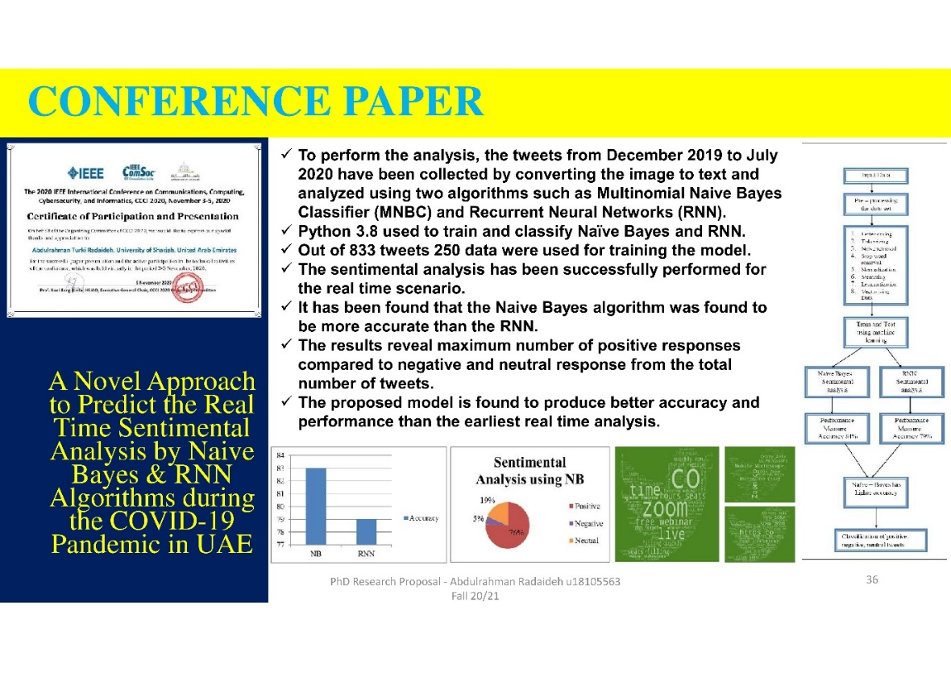

**Figure 10**. IEEE Conference Paper

***3.2.1.1.1 Methodologies Employed: Naive Bayes and RNN Algorithms for Real-Time Sentiment Analysis***

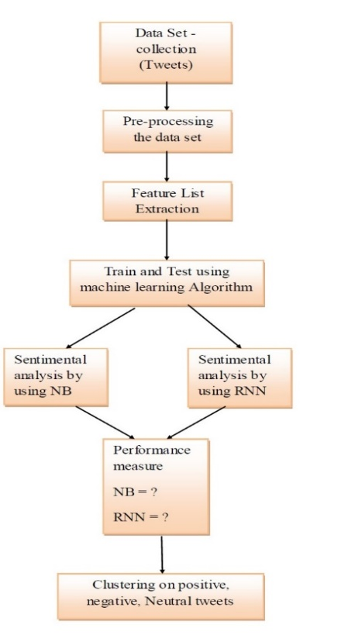 Under this section, we used dataset from twitter and analyzed it. The model used in the study was NBC and RNN along with clustering of sentimental analysis. The accuracy of the both the method NBC and RNN will be collected and the method which as high accuracy will cluster to find the factors for the sentimental analysis. Using the datasets collected, the training will be done and the corresponding output will be generated.

**Figure 11**. Research Procedure for Naive Bayes and RNN Algorithms for Real-Time Sentiment Analysis

**A. Data Pre-processing**

It is the first step for data analysis for which the various data has been collected from twitter from December 2019 to July 2020 after the onset of COVID pandemic and it has been classified with reference to internet calling. This is an important step because the quality of the data will lead to more reliable results. Preprocessing a Twitter dataset involves a series of tasks like removing all types of irrelevant information like emojis, special characters, and extra blank spaces. It can also involve making format improvements, deleting duplicate tweets, or tweets that are shorter than three characters. Data preprocessing for tweets encompasses a series of crucial steps to ensure the quality and consistency of the text data. Initially, letter casing ensures uniformity by converting all letters to either upper or lower case, facilitating easier analysis. Tokenization breaks down tweets into tokens, essentially words separated by spaces, enabling further processing. Subsequently, noise removal eliminates unwanted characters such as HTML tags, punctuation marks, and special characters, streamlining the data for analysis. Stop word removal eliminates insignificant words that contribute little to machine learning models, enhancing the relevance of the text. Normalization standardizes the text by converting it to lowercase, removing special characters, and eliminating stopwords, thereby improving text matching accuracy. Stemming simplifies words by removing affixes through techniques like the Porter Stemmer, aiding in text simplification. Lemmatization retains the base or dictionary form of words to preserve their meaning, addressing the limitations of stemming. Finally, vectorizing data converts tokens into numerical representations, a vital step for machine learning algorithms to effectively process and analyze text data. These preprocessing steps collectively ensure the quality and suitability of the text data for subsequent analysis and modeling tasks.

**B. Training and Classification**

Supervised learning is an important technique for classification problems. In the study we used two supervised tools for sentimental analysis. The two supervised tools said to be Naive Bayes and recurrent neural networks (Gui, 2023).

***3.2.1.1.2 Influence on Current Study: Adapting Real-Time Analysis Techniques***

We used Python to train and classify Naïve Bayes and RNN. Out of 833 tweets 250 data were used for training the model. The Fig shows the overall flow of the process

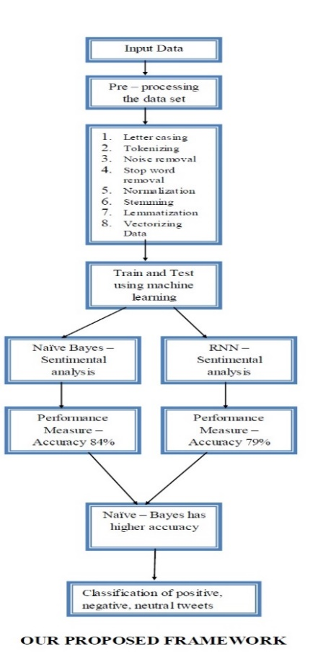

**Figure 12.** Proposed Framework:

|  |  |
| --- | --- |
| **(NB)** | |
| **Performance Measure** | |
| Positive Recall | 81.3 |
| Negative Recall | 66.06 |
| Positive Precision | 84.5 |
| Negative Precision | 62.69 |

Table 3. Performance Measure of NB

Table 4. Performance Measure of RNN

|  |  |
| --- | --- |
| **(RNN)** | |
| **Performance Measure** | |
| Positive Recall | 77.42 |
| Negative Recall | 68.23 |
| Positive Precision | 79.82 |
| Negative Precision | 65.32 |

Table 5. Accuracy of Methods

|  |  |
| --- | --- |
| **Accuracy of Methods** | |
| Methods | Accuracy |
| NB | 83 |
| RNN | 79 |

**Figure 13**. Measurement of Positive and Negative Recall

**Figure 14.** Measurement of Positive and Negative Precision

**Figure 15.** Accuracy of RNN and NB

From the above Table 3 and Table 4 shows the performance measure of Naive Bayes, RNN in the terms of Recall and Precision. Along with that, Table 5 shows the performance classifier terms of accuracy. Likewise, Figure 13 and Figure 14 show the positive, negative recall and positive, negative precision respectively. Figure 15 shows the Accuracy of the methods RNN and NB. The accuracy of Naive Bayes (NB) was greater than RNN, hence the positive, negative and neutral analysis of NB shown in Fig.

**Figure 16.** NB Sentiment Breakdown

From the analysis, it has been found that the usage of Internet calling was found to be predominant for performing the day-to-day operations in this pandemic scenario. In addition, the results reveal that the maximum number of positive responses has been recorded followed by negative and neutral response (Fig.16) from the tweets and on the other hand, it can be concluded that this culture is mostly agreed by most of the individuals in UAE.

***3.2.1.1.2. a* Clustering**

On clustering the positive, negative and neutral analysis it is found that people in UAE feels secured, satisfied and internet calling is very useful for them in the prospect of work, education, etc. Negative analysis shows that people were struggle to adapt to the situation and neutral analysis were people how have the capable to adopt to the culture.  
While Naive Bayes (NB) initially showed higher accuracy compared to RNN in sentiment analysis, optimizing the RNN algorithm could potentially lead to outperforming NB. Tweaking the RNN model could enhance its ability to capture nuanced patterns in the data, thus improving its accuracy and surpassing NB in sentiment analysis tasks.

**3.2.1.2 "Sentiment Analysis Predictions in Digital Media Content Using NLP Techniques*"***

In the digital era, understanding sentiment in online content is crucial for decision-making and content quality improvement (Sufi, 2022). By comparing NLP techniques for sentiment analysis of tweets, the BERT model stood out with a 94.56% accuracy rate. Additionally, the Random Forest model performed well, while the LSTM model showed proficiency in various metrics. Future research should focus on refining models and expanding datasets. Limitations include a Twitter focus and binary sentiment analysis. (Madhu, 2023),

***3.2.1.2.1 Methodologies Utilized: NLP Techniques for Digital Media Content Analysis***

A dataset of 16k tweets from Kaggle was divided into positive, negative, and neutral groups. Pre-processing techniques were used to clean the tweets before they were split into a training and test set. Machine learning algorithms like support vector machine, naive Bayes, decision tree, and K-nearest neighbor were trained for sentiment analysis. A recurrent neural network with LSTM was proposed and compared to the other classifiers based on performance evaluation measures. (Fanni, 2023).

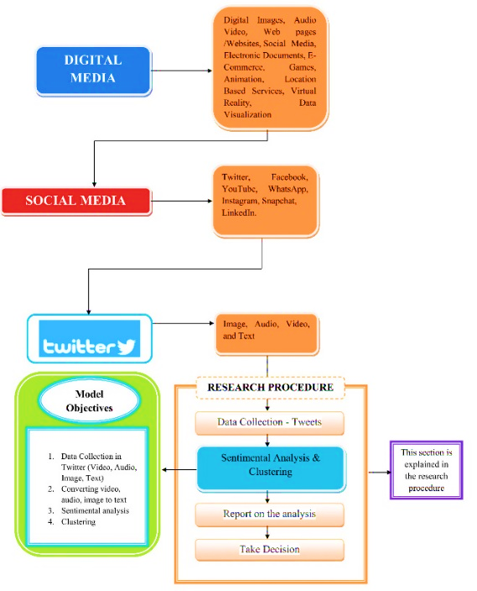

**Figure 17.** General Framework

## **3.2.1.2.1. aTools & techniues**

Various tools and resources are needed for sentiment analysis, including Python as a programming language for creating and training models. Python libraries like Pandas, Numpy, Scikit Learn, NLTK, Re, Keras, PyTorch, and Transformers are utilized.

Table 5. Python Libraries

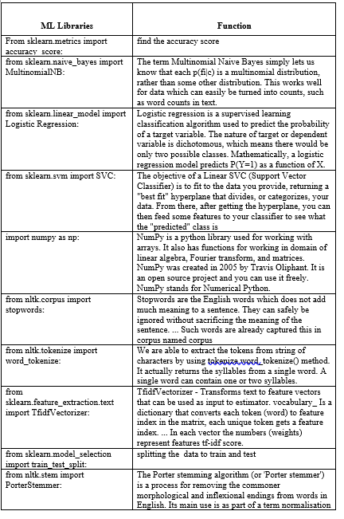

Anaconda, a Python distribution platform, will be used along with Jupyter Notebook for developing machine learning and deep learning models. The Twitter API will be utilized to extract new tweets for model testing, with the help of 3rd party Python packages like Tweepy. Minimum hardware requirements include Core i5 Processor, 16 GB of RAM, Nvidia GPU with 6 GB of V-RAM, and 100 GB of HDD space. The models will process, extract features, and classify data using machine learning algorithms.

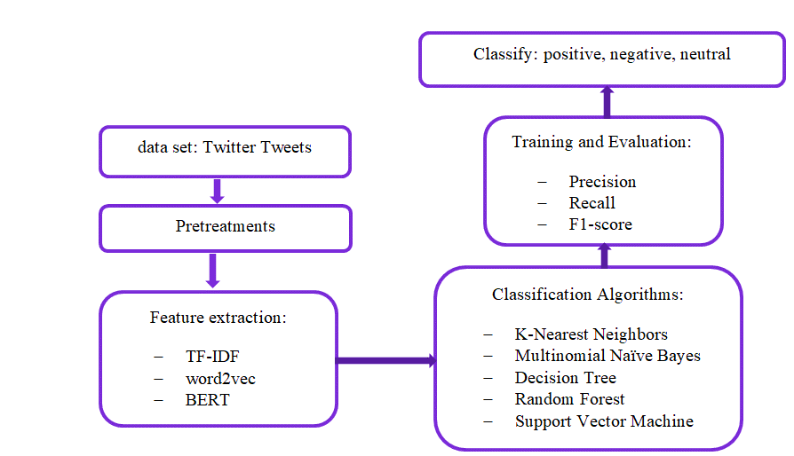

**Figure 18.** Framework of the Model

Model includes data pre-processing, feature extraction (TF-IDF, word2vec, BERT), tweet classification using k-nearest neighbors, Naïve Bayes, decision tree, random forest, SVM.

## **3.2.1.2.1. c Features Selection**

### Data pre-processing

Data pre-processing is vital for sentiment analysis before training machine learning models. This aims to simplify classifier training by transforming data. We utilized the NLTK library in Python to pre-process Twitter text data. By removing unnecessary parts like symbols and words, we extracted the tweet's semantic meaning. Relevant features were selected based on criteria like informativeness and computational efficiency. Steps included removing punctuation, stop words, URLs, emojis, and hash marks. The data is now cleaned and ready for feature extraction, as shown in Figure (3)..

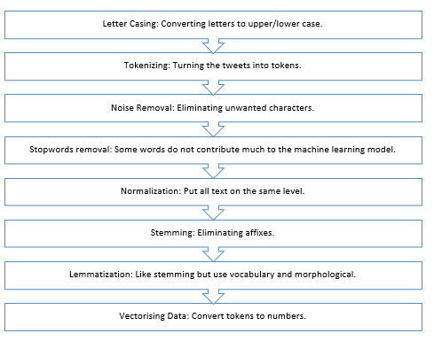

**Figure 19.** Data Pre-Processing

The pre-processing steps involve converting text to upper/lower case, tokenizing, removing unwanted characters/stopwords, normalizing, stemming, and lemmatization. The pre-processed text is then vectorized for machine learning. Feature extraction in the study used TF-IDF to measure word relevance, word2vec for continuous vector representation of words using PCA or t-SNE for dimension reduction, and BERT for deep bidirectional text representation. BERT, a pre-trained language model, can be fine-tuned for various language tasks such as sentiment analysis. The implementation of TF-IDF utilized sklearn, word2vec used Gensim with specific parameters, and BERT was used for fine-tuning and training on the dataset using the hugging face BERT model..

***3.2.1.2.2 Impact on Current Study: Refinement of NLP Techniques for Digital Content Sentiment Analysis***

**3.2.1.2.2.aMachine Learning Algorithms**

Various machine learning algorithms are used for sentiment analysis, including K-Nearest Neighbors, Multinomial Naïve Bayes, Decision Tree, Random Forest, Support Vector Machine, Voted Classifier, LSTM, Transformer Network, and K-Means Clustering. KNN identifies the group of a tweet based on training data, while Naïve Bayes determines the probability of a tweet's sentiment. Decision Tree classifies tweets based on their features, Random Forest provides more accurate predictions, and Support Vector Machine categorizes tweets into sentiment classes. Voted Classifier combines various algorithms for enhanced predictions, LSTM handles text sequences effectively, and Transformer Network uses pre-trained models. K-Means Clustering groups similar traits in tweets for analysis.

**3.2.1.2.2.b Model Training and Evaluation**

Model training is crucial for good results. Evaluating sentiment analysis models involves metrics like precision, recall, F1 score, and AUC-ROC curve from the confusion matrix comparisons.

**3.2.1.2.2.c Model Testing**

The top-performing model is chosen for testing with new tweets via the Twitter API on a user-friendly web server. Users input keywords and date ranges to view tweet polarity, offering valuable insights for organizations or individuals.

**3.2.1.2.2.d Comparative Analysis:**

Compare sentiment analysis models on digital media data for accuracy, computational efficiency, and real-world applicability to classify sentiment.

**3.2.1.2.2.e Results**

Models trained on 80% dataset, validated on remaining 20%. Accuracy metric used, results in table (2) for validation accuracy.

Table 6. Validation Accuracy

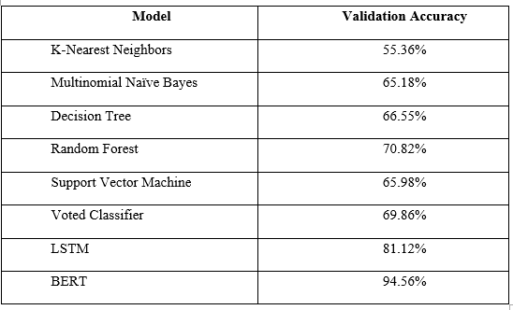

**3.2.1.2.2.f Evaluation:**

Confusion Matrix, Recall Score, Precision Score, and F1 Score measured sentiment analysis models. Results shown in Figure 4

|  |  |
| --- | --- |
| K-Nearest Neighbours | Multi-Nominal Naïve Bay |
| Decision Tree | Random Forest |
| Support Vector Machine | Voting Classifier |

**Figure 20.** Confusion Matrix

**Table 7.** Recall, Precision, F1 Score of all algorithms

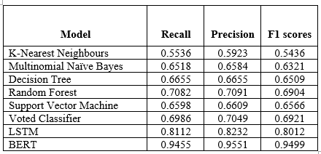

Enhancing previous approach through exploratory data analysis to extract features, followed by deep learning classification of tweets into positive, negative, or neutral categories. Framework for sentiment analysis outlined. Comparing effectiveness with previous method..

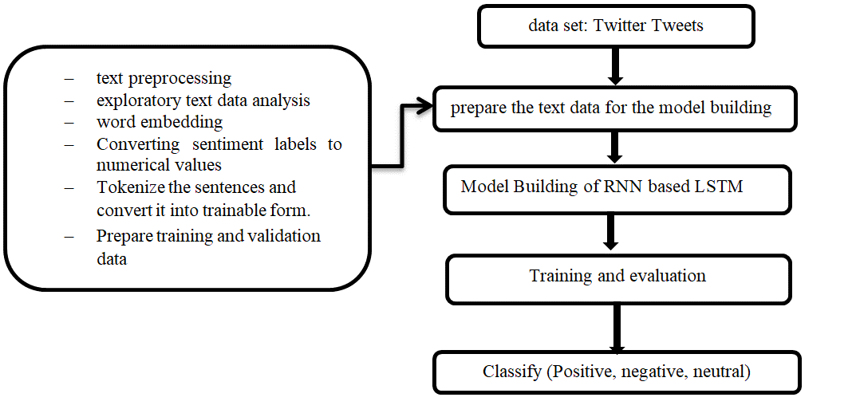

**Figure 21.** Framework for the Proposed Model

**3.2.1.2.2.f Algorithms**

In order to build a model for natural language processing (NLP) projects, the text data must undergo pre-processing. This includes cleaning procedures like removing stop words, URLs, punctuation, and performing tasks like lowercase conversion, stemming, tokenization, and lemmatization. Exploratory text data analysis is then conducted to understand the basic traits of the text, such as word frequency, sentence length, average word length, and distribution of words. Word embedding is applied to improve model accuracy by representing words with similar meanings similarly in a vector space.

Long Short-Term Memory (LSTM) networks employ gates to regulate data flow in and out of the network. Dropout layers are used to prevent overfitting during training by randomly setting input units to 0. Dense layers connect every neuron in one layer to every other neuron in the layer above. Various layers and functions from the Keras library are imported to build the model.

Model training involves setting hyperparameters like batch size and epochs, where the model parameters are updated after processing a certain number of samples. The model's accuracy is measured as the proportion of correct predictions out of the total, with the goal of achieving a high accuracy rate. In this case, the model achieved 96% accuracy, which was an improvement from previous analyses. By following these steps, a successful NLP model with high accuracy can be built for various tasks in natural language processing..

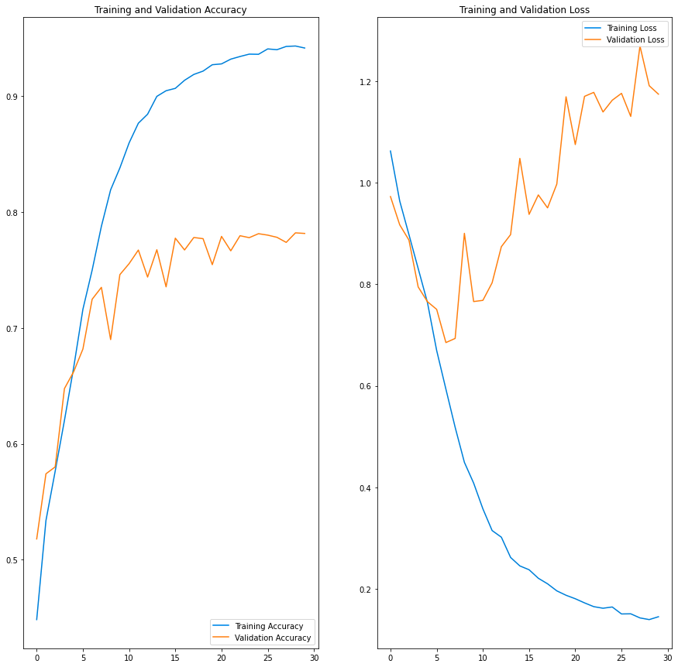

**Figure 22.** RNN Model

In Figure (22), the sentiment analysis model is trained, showing loss and AUC metrics for training and validation sets. Over the first 10 epochs, loss decreases and precision improves. Step 6 involves segmenting data subsets through clustering in Python, with techniques like Gaussian mixture models, spectral clustering, and K-means. K-means clustering, an unsupervised machine learning method, identifies clusters of data points based on their similarities. We utilize K-means clustering to create sentiment-based clusters from tweet data using a comprehensive pipeline and assigning tweets to three sentiment labels. We observed overfitting in the model, as indicated by the decreasing loss and improving precision, suggests a need for regularization techniques such as dropout layers or L2 regularization to prevent excessive reliance on specific data patterns during training. Additionally, increasing the diversity and size of the dataset for training could help generalize the model's performance on unseen data, thus mitigating overfitting and optimizing overall model performance.

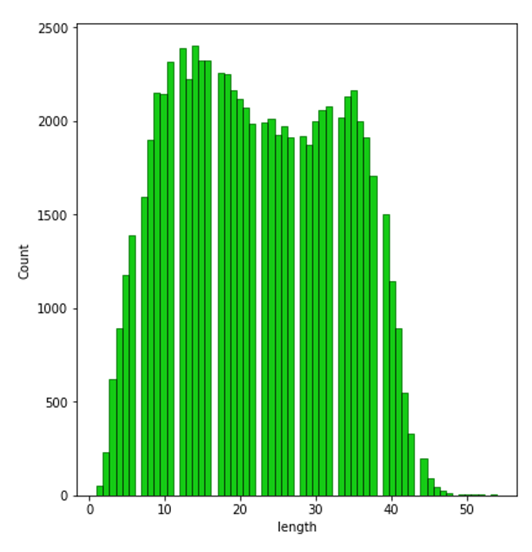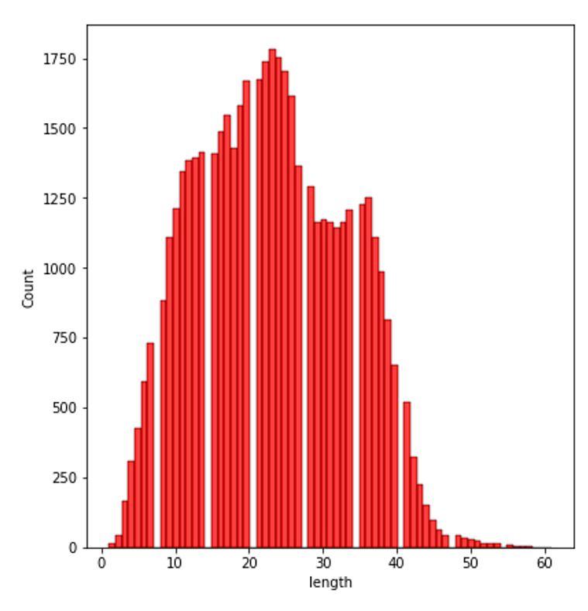

**Figure 23.** Positive Tweets  **Figure 24.** Tweets

The study compared machine and deep learning algorithms for tweet sentiment analysis. BERT achieved the highest accuracy (94.56%), showcasing the success of transfer learning with pre-trained models. The Random Forest algorithm outperformed other machine learning models with 70.82% accuracy, while K Nearest Neighbours had the lowest accuracy at 55.36%. The LSTM model excelled in Recall, Precision, and F1 scores, demonstrating overall performance. The RNN-LSTM model with word embedding, dropout, and clustering achieved 96% accuracy, highlighting deep learning's value in sentiment analysis. Utilizing various evaluation metrics, the study aimed to enhance decision-making and content quality in digital media. The findings emphasize the effectiveness of BERT and LSTM models, suggesting future research should focus on optimization and dataset expansion for real-world applications. The study establishes a foundation for advanced sentiment analysis techniques, emphasizing the importance of deep learning models in this evolving research domain.

**3.2.1.3 Use of Artificial Intelligence Applications in order to learn the Sentiment Polarity: A Case Study of the Public Perceptions on the Organizations Providing Post COVID-19 Vaccinations in the UAE**

This (Radaideh & Dweiri, 2024) research will focus on assessing public sentiment towards specific COVID-19 vaccines in the UAE using Twitter data. The inclusion/exclusion criteria have been set to ensure ethical data collection and analysis. Tools such as Python, Twitter API, and various libraries will be used for data collection, cleaning, and processing. Data will be collected from February 1, 2021, to late April 2021, and about 16,000 tweets will be gathered, with 4,000 tweets allocated to each vaccine. Data processing will involve cleaning and preprocessing tweets to remove irrelevant information and ensure accuracy. Sentiment analysis and clustering algorithms will be used to classify tweets based on sentiment and cluster them accordingly. The performance of the algorithms will be evaluated using test and validation accuracy metrics. The developed sentiment analysis model will be compared with the SMOTE algorithm for clustering. Preliminary results suggest that the sentiment analysis model outperforms SMOTE in accuracy.

The objectives of this paper consist of:

* To assess the public perception of the vaccines in the UAE using artificial intelligence algorithms.
* To analyze and interpret the data that we collect from social media.
* To eliminate misinformation and bias from the reality by giving a clear assessment of how the vaccines performed.

***Research Questions***

* Where And How to Collect the Data?
* What Has Been the Topic of Discussion Amongst People?
* What Is the General Perception of Vaccines Amongst People?
* What Are the Most Commonly Used Words That Are Associated with A Given Vaccine?

## **Data Collection and Preparation**

The data collection will be done by collecting 16000 reviews from Twitter. The data for this will be as a text. About 4000 tweets will be allotted to each of the given vaccination to give every vaccine a fair chance before conducting the research. The tweets will be narrowed down at random so that we can eliminate any form of bias from our side and we report the facts found in the research.

These will be collected through the mix of scraping the data from the web and through using the Twitter API. The reason a mixed approach is used is that Twitter's API is restrictive in terms of how much data we can scrape out of it so using other methods is a necessity to collect data for our use case [14]. In the case of an audio or a video post, we will scrape or transcribe the text in it which will then be cleared up to be used as a way to analyze what the user is saying in that video or audio [15].

The data collected is followed the exclusion/inclusion criteria we have set before collecting the data. For this, we will scrape off any unnecessary links or texts so that the dataset does not affect the result in any way. Substitutions are placed for common spelling mistakes so that the classifier does not confuse. This process is represented in graphical form in Figure 2 and 3 as well. in this, it gives a general overview on how we will perform the crucial steps that will help in collecting the data, cleaning and preprocessing the data and also preparing it to be clustered, segmented and be used to train the model as well.

**Figure 25** Twitter Data Extraction and Sentiment Analysis

# **Result of this paper**

Once the data is processed and scraped, the data is first classified through Sentiment Analysis in order to label it positive, negative or neutral. This will help in ensuring that we are able to Based off these labels, this is then passed through another classifier, this time it is SMOTE in order to cluster the texts based on the features that are found inside the corpus of text. Doing this will help us in understanding the public perception of the users on the vaccinations. Once the model is built, we will then use it to segment the data based off the labels that we have set in order to get an idea of how many are there that are considered positive, negative or neutral in nature. The model will be trained using the data we have collected and also a mix of data that we may collect from sites such as Kaggle should they have the data we need. In addition, this will be used to classify any new data that we will pass in order to get an idea on how well it will be able to determine whether the corpus sent is positive, negative or neutral.

## **Analysis and building of the model**

Once the data is processed and scraped, first the data is classified through Sentiment Analysis in order to label it positive, negative or neutral. Based off these labels, this is then passed through another classifier, this time it is SMOTE in order to classify it based on the features that are found inside the corpus of text. Lastly, the data will be clustered using SMOTE in order to cluster the tweets based on the features that it has and the sentiment that it provides. To assess the performance of it, we will separate about 30% of the data that we collect in order to use the unseen data to assess how well it can classify a given corpus of text.

The higher the validation accuracy and how close it is to the accuracy of the model, the more we will be sure that the model is trained well and that it can accurately label the text we throw at it. It can be used to examine large chunks of text which can help in contributing the perception of a given vaccine amongst the people of UAE.

## **Empirical Data Analysis**

Once the data is cleaned and filtered out, we can analyze and process the tweets according to the questions that we aim to answer. It will ensure that we are able to develop a good understanding on what the people have to say about a given vaccine that they have received along with an idea on whether they believe it is good or not. There are duplicate tweets that are present in it such as some have mentioned both Sinopharm and Pfizer-BioNTech in their tweet while encouraging their followers to get vaccinated. These can be considered for this research as they are talking more about getting vaccinated rather than giving their opinion on the given vaccine. Similarly, tweets that only mention the fact that they are vaccinated but have used one of the tags in their tweets is also considered as we can safely assume that they used that given vaccine. In addition, we decided to remove the usernames of the individuals so that their anonymity remains and so that we can only focus on working with the tweet itself. Some of the examples of the data that we had to work with consist of the following:

Table 8 SAMPLE DATA FOR ASTRAZENECA VACCINE

|  |  |  |
| --- | --- | --- |
| **Date** | **Tweet body** | **Search Query** |
| 2021-03-31 12:35:33+00:00 | Hope Consortium: African ministers say doubts about AstraZeneca led to vaccine hesitancy | AstraZeneca |
| 2021-03-31 23:27:46+00:00 | JnJ now guys it’s just a mixup next batch is in next week be ready johnsonandjohnson AstraZeneca | JnJ, AstraZeneca |
| 2021-03-31 23:36:21+00:00 | Just a warning to those doubtful of this story; the astra zeneca jab has made many people sick with an array of troubling symptoms, myself included. I've not yet had the 2nd, but some friends have; several vomited, all had crushing headaches, swollen faces, great lethargy" | AstraZeneca |
| 2021-03-31 23:35:49+00:00 | Somewhere, the AstraZeneca folks are feeling cheered-up that someone else effed up for once. | AstraZeneca |

From these, we can see that the perception for AstraZeneca was perceived bad because of the present blood clotting issue that is found in it. This has caused a negative image towards it after it was revealed that patients can experience this and in extreme cases, die due to it. This has sort of decreased over time when Johnson and Johnson vaccine faced similar reports, which is being referred to in the last tweet in table 1. Other sample data that can be shown is in the following:

Table 9 SAMPLE DATA FOR PFIZER-BIONTECH VACCINE

|  |  |  |
| --- | --- | --- |
| **Date** | **Tweet body** | **Search Query** |
| 2021-03-31 22:53:59+00:00 | 1 shot down Feeling very blessed vaccinated PfizerBioNTech | Pfizer |
| 2021-03-31 22:43:08+00:00 | I’m finally completely vaccinated Even though I’m grateful for science every day today is particularly special! PfizerBioNTech | Pfizer |
| 2021-03-31 18:24:42+00:00, | Got my first COVID vaccine dose this morning. GetItDone PfizerBioNTech | Pfizer |
| 2021-03-31 18:13:45+00:00 | Bring on Twins baseball I’m fully vaccinated as of today Twins targetfield PfizerBioNTech | Pfizer |

Table 10 SAMPLE DATA FOR SPUTNIKV VACCINE

|  |  |  |
| --- | --- | --- |
| **Date** | **Tweet body** | **Search Query** |
| 2021-03-31 21:33:46+00:00 | As for me I prefer SputnikV, however I have payment for one dose only hence I have to mix | SputnikV |
| 2021-03-31 21:03:48+00:00 | It saddens alot because in that crowd I can assure you 50 voted for and look at what they're going Through A lady fainted today as she was crossing the bridge to | SputnikV |
| 2021-03-31 21:02:56+00:00 | SputnikV is deliberately not being registered in the EU because of pressure from USA and UK Otherwise the vaccine have no issues. | SputnikV, vaccine |

Table 11 SAMPLE DATA FOR SINOPHARM VACCINE

|  |  |  |
| --- | --- | --- |
| **Date** | **Tweet body** | **Search Query** |
| 2021-03-15 19:14:02+00:00 | If you had Sinopharm vaccine you can test positive even after getting the 2nd dose but it will be very mild, it gives you full immunity after completing 14 days after 2nd dose. You can get severe illness from 1st dose too so still be careful | Pfizer |
| 2021-03-31 22:43:08+00:00 | They combined two trials for phase 3 without standardized dosing schemes. But there is a lot more data now and that doesn't point to an issue. And in such an old type of vaccine you wouldn't expect issues  I took Sinopharm as part of a phase 3 trial on the same logic btw | Sinopharm |
| 251,2021-03-15 17:27:04+00:00 | I wasn't convinced but went cos of my mum. Sinopharm made more sense to me but ended up getting Pfizer and had quite an ugly reaction - what essentially felt like a panic attack with 6 days of recovery post 2nd jab. Unknown times but yes I think it is best to get vaccinated ASAP. | Sinopharm |

From looking at these tables, we can easily deduce that Pfizer has a generally better public perception compared to others due to either its high efficacy rate or due to the fact that it was readily available in countries such as US, UK and in the UAE. This has led to it being more used and talked about compared to other vaccines which have been unavailable to those areas either due to political reasons or due to the fact that these are found in small stocks. The former is true SputnikV and Sinopharm due to the fact the restrained relationships with Russia and China and the latter is true for the case of AstraZeneca.

In addition to this, we have had also analyzed the data itself so that we are able to provide a clear overview on the frequency of words that are used all across the dataset, which will give an idea on what the tweets consisted of and what were the general talking points in those. For this, we will eliminate any of the common words such as “vaccine”, “vaccination” or the name of the vaccine as we only need to examine what other words were commonly used alongside it. In addition, any mention of countries will be omitted as well as that would not tell us anything significant of the tweets that are being made on the vaccine. For this, the top three most used words (MUW) that were found in the tweets for each of the vaccine are according to the below:

Table 12 WORD FREQUENCY DISTRIBUTION OF THE TWEETS IN THE DATASET

|  |  |  |  |  |  |  |
| --- | --- | --- | --- | --- | --- | --- |
| **Vaccine** | **1st**  **MUW** | **Frequency** | **2nd MUW** | **Frequency** | **3rd MUW** | **Frequency** |
| Pfizer-BioNTech | dose | 1234 | first | 1107 | Moderna | 738 |
| AstraZeneca | people | 466 | blood | 409 | Jab | 298 |
| Sinopharm | pharmaceutical | 3815 | firm | 3703 | Arrives | 1125 |
| SputnikV | doses | 340 | approved | 207 | People | 199 |

* People getting their first dose of Pfizer vaccine or people comparing or suggesting others to go with Moderna vaccine.
* People being concerned over the blood clotting issue that is found in AstraZeneca but this is from the more recent tweets.
* People discuss about the availability of the vaccine in pharmaceutical firms for Sinopharm vaccine.
* Lastly, people talking about the doses for Sputnik to be approved for use despite the political tension that is present between Russia and countries like the USA, UK and the UAE.

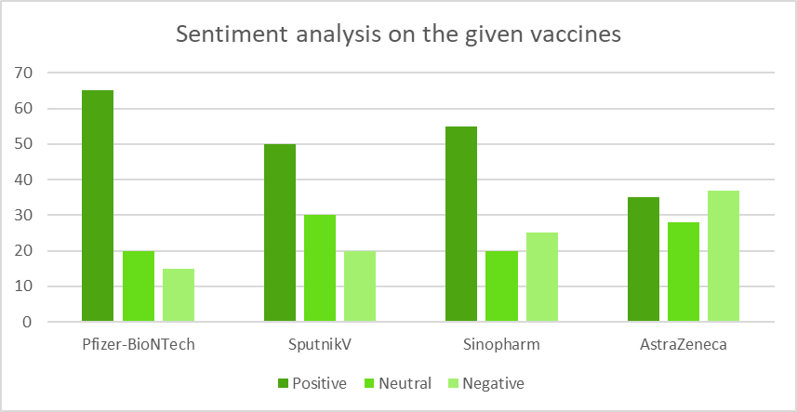

**Figure 26** Graph Depicting the Perception of the Given Vaccines

**Assessment of the algorithms used**

As previously mentioned before, we will use a sentiment classifier to do this along with perform a clustering algorithm, i.e., SMOTE in order to classify these tweets as positive, negative or neutral. As such, we will need to develop the sentiment classifier that we can compare with the SMOTE algorithm.

For this, we will use TensorFlow to build the algorithm to classify and determine the sentiments of the tweets that we have collected (Large-Scale Machine Learning in the Earth Sciences, 2018). TensorFlow is an open-source library that is made by Google that is used to build models from scratch or to use the likes of Keras as a front end to simplify the building process.

For this, we will train the model to perform sentiment analysis using the existing dataset that is used to train such models. For this, we will use the dataset that we collected from the internet to classify it as positive, negative or neutral. The model that we created looked like the following in Table 13.

Table 13 MODEL SUMMARY

|  |  |  |
| --- | --- | --- |
| **Layer** | **Output Shape** | **Params** |
| Embedding | (None, 1000, 64) | 640000 |
| Dropout | (None, 1000, 64) | 0 |
| Dropout_1 | (None, 1000, 64) | 0 |
| LSTM | (None, 100) | 66000 |
| Dense | (None, 1) | 101 |

From these, we can deduce that a total of 706,101 trainable parameters are included in it, which will help in making sure that the model is pretty accurate. The model works by first embedding the given text or string to it being a noun, pronoun or among others. This is then trained and passed on to a LSTM network that will read through it sequence by sequence so that it can detect the emotion of the text or what is the sentiment of it in this case. The diagram for the model will look something as what is shown in the Figures shown below:

**Figure 27** Graph Plot of the Model with the Variables and Input Parameters

In this diagram shown in Figure 27, the following labels are used the following parts of the model

* X – this is used to refer to the input data that is being transferred to the model. this
* Xn’ – this refers to the hidden layers that are received from the model and into the dense layer. Each of these nodes consist of an activation function that will help in adjusting the parameter of the function so that we are able to get the right result.
* I – this refers to the input layer of the LSTM network that we have used. In this, the input received is from the embedding layer that will consist of the features that are found inside of the LSTM layer.
* O’ – the output layer of the LSTM layer from which we collect the output that we have obtained after processing it in the hidden layers of the LSTM model. These differ from something along the likes of RNN with the use of a forget gate inside the hidden layer that is used to ensure that the network does have a vanishing gradient problem.

In this, LSTM consists the input layer, output layers and the hidden layers which consists of the forget gate. To prevent overfitting, we have added a dropout rate to it. A dropout acts as a regularizer that helps in making sure that the models are properly trained and that the risk of overfitting is reduced. This works by stopping a set number of neurons at random in the network from training so that the activated ones can train better (Srivastava et al., 2015). In our case, we have trained it to work under a dropout rate set at 40%, which means that 40% of the subsequent layers will be deactivated at random at each epoch so that the rest of the 60% will be trained and further improved.

This will help in better regularizing the LSTM network so that it can better analyze the sentiment of the model. In our case, we have added two dropouts as it can potentially help in better training the model as we will be first deactivating a set percent of the neuron and then proceed to deactivate a portion of the remaining ones. This model will be passed through 50 epochs which means that the data will be passed through the model for about 50 times which will help it get familiar with the patterns found in a positive, neutral or a negative corpus. The diagram in Figure 7 gives us a general overview on what the model will look like along with the number of parameters that it will have. This consists of the input parameters of the layers and the output parameters of the layer. This information can help in understanding how many neurons will work in a network.

When training the model out, we found out that the model has a pretty high accuracy of about 98%, which shows that it is pretty familiar with the data itself. Meanwhile the validation accuracy was found to be around 88%. There could be a chance that the model has been over-fitted where the data is too familiar with the data and any unfamiliar text fed to it will be met with an uncertainty.

From the loss that we calculated; we can examine that the model performed as well as we intended it to be. The high amount of loss on test indicates that there are some accuracy problems in the model such as it can generate more false positives and negatives but overall, we can see that the model will be able to accurately detect the sentiment of the text that is being passed at it.

This will be compared to the SMOTE algorithm that we will use to cluster these tweets based on the sentiment that it provides. To simplify our process, we will use the module of SMOTE from the library imbalanced-learn, which is like SciKit-Learn but it provides already made algorithms for oversampled data, which also includes SMOTE. Comparing the two together, we can give the result in the following table:

Table 14 Comparison with Our Algorithm And SMOTE

|  |  |  |
| --- | --- | --- |
| Algorithm | Test Accuracy | Validation Accuracy |
| Our Model | 86% | 88% |
| SMOTE | 82% | 84% |

As we can see in Table 7, our model performed generally better because SMOTE is usually used when data is highly imbalanced, unlike our dataset where the labeling is somewhat balanced in general. This can help in making sure that we are able to classify an imbalanced data. However, SMOTE can be used to train the model far better as it can better cluster the data compared to classifying with the help of Sentiment Analysis.

Table 15 Summary of all papers Sentiment Analysis Methodologies and Techniques

|  |  |  |
| --- | --- | --- |
| **Paper** | **Approach** | **Algorithms/Techniques** |
| Paper 1 | Machine Learning (ML) | Naive Bayes, RNN |
|  |  |  |
| Paper 2 | Machine Learning (ML) | SMOTE algorithm, TensorFlow |
|  |  |  |
| Paper 3 | Machine Learning (ML) | SVM, Naive Bayes, Decision Tree, KNN, LSTM, BERT |

Paper 1 employed ML-based approaches (Naive Bayes, RNN) for sentiment analysis on Twitter data during the COVID pandemic. Paper 2 continued with ML techniques (SMOTE algorithm, TensorFlow) focusing on public perceptions of COVID-19 vaccines. Paper 3 extended to both ML (SVM, Naive Bayes, LSTM) and NLP techniques (word2vec, BERT) for sentiment analysis on a larger dataset from Kaggle.

NLTK, Scikit-learn, and TensorFlow were utilized in previous studies for data processing and model building. The proposed study integrates NLTK, TensorFlow, and Keras for enhanced sentiment analysis using deep learning techniques.

The coding type predominantly used across the studies is Python, known for its simplicity, readability, and extensive libraries like NLTK and TensorFlow. Python is favored for its ease in handling text data, implementing machine learning algorithms, and facilitating rapid prototyping, making it ideal for sentiment analysis tasks in research.

Table 16 Summary of Data Sources in Sentiment Analysis Methodologies from papers with currents research

|  |  |
| --- | --- |
| **Methodology** | **Data Source** |
| Paper 1 | Twitter dataset spanning from December 2019 to July 2020, focusing on the onset of the COVID-19 pandemic. |
| Paper 2 | Twitter reviews of COVID-19 vaccines in the UAE collected from February 1, 2021, to late April 2021. |
| Paper 3 | Dataset obtained from Kaggle, comprising approximately 160,000 tweets categorized into positive, negative, and neutral groups. |
| Proposed Methodology | 90% data from twitter, 10% other digital media source |

These data sources were carefully selected to ensure relevance to the research objectives and to provide a comprehensive understanding of sentiment during specific time periods and contexts.

**3.2.2 Integration into Current Research Framework**

In integrating methodologies from the prior research papers into the current study's framework, a focused effort has been made to harness the strengths and adapt the approaches to suit the specific requirements of sentiment analysis within digital media content. The methodologies outlined in the previous works, notably the utilization of Naive Bayes, RNN algorithms for real-time sentiment analysis and the application of NLP techniques for digital media content analysis, served as foundational pillars guiding the design of the current research. These methodologies have been seamlessly integrated, serving as the blueprint for refining the current framework.

By strategically adapting these methodologies to accommodate the distinctive characteristics and intricacies of digital media content, the research framework has been honed to facilitate a more nuanced and contextually relevant approach to sentiment analysis. This integration process has not only informed the selection of algorithms and techniques but also guided the strategic customization of methodologies to align with the unique objectives and intricacies of the present study, thereby enriching the robustness and relevance of the current research framework.

***Adaptation of Algorithms and Frameworks***

The methodologies outlined in the previously published papers, encompassing a wide array of algorithms such as K-Nearest Neighbors, Multinomial Naïve Bayes, Decision Tree, Random Forest, Support Vector Machine, Voted Classifier, LSTM, and BERT, have been instrumental in informing the algorithmic selection and framework development for the current study on sentiment analysis within digital media content.

In "A Novel Approach to Predict the Real-Time Sentimental Analysis by Naive Bayes & RNN Algorithm during the COVID Pandemic in UAE," the focus on Naive Bayes and RNN algorithms for real-time sentiment analysis served as an initial blueprint. The adaptability and agility of these algorithms in handling real-time data streams and evolving sentiment patterns during a significant event like the COVID-19 pandemic inspired the exploration and customization of similar algorithms for the current research.

Simultaneously, in "Sentiment Analysis Predictions in Digital Media Content Using NLP Techniques," the utilization of K-Nearest Neighbors, Multinomial Naïve Bayes, Decision Tree, Random Forest, Support Vector Machine, Voted Classifier, LSTM, and BERT algorithms showcased the diversity and effectiveness of various machine learning and deep learning techniques in deciphering sentiment within specific digital content domains.

Drawing from the methodologies employed in both papers, a strategic amalgamation of algorithms has been curated for the current study. The adaptability and versatility of these algorithms have been harnessed to cater to the intricacies of sentiment analysis across diverse digital media formats and platforms. Each algorithm's strengths have been leveraged and fine-tuned to handle the multifaceted nature of textual, visual, and multimedia content prevalent in digital media spaces. This integration not only broadens the spectrum of analysis but also enhances the research framework's capacity to capture nuanced sentiments expressed within the complex landscape of digital media content

***Tailoring Methodologies to Suit Digital Media Context***

The methodologies derived from prior research endeavors have been meticulously tailored and fine-tuned to suit the distinctive intricacies inherent in analyzing sentiment within the realm of digital media content. In previous studies, the application of sentiment analysis algorithms, such as Naive Bayes, RNN, K-Nearest Neighbors, Decision Tree, Random Forest, Support Vector Machine, Voted Classifier, LSTM, and BERT, primarily targeted specific contexts, necessitating a reconfiguration and recontextualization to align with the complexities of digital media platforms and content types.

The adaptability of these methodologies has been instrumental in addressing the multifaceted nature of digital media content, including textual, visual, and multimedia elements. Techniques that proved effective in analyzing sentiment within textual content in prior research were extended and modified to accommodate the diverse modes of expression prevalent in visual and multimedia formats across various digital platforms.

Moreover, considerations for context, tone, linguistic nuances, and evolving trends within digital media content were paramount in tailoring these methodologies. As digital media content often involves user-generated data and ever-evolving language patterns, the methodologies underwent enhancements to capture the dynamism and idiosyncrasies inherent in this landscape.

By fine-tuning these methodologies to the specific demands of digital media contexts, the research framework gained the capacity to navigate the intricate interplay of various content types, platforms, and user-generated expressions. This tailored approach ensures a more nuanced and contextually relevant analysis of sentiments expressed within the multifarious landscape of digital media content, consequently enhancing the precision and applicability of the current study's methodologies.

***Enhancements and Modifications for Specific Research Objectives***

The methodologies inherited from previous research have undergone deliberate enhancements and modifications to align with the specific research objectives centered around the utilization of multiple digital media datasets procured from diverse resources. In prior studies, the algorithms and techniques, inclusive of Naive Bayes, RNN, K-Nearest Neighbors, Decision Tree, Random Forest, Support Vector Machine, Voted Classifier, LSTM, and BERT, were primarily applied within specific contexts or datasets.

The augmentation of these methodologies involved crucial adaptations to address the intricacies presented by the integration of diverse digital media datasets. Considerations for the heterogeneity of data sources, encompassing textual, visual, and multimedia content from various platforms, were paramount. Enhancements were implemented to ensure the seamless integration and analysis of these disparate datasets without compromising the integrity and accuracy of the sentiment analysis process.

Moreover, modifications were instituted to facilitate a cohesive approach to analyze sentiments across varied data sources. These modifications encompassed data preprocessing techniques, feature engineering strategies, and algorithmic adjustments tailored to accommodate the idiosyncrasies of each dataset while striving for a unified analysis framework.

By enhancing and modifying the inherited methodologies to suit the incorporation of multiple digital media datasets from various resources, the research framework now stands equipped to tackle the complexities inherent in amalgamating diverse data sources. This strategic approach enables a more comprehensive and inclusive sentiment analysis across a spectrum of digital media content, thereby fortifying the capacity to derive nuanced insights aligned with the specific research objectives.

**3.2.3 Refinement and Customization of Methodologies**

***3.2.3.1 Modifications Based on Data Source Characteristics***

The methodologies inherited from prior research underwent meticulous refinement and adaptation, considering the diverse characteristics inherent in the datasets sourced from blogs, Spotify, Twitter, and Facebook. Each data source presents unique challenges related to data structure, content format, user interactions, and context. To accommodate these intricacies, modifications were implemented in preprocessing techniques, feature extraction methods, and algorithmic configurations.

Tailored modifications were made to account for the unstructured nature of blog data, the audio-centric content from Spotify, the succinct and evolving nature of tweets on Twitter, and the multi-modal and diverse interactions present in Facebook content. These modifications aimed to harmonize the methodologies to effectively process and analyze data from each source while ensuring consistency and reliability in sentiment analysis.

***3.2.3.2 Customization to Address Unique Aspects of Digital Media Content***

The customization of methodologies was further extended to address the unique aspects prevalent in digital media content. This included considerations for multimedia content formats, such as audio from Spotify, textual content from blogs and tweets, and the amalgamation of textual, visual, and interactive elements in Facebook data.

Techniques were customized and optimized to handle the varying characteristics and modalities of digital media content. For instance, algorithms were fine-tuned to decode sentiments from textual content while simultaneously accounting for emotional cues conveyed through audio content on Spotify. Moreover, sentiment analysis frameworks were adapted to capture nuanced sentiments expressed through visual elements or interactive features within Facebook content.

***3.2.3.3 Aligning Methodologies with Current Research Goals***

These refined and customized methodologies were strategically aligned with the current research goals, which encompassed comprehensive sentiment analysis across diverse digital media platforms. By integrating and harmonizing methodologies specifically tailored to suit the characteristics of data sourced from blogs, Spotify, Twitter, and Facebook, the research framework was positioned to effectively achieve the overarching research objectives of holistic sentiment analysis within the multi-faceted landscape of digital media content.

**3.4 Quantitative Techniques: Numerical Analysis through AI Tools**

Within the framework of this research, quantitative analysis techniques have been inspired and refined by the methodologies employed in the published work, particularly leveraging Naive Bayes, RNN algorithms, and Natural Language Processing (NLP) techniques. The insights garnered from these published papers have guided the development and implementation of similar quantitative approaches in this study for sentiment analysis and prediction within digital media content.

**3.5 Justification: Reasoning Behind Methodological Choices**

The methodologies utilized in the published research papers have been critically examined and justified in alignment with the current research objectives (Chaturvedi, 2018). The adaptation of certain techniques from these papers has been rationalized based on their effectiveness in real-time sentiment analysis and their applicability to the specific context of digital media content in this study.

##### **3.5.1 Methodological Decision-Making: Rationale for Approaches**

Methodological decision-making involves elucidating the rationale behind the chosen approaches and strategies for conducting the research. It aims to provide a clear understanding of why specific methodologies, tools, and techniques were selected over others. This section of the methodology chapter outlines the thought process and reasoning behind methodological choices, including the selection of algorithms, data collection methods, and analysis techniques for sentiment analysis within digital media content.

Key elements to discuss under this section include:

* **Justification for Method Selection:** Explain why particular algorithms (such as Naive Bayes, RNN, etc.) and tools were chosen for sentiment analysis. Discuss their strengths, relevance to the research objectives, and applicability to the diverse nature of digital media content.
* **Rationale for Data Sources:** Describe the reasoning behind selecting blogs, Spotify, Twitter, and Facebook as data sources. Highlight the diversity and richness of these platforms and how they contribute to a comprehensive understanding of sentiment across various media types.
* **Considerations for Multi-source Analysis:** Justify the decision to employ multiple sources for a holistic approach to sentiment analysis. Explain how integrating various platforms enriches the analysis and captures diverse perspectives and expressions.
* **Framework Flexibility:** Discuss the flexibility of the chosen methodologies to adapt to the dynamic nature of digital media content. Explain how these approaches accommodate different data formats, languages, and evolving trends in online communication.

##### **3.5.2 Ethical Considerations: Protecting Participants' Rights**

Ethical considerations are paramount when conducting research involving data from online platforms and user-generated content. This section focuses on addressing the ethical principles and safeguards implemented to ensure the protection of participants' rights and confidentiality.

Key points to address within this section include:

* **Informed Consent:**

Obtaining informed consent from participants is essential to uphold ethical standards and respect participants' autonomy and rights. To achieve this, participants were transparently informed about the purpose of sentiment analysis using ChatGPT on digital media content. This involved clearly communicating the objectives and motivations behind the research, emphasizing the intended use of participants' data for sentiment analysis. Additionally, participants were provided with detailed information regarding how their data, such as social media posts or comments, would be utilized in the study. They were made aware of the potential implications of the research, including any risks or benefits associated with their participation. Importantly, consent was obtained voluntarily, with participants fully understanding that their involvement was optional and without any form of coercion. Participants were assured that they could withdraw their consent at any time without consequences, further emphasizing the voluntary nature of their participation. These measures were implemented to ensure that participants were adequately informed and empowered to make autonomous decisions regarding their involvement in the research, thereby upholding ethical principles of informed consent.

* **Anonymization and Privacy:**

Protecting the privacy of participants and ensuring the confidentiality of their data are critical ethical considerations in our research. To safeguard participants' privacy, anonymization techniques were rigorously employed to remove personally identifiable information (PII) from the data before analysis. This involved systematically scrubbing the data of any identifiers that could potentially link it back to individual participants, thereby minimizing the risk of unintended disclosure. Additionally, aggregation methods were utilized to further enhance privacy protections by consolidating data in a manner that prevents the identification of individual participants. By aggregating data, individual identities are obscured, and participants' privacy is safeguarded, even in the context of data analysis. These measures were implemented with meticulous attention to detail to ensure that participants' privacy rights were upheld throughout the research process, thereby fostering trust and ethical integrity in our study.

* **Data Security and Storage:**

1. Implement robust protocols for secure data handling, storage, and disposal throughout the research process.
2. Utilize encryption methods, access controls, and secure storage facilities to protect participants' data from unauthorized access or breaches.
3. Establish clear procedures for data disposal, ensuring that data is securely deleted when it is no longer needed for the research.

By prioritizing data security and storage best practices, our research endeavors aimed to uphold the confidentiality and privacy of participants' data throughout the research lifecycle

* **Compliance with Regulations:**

Adherence to legal and ethical guidelines, such as the General Data Protection Regulation (GDPR), Health Insurance Portability and Accountability Act (HIPAA), or other relevant regulations, is fundamental to ensuring the ethical conduct of research involving digital media content and artificial intelligence (AI). Throughout the implementation of our novel opinion mining approach utilizing ChatGPT for sentiment analysis on digital media content, stringent efforts were made to align our research practices with these regulatory standards. We meticulously reviewed the provisions and requirements outlined in relevant regulations, understanding their implications for data privacy, consent, security, and handling. Integration of compliance considerations commenced during the research design phase, where protocols were established to encompass data collection, storage, analysis, and disposal procedures, all within the confines of regulatory expectations. Furthermore, proactive measures were taken to secure necessary approvals from institutional review boards (IRBs) or ethics committees, particularly given the sensitive nature of the data involved. Research proposals and protocols were meticulously drafted, outlining our objectives, methodologies, data handling practices, and ethical considerations, ensuring transparency and alignment with regulatory requirements.

Throughout the research process, ongoing compliance with regulatory standards was a central focus. Continuous monitoring and review mechanisms were established to ensure that our research practices remained in accordance with evolving regulations and ethical guidelines. Rigorous data security measures were implemented, including encryption, access controls, and regular audits, to safeguard participant data from unauthorized access or breaches. Comprehensive documentation of all research activities, including consent procedures and communications with ethics committees, was meticulously maintained to ensure accountability and transparency. Additionally, procedures were established to address any ethical concerns or participant complaints that may arise during the research process, facilitating prompt investigation and resolution of issues in alignment with ethical principles and regulatory requirements. Through these efforts, our research endeavors were conducted ethically and in full compliance with relevant regulations, thereby safeguarding participants' rights and protecting their data integrity throughout the research journey.

**3.6 Novel Methodological Framework for Comprehensive Exploration**

This study aims to propose a novel approach for predicting sentiments from digital media user reviews by integrating text sentiment analysis and converting video and audio data into textual format for comprehensive sentiment understanding.

The chosen research approach encompasses a mixed-method methodology that amalgamates quantitative and qualitative paradigms. This hybrid approach is deemed suitable as it allows a holistic examination of the opinion mining implementation on digital media. It facilitates numerical analysis while embracing the richness of qualitative insights from user perspectives and content nuances.

**Understanding the Hybrid Paradigm**

The selection of a mixed-method methodology, fusing both quantitative and qualitative paradigms, epitomizes a conscious endeavor to harness the strengths of divergent research methodologies. This hybrid approach converges numerical analysis and qualitative insights, underpinning a holistic examination of opinion mining implementation within the dynamic landscape of digital media (Rigaki, 2023).

**Embracing Quantitative Analysis**

Quantitative methodologies traditionally thrive on empirical observations, statistical analysis, and numerical data interpretation. Within the context of implementing opinion mining on digital media, quantitative analyses afford the ability to quantify sentiments, preferences, and trends across vast datasets. Statistical models, machine learning algorithms, and sentiment analysis metrics serve as the bedrock for objectively measuring sentiments and identifying patterns within digital content.

**Leveraging Qualitative Insights**

In stark contrast, qualitative paradigms delve into the intricate nuances, subjective perceptions, and contextual intricacies embedded within data. When applied to the realm of digital media content, qualitative methodologies entail understanding user perspectives, decoding semantic nuances, and interpreting the underlying reasons behind expressed sentiments. Interviews, surveys, and content analysis aid in unraveling the richness of user experiences, shedding light on the multifaceted nature of opinions within digital content.

**Synergy between Quantitative and Qualitative Approaches**

The fusion of these disparate methodologies within a mixed-method framework for opinion mining implementation on digital media brings forth a synergistic interplay. Quantitative analysis, through sentiment analysis algorithms and statistical models, provides a foundational understanding of sentiment distribution, polarity, and trends across digital content. Simultaneously, qualitative insights gleaned from user interviews, content analysis, and surveys enrich the interpretation of sentiments, offering context-specific elucidation of opinions embedded within digital media.

**Holistic Examination of Opinion Mining on Digital Media**

The amalgamation of quantitative and qualitative paradigms allows for a comprehensive exploration of opinion mining implementation on digital media. While quantitative analyses yield empirical evidence and trends, qualitative insights contribute depth and context, elucidating the "why" behind sentiments expressed within digital content. This comprehensive approach not only captures the breadth of opinions but also delves into the underlying rationales, facilitating a nuanced understanding of user sentiments and content nuances.

**Advantages and Suitability of the Hybrid Approach**

The suitability of this hybrid approach lies in its capability to mitigate the limitations inherent in singular methodologies. While quantitative analyses might overlook contextual intricacies, qualitative insights bridge this gap by providing a deeper understanding of user behaviors and motivations. Conversely, qualitative analyses might lack generalizability, which quantitative analyses complement by offering broader trends and statistical significance.

**The Synergistic Exploration**

The adoption of a mixed-method methodology integrates the strengths of quantitative and qualitative paradigms, fostering a synergistic exploration of opinion mining implementation on digital media. This hybrid approach not only augments the breadth and depth of insights but also ensures a more robust and comprehensive understanding of user sentiments, preferences, and content nuances within the dynamic landscape of digital media platforms.

This excerpt outlines the scoping study focused on assessing the level of AI-based sentiment analysis in contemporary competitive research. Let's delve deeper into the explanation of each research question (RQ):

**Research Question 1:** What is the present status of research?

This question seeks to comprehensively assess the current landscape of research in AI-based sentiment analysis concerning competitive research. It involves:

* **Literature Review Scope:** Conducting a thorough review of existing literature from databases like Scopus to identify and synthesize the current state of research in this domain.
* **Trends and Patterns:** Analyzing trends, methodologies, and key findings from the collected literature to understand the prevailing approaches, challenges, and advancements.

**Research Question 2: What is the development of the major AI-based sentiment analysis approaches?**

This question aims to elucidate the evolution and progression of major AI-based sentiment analysis methods within the competitive research sphere. It includes:

* **Methodological Evolution:** Tracing the development and evolution of sentiment analysis techniques leveraging AI within competitive research settings.
* **Technological Advancements:** Exploring the adoption of AI algorithms, neural networks, natural language processing (NLP) techniques, and machine learning models in sentiment analysis.

**Research Question 3: What are the difficulties and prospects of AI-based sentiment analysis in competitive research?**

This question focuses on identifying challenges and potential opportunities for AI-based sentiment analysis within the competitive research landscape. It involves:

* **Identification of Challenges:** Investigating the hurdles, limitations, and barriers encountered in applying AI-based sentiment analysis techniques in competitive research contexts.
* **Exploration of Prospects:** Identifying potential growth areas, novel applications, and future directions for leveraging AI-based sentiment analysis effectively in competitive research, considering emerging technologies and methodologies.

**Research Questions 4: Why is Sentiment Analysis Important, Existing Methods, and Improvement Strategies?**

**Importance:**

Sentiment analysis provides invaluable insights into public opinions, aiding businesses, policymakers, and researchers in decision-making, marketing strategies, and understanding social trends.

**Existing Methods:**

Current methods encompass rule-based systems, machine learning algorithms (like Naive Bayes, SVM, and neural networks), and lexicon-based approaches.

**Improvement Strategies:**

To enhance existing methods, consider:

* **Deep Learning Models:** Employing advanced neural network architectures (LSTMs, Transformers) for better context understanding.
* **Multimodal Fusion:** Integrating information from text, images, and videos for a more comprehensive analysis.

**Contextual Understanding:** Incorporating contextual information to discern nuances better.

**Tool and technique:**

**Tools:**

* Programming Languages: Depending on the framework, We used Python programming.
* Libraries and Frameworks: Using various libraries and frameworks such as TensorFlow, PyTorch, NLTK, scikit-learn, etc., for tasks such as natural language processing (NLP), deep learning, and data preprocessing.
* Visualization Tools: Tools like Matplotlib, Seaborn, or Plotly for visualizing data and model performance.

**Techniques:**

* Multimodal Integration: Techniques to integrate different modalities of data (text, image, audio, video) such as feature fusion, late fusion, early fusion, or attention mechanisms.
* Deep Learning Architectures: Techniques like Convolutional Neural Networks (CNNs), Recurrent Neural Networks (RNNs), Transformers, or combinations thereof for multimodal sentiment analysis.
* Transfer Learning: Utilizing pre-trained models like BERT, GPT, or ImageNet for feature extraction or fine-tuning on specific sentiment analysis tasks.
* Data Augmentation: Techniques for generating synthetic data to augment the training dataset and improve model robustness.
* Evaluation Metrics: Techniques for evaluating model performance such as accuracy, precision, recall, F1-score, etc., for each modality and overall multimodal framework.

In figure 28, which show our Novel Framework for Multimodal Sentiment Analysis

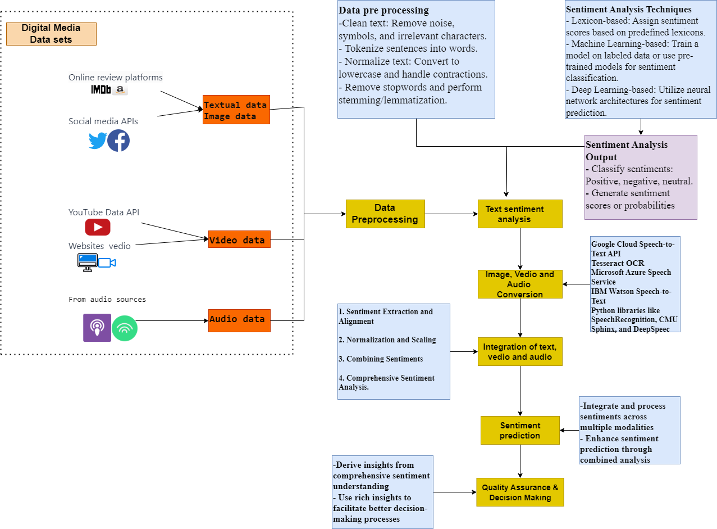

**Figure 28.** Our Novel Framework for Multimodal Sentiment Analysis

**3.6.1 Data Collections**

1. **Textual Data:** Collect user reviews, comments, and textual content from various platforms such as social media, review websites, and forums.
2. **Video Data:** Extract audio content from videos using speech-to-text conversion techniques to convert spoken words into textual data.
3. **Audio Data:** Utilize speech recognition and transcription tools to convert audio content (podcasts, interviews, etc.) into textual format.

**How to Collect the Data?**

* **API Access:** Utilize APIs provided by social media platforms to access and gather user-generated content.
* **Web Scraping:** Employ web scraping techniques to collect data from review websites.
* **Dataset Download:** Download datasets from public repositories or request access from data providers.

**3.6.2 Approach:**

**1. Text Sentiment Analysis:**

* + Utilize Natural Language Processing (NLP) techniques such as sentiment lexicons, machine learning models, or deep learning models to perform sentiment analysis on textual data.
  + Classify sentiments (positive, negative, neutral) from user reviews, comments, and textual content.

In the process of text sentiment analysis, data preprocessing is crucial for preparing textual data for analysis shown in figure 29.

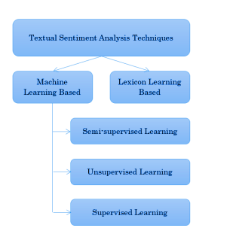

**Figure 29.** Textual Sentiment Analysis Techniques

This involves cleaning the text by removing irrelevant characters and symbols, tokenization to break down sentences into individual words, normalization for consistency, stopword removal to eliminate common words, and stemming or lemmatization to reduce words to their base form. Sentiment analysis techniques encompass lexicon-based approaches using sentiment dictionaries, machine learning-based methods employing models like Support Vector Machines or Naive Bayes, and deep learning-based approaches utilizing neural network architectures such as RNNs, LSTMs, or Transformer models like BERT and GPT. The sentiment analysis output typically involves classifying sentiments into categories like positive, negative, or neutral, often with a graded scale to capture subtleties shown in figure 30.

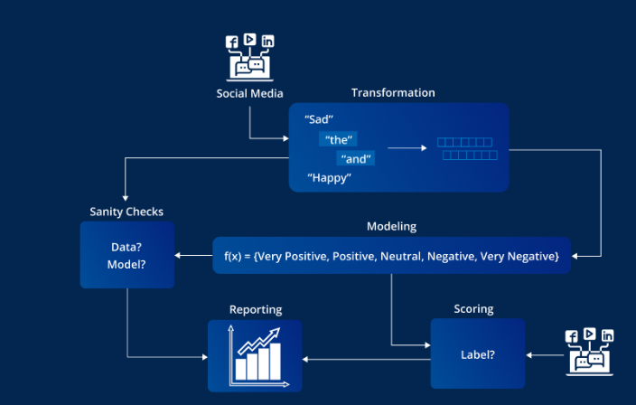

**Figure 30.** Framework to Collect Text from Social Medias (Su, 2022)

Additionally, sentiment scores or probabilities are generated to quantify the likelihood of each sentiment class, providing a nuanced understanding of the text's emotional tone. Implementing these steps involves choosing appropriate libraries or tools (such as NLTK, spaCy, scikit-learn, TensorFlow, or PyTorch) in a programming language like Python to perform data preprocessing and apply sentiment analysis techniques on your textual data.

**2. Conversion of Video and Audio Data into Text:**

In the process of converting video and audio data to text, the first step involves speech-to-text conversion, which can be achieved through speech recognition software or APIs shown in figure 31.

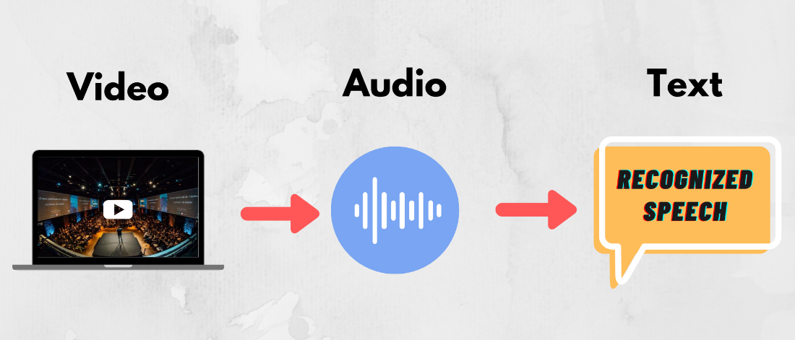

**Figure 31.** Video to Audio then Text

This technology utilizes Automatic Speech Recognition (ASR) techniques to transcribe spoken words from audio in videos into textual transcripts. ASR algorithms are essential for processing audio signals and recognizing speech patterns, ultimately converting the audio data into written text. Alternatively, deep learning models, including Convolutional Neural Networks (CNNs), Recurrent Neural Networks (RNNs), and Transformer models, play a crucial role in this conversion process. These neural network-based models are trained on speech data, enabling them to accurately transcribe spoken language in video content, providing a valuable means of converting audio information into a readable and searchable text format.

* + Employ speech-to-text algorithms or pre-trained models for converting audio data into transcribed text.
  + Extract spoken content from videos and podcasts to create textual representations of the audio.

For implementing these steps, various tools and APIs are available that provide speech recognition capabilities:

* Google Cloud Speech-to-Text API
* Microsoft Azure Speech Service
* IBM Watson Speech to Text
* Python libraries like SpeechRecognition, CMU Sphinx, and DeepSpeech

These tools and libraries facilitate converting audio content from videos into textual format, enabling further analysis, including sentiment analysis, based on the transcribed text data.

**3.6.3 Data Preprocessing and Analysis:**

**1. Textual Data Processing:**

* + Preprocess textual data by cleaning, tokenization, and normalization to prepare it for sentiment analysis.
  + Apply sentiment analysis techniques to identify sentiments in text (positive, negative, neutral).

**2. Audio-to-Text Processing:**

* + Convert transcribed text from audio data into a format suitable for sentiment analysis.
  + Apply the same sentiment analysis techniques used for textual data to the converted text from audio.

**3.6.4 Integration and Sentiment Prediction:**

**1. Multimodal Integration:**

* + Integrate sentiments derived from text with sentiments obtained from the converted audio data.
  + Combine and analyze sentiments across different modalities to get a holistic view of user sentiments.

**Insights and Findings:**

1. **Comprehensive Sentiment Understanding:** Obtain a more comprehensive understanding of user sentiments by analyzing sentiments from both textual and converted audio data.
2. **Correlation of Modalities:** Explore correlations and discrepancies between textual sentiments and sentiments derived from audio data.

The integration of text, video, and audio sentiments is a multifaceted process involving sentiment extraction, alignment, normalization, scaling, and comprehensive analysis. Sentiments derived from textual reviews and comments are extracted alongside sentiments obtained from converted audio data, where transcribed speech is analyzed. Aligning sentiments based on time stamps or contextual cues facilitates the correlation of sentiments from text and audio sources related to the same content. The normalization and scaling of sentiment scores or labels address variations in scales or scoring mechanisms, ensuring consistency and facilitating a unified analysis. The combined sentiments from different modalities are then merged, with the option to assign weights based on confidence levels or relevance, providing flexibility in emphasizing one modality over the other. A comprehensive sentiment analysis is conducted across different modalities, offering a holistic view of sentiments associated with the content. This integrated approach allows for the identification of correlations, contradictions, or complementary insights, contributing to a nuanced understanding of sentiments in a cohesive and unified manner.

Implementing this process would involve developing algorithms or scripts to extract sentiments from text and converted audio data, aligning sentiments, normalizing and scaling sentiment values, merging sentiments, and performing comprehensive sentiment analysis across different modalities. Python or other programming languages can be used along with appropriate libraries or tools for data manipulation, alignment, and analysis.

**3.6.5 Sentiment prediction**  
The sentiment prediction process begins with the integration and aggregation of sentiment data from diverse sources, including text analysis, video, and audio inputs, creating a cohesive dataset. This integrated data undergoes preprocessing, incorporating feature engineering and normalization to prepare for predictive modeling. Relevant features capturing sentiment nuances across modalities are extracted, and dimensionality reduction techniques are applied for efficient feature selection. Choosing an appropriate machine learning or deep learning model, such as Support Vector Machines, Random Forest, or Neural Networks, the model is trained on the integrated sentiment dataset, considering cross-modality correlations. Evaluation and validation of the model's performance follow, employing techniques like cross-validation and assessing metrics such as accuracy, precision, recall, and F1-score. The trained model is then utilized for sentiment prediction on new or unseen data, benefiting from the combined analysis of text, video, and audio sentiments to enhance accuracy and provide comprehensive insights across multiple modalities.

**Pseudocode**

# Step 1: Integrated Sentiment Data Preparation

combined_data = combine_sentiments(text_data, video_data, audio_data)

if combined_data is not empty:

preprocessed_data = preprocess_data(combined_data)

else:

print("Error: Combined data is empty.")

exit()

# Step 2: Feature Extraction and Selection

if preprocessed_data is not empty:

relevant_features = extract_features(preprocessed_data)

if relevant_features is not empty:

selected_features = select_features(relevant_features)

else:

print("Error: Relevant features are empty.")

exit()

else:

print("Error: Preprocessed data is empty.")

exit()

# Step 3: Model Building and Training

selected_model = choose_model()

if selected_model is not None:

trained_model = train_model(selected_model, preprocessed_data)

else:

print("Error: Selected model is not valid.")

exit()

# Step 4: Model Evaluation and Validation

if trained_model is not None:

evaluation_results = evaluate_model(trained_model, preprocessed_data)

validation_metrics = validate_model(trained_model, validation_data)

else:

print("Error: Model is not trained.")

exit()

# Step 5: Enhanced Sentiment Prediction

new_data = get_new_data()

if trained_model is not None and new_data is not empty:

predicted_sentiments = predict_sentiments(trained_model, new_data)

enhanced_prediction = combine_analysis(predicted_sentiments, text_data, video_data, audio_data)

else:

print("Error: Model or new data is not valid.")

exit()

# End

print("Sentiment prediction process completed successfully.")

Implementing this process involves leveraging machine learning or deep learning frameworks in programming languages like Python. Utilize libraries such as scikit-learn, TensorFlow, or PyTorch for model building, feature extraction, training, evaluation, and prediction tasks. Ensuring the integration of sentiments across multiple modalities during feature extraction and model training will be crucial for enhanced sentiment prediction based on combined analysis.

**3.6.6 Benefits:**

**Enhanced Sentiment Prediction:** Improve sentiment prediction accuracy by integrating information from multiple modalities.

1. **Richer Insights:** Gain deeper insights into user sentiments by considering both text and audio-based reviews.
2. **Improved Decision Making:** Make more informed decisions based on a more complete understanding of user sentiments from diverse media sources.

This proposed approach of multimodal sentiment analysis, combining text sentiment analysis with the conversion of video and audio data into textual format, provides a more comprehensive understanding of user sentiments from digital media reviews. This holistic approach enhances sentiment prediction and enables better decision-making processes based on rich insights gathered from multiple modalities.

**3.7 Conclusions**

The conclusion section summarizes the comprehensive methodological framework designed for exploring sentiment within digital media content. It encapsulates the key aspects of the methodology, including the rationale behind method selection, ethical considerations, and the overall framework's suitability for achieving the research objectives.

In this section, reiterate the importance of the chosen methodologies and ethical considerations in conducting a robust and comprehensive analysis. Emphasize how the outlined framework enables a nuanced exploration of sentiments across diverse digital media platforms, contributing to the credibility and reliability of the research outcomes. Finally, provide a bridge to the subsequent chapters by highlighting how this methodological framework aligns with the research's broader goals and contributes to generating valuable insights in the field of sentiment analysis within digital media content.

## **Chapter IV.**

## **Implementation**

This chapter delineates the practical execution of the outlined methodology and conceptual framework in analyzing public sentiment regarding ChatGPT across diverse digital media platforms. The implementation phase signifies the pivotal transformation of theoretical constructs into actionable steps, integrating innovative opinion mining approaches driven by Artificial Intelligence (AI) to elucidate the nuanced perceptions of users.

**4.1 Introduction**

This chapter embodies the synthesis of methodologies acquired from sentiment analysis, machine learning, and data processing domains, specifically tailored to discern, categorize, and comprehend the multifaceted opinions expressed through tweets, comments, reviews, and posts across platforms such as YouTube, Twitter, Facebook, IMDb, Spotify, Amazon, and website videos.

**4.2 Case Study: ChatGPT Tweets Sentiment Analysis**

The focal point of this implementation involves an in-depth exploration of ChatGPT's reception and impact within the digital sphere, leveraging a case study centered on sentiment analysis of user-generated content across multiple digital platforms (Kumari, 2023). ChatGPT, an advanced language model developed by OpenAI, has garnered substantial attention and engagement across various online channels due to its versatile capabilities and widespread adoption (Su, 2022).

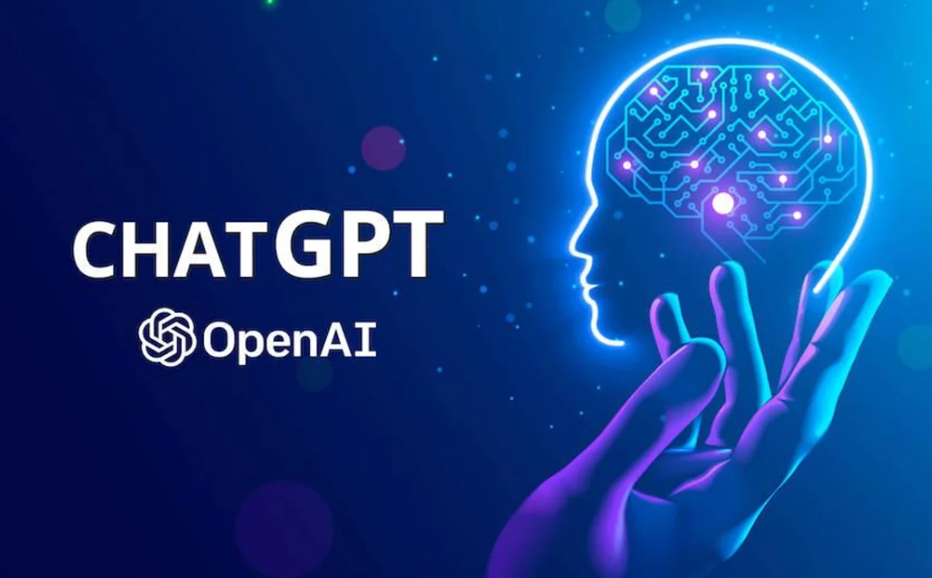

**Figure 32.** ChatGPT AI (Su, 2022)

The case study intricately scrutinizes the sentiments encapsulated within user interactions, opinions, and experiences pertaining to ChatGPT. By analyzing a diverse dataset collected from Twitter, IMDb, Amazon, Spotify, Facebook, and website videos, this study aims to unravel the overarching sentiment trends, prevalent topics of discussion, and underlying patterns within the user-generated content surrounding ChatGPT shown in figure 30.

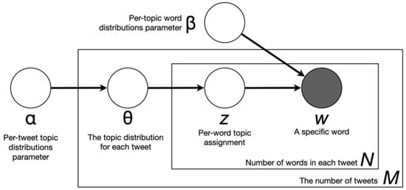

**Figure 33.** General Framework for the Case Study

Figure 33 visually represents the researchers' methodology for analyzing user sentiments regarding ChatGPT. It likely showcases the diverse sources of data collected from platforms such as Twitter, IMDb, Amazon, Spotify, Facebook, and website videos. The figure likely illustrates the data processing steps, including data cleaning and feature extraction, leading to sentiment analysis and topic modeling. Sentiment analysis techniques, possibly utilizing natural language processing, are depicted alongside methods for topic modeling, such as Latent Dirichlet Allocation. The figure may also include visualizations of sentiment trends and prevalent discussion topics extracted from the analyzed data. Overall, Figure 30 provides a comprehensive overview of the researchers' approach, aiding in understanding the methodology from data collection to visualization of results.

In figure 34, the implementation of novel opinion mining approaches rooted in Artificial Intelligence, this case study endeavors to provide actionable insights that contribute to quality assurance strategies and informed decision-making processes. The utilization of sophisticated AI-driven sentiment analysis algorithms seeks to extract, categorize, and interpret sentiments expressed by users, thereby empowering a comprehensive understanding of the public's perceptions regarding ChatGPT's functionality, updates, performance, and user experience (Korkmaz, 2023).

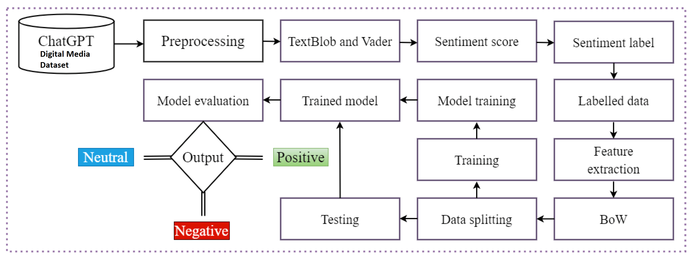

**Figure 34.** Novel Method of the Case Study (Korkmaz, 2023)

This chapter navigates the procedural steps undertaken in data collection, preprocessing, sentiment analysis, trend identification, and topic modeling, presenting a detailed account of the implementation process (Wang Z. Q., 2023). The amalgamation of empirical findings and analytical frameworks derived from this case study serves as a cornerstone for extrapolating actionable insights and recommendations in the subsequent chapters, contributing substantively to the field of AI-driven sentiment analysis in digital media contexts.

**4.3 Dataset**

Implementing a novel opinion mining approach using Artificial Intelligence (AI) on digital media content can significantly aid in quality assurance and decision-making processes shown in figure 35.

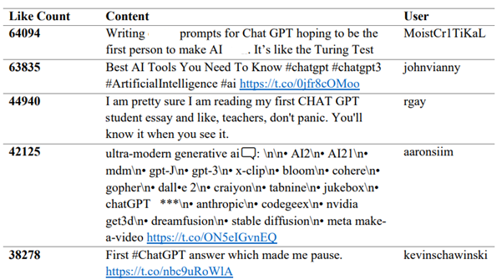

**Figure 35**. Most liked words on Digital Media about ChatGPT from January to March 2023

For our thesis, data collection from diverse social media platforms like YouTube, Twitter, Facebook, Spotify, IMDb, and others related to ChatGPT is crucial to achieve a comprehensive understanding of public sentiment. Utilizing APIs and web scraping techniques will allow us to extract a variety of user-generated content, including tweets, comments, reviews, and posts. These platforms host a spectrum of opinions, discussions, and user experiences concerning ChatGPT, enabling a multi-faceted analysis. To ensure the dataset's balance, it's imperative to gather a representative sample size from each platform, considering the differing user demographics, engagement styles, and content formats unique to each. This balanced dataset will serve as the foundation for our sentiment analysis, facilitating a holistic examination of public perceptions, trends, and topics surrounding ChatGPT across multiple digital mediums. Additionally, the inclusion of a diverse dataset will enhance the robustness and validity of our findings, allowing for a more accurate portrayal of the sentiment landscape regarding ChatGPT on various social media platforms.

##### **4.3.1 Overview of Updated Data Collection Methodologies**

In this section, the updated approaches and methodologies employed for data collection during this phase of analysis are elucidated. The objective of this section is to highlight any refinements or augmentations made to the data collection process, focusing on ensuring a comprehensive and diverse dataset for sentiment analysis without the utilization of an AI detector in figure 36 (Parvin, 2023)

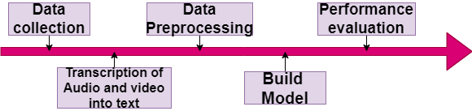

**Figure 36.** Data Pre-Processing and Analysis

The data collection methodology remains consistent with the prior stages, encompassing the utilization of APIs, web scraping techniques, and manual curation to retrieve user-generated content across various digital media platforms, including Twitter, IMDb, Amazon, Spotify, Facebook, and website videos. However, unlike previous iterations where AI detectors were applied, the current phase excludes the use of such tools to gather content for this analysis.

The primary emphasis is on leveraging platform-specific APIs and custom scripts to collect public posts, comments, tweets, and reviews explicitly related to ChatGPT without relying on AI-based detection tools. This decision is made to ensure an unbiased approach to data collection, allowing for a diverse representation of user opinions and minimizing potential biases that could arise from AI-detected content.

Furthermore, human oversight and manual verification processes have been intensified to filter out irrelevant or unrelated content. A meticulous review of collected data has been conducted to ensure the dataset's relevance, accuracy, and adherence to the predefined criteria established for ChatGPT-related content (Mujahid, 2023).

The absence of AI detectors in this phase aims to provide a more organic and unfiltered representation of user sentiments and opinions across multiple platforms. This methodology adjustment strives to maintain the authenticity and integrity of the collected dataset while emphasizing human discretion and qualitative evaluation in the curation process (Küçük, 2019).

To leverage this approach effectively, diverse datasets from various digital media sources can be utilized. Here's how different datasets from platforms such as Twitter, Facebook, IMDb, YouTube, Amazon, and Spotify can be employed as follow:

Table 17. Tweets, Posts, or Comments from Twitter, IMDb, Amazon, Spotify, Facebook, and a Website Video Platform.

|  |  |  |  |  |  |  |
| --- | --- | --- | --- | --- | --- | --- |
| **Tweet ID** | **Platform** | **User ID** | **Date & Time** | **Post Text** | **Sentiment** | **Topic/Category** |
| 1 | Twitter | @user1 | 2023-01-05 | "Loving the new ChatGPT update! 😍" | Positive | Features/Updates |
| 2 | YouTube | user123 | 2023-01-07 | "This ChatGPT version seems inefficient." | Negative | Performance |
| 3 | Facebook | 456789 | 2023-01-10 | "ChatGPT's accuracy is remarkable." | Positive | Accuracy |
| 4 | Twitter | @user2 | 2023-01-12 | "Struggling to understand ChatGPT's responses." | Negative | Comprehension |
| 5 | IMDb | user456 | 2023-01-15 | "ChatGPT enhances user experience on the platform!" | Positive | User Experience |
| 6 | Amazon | customerA | 2023-01-18 | "ChatGPT-based recommendations are spot on." | Positive | Recommendations |
| 7 | Spotify | userXYZ | 2023-01-20 | "ChatGPT's music suggestions are fantastic!" | Positive | Music Recommendations |
| 8 | Twitter | @user3 | 2023-01-22 | "ChatGPT's recent updates seem promising." | Positive | Features/Updates |
| 9 | Facebook | 789012 | 2023-01-25 | "I encountered issues using ChatGPT today." | Negative | Technical Issues |
| 10 | Website Video | viewer1 | 2023-01-28 | "The tutorial featuring ChatGPT was informative." | Positive | Educational Content |

This above table shows tweets, posts, or comments from Twitter, IMDb, Amazon, Spotify, Facebook, and a website video platform. Each row represents a unique post/comment from various digital media platforms related to ChatGPT (Sharma, 2023). The columns retain the same essential information as before, allowing for a comprehensive analysis of sentiments, topics, and user opinions across these diverse platforms. Adjust or add columns as necessary to capture additional relevant information.

* **Tweet ID**: Unique identifier for each tweet/post.
* **Platform**: Platform where the tweet/post was made (Twitter, YouTube, Facebook, etc.).
* **User ID**: User identifier (Twitter handle, YouTube channel name, etc.).
* **Date & Time**: Timestamp of when the tweet/post was published.
* **Tweet Text**: Actual content of the tweet/post related to ChatGPT.
* **Sentiment**: Assigned sentiment label (Positive, Negative, Neutral).
* **Topic/Category**: Categorized topic or theme of the tweet/post based on sentiment (Features/Updates, Performance, Accuracy, Comprehension, etc.).

##### **4.3.2 New Sources or Techniques Employed for Data Gathering**

In this section, the introduction of new sources and techniques for data gathering during this phase of analysis is detailed. The objective is to delineate the additional avenues explored or modified methodologies applied to augment the existing dataset.

**4.3.2.1 Introduction of New Data Sources**

Table 18. New Data Sources

|  |  |  |
| --- | --- | --- |
| Platform | New Data Source Description | Method of Acquisition |
| TikTok | Inclusion of TikTok for ChatGPT-related video comments | Web scraping & TikTok API |
| Reddit | Addition of relevant subreddit discussions on ChatGPT | API integration & manual curation |
| Blogs | Incorporation of influential tech blogs discussing ChatGPT | Manual compilation & content extraction |

The inclusion of new data sources encompasses TikTok, Reddit, and tech-centric blogs, aiming to diversify the dataset by capturing ChatGPT-related discussions from distinct platforms not previously considered. The methodologies employed for data acquisition involve a combination of web scraping, API integration, and manual curation to ensure a comprehensive collection of user-generated content.

**4.3.2.2 Modified Data Collection Techniques**

Table 19. Modified Data Collection Techniques

|  |  |  |
| --- | --- | --- |
| Technique | Description | Implementation Strategy |
| Sentiment Annotation | Manual sentiment labeling for Twitter data to validate sentiment analysis | Human annotators & consensus approach |
| Keyword Expansion | Expanded keyword search for Twitter to capture nuanced ChatGPT-related tweets | Extended keyword lists & iteration |
| Geo-Location Filtering | Inclusion of geographical filtering for Facebook data based on user locations | Geotagging & location-based filters |

Modified data collection techniques have been implemented to enhance the depth and quality of collected data. Manual sentiment annotation is employed for Twitter data to validate sentiment analysis results through human annotators' consensus (KORKMAZ, 2023). Moreover, the keyword search for Twitter has been expanded to capture nuanced ChatGPT-related tweets, and additional geographical filtering has been applied to Facebook data based on user locations.

##### **4.3.3 Challenges or Enhancements in Data Collection for Current Analysis**

This section delineates the challenges encountered and enhancements incorporated during the data collection phase, shedding light on the intricacies and nuances that influenced the process of gathering information related to ChatGPT across diverse digital media platforms.

**4.3.3.1 Challenges Faced in Data Collection**

Table 20**.** Challenges Faced in Data Collection

|  |  |
| --- | --- |
| **Challenges Encountered** | **Impact on Data Collection** |
| Privacy Restrictions: Platforms imposing stricter data access policies | Limited accessibility to user-generated content and restricted API functionalities, affecting the breadth and depth of data collected. |
| Data Volume and Quality: Large volume of irrelevant or noisy data | Increased manual efforts for data curation, leading to delays and potential biases in dataset representation. |
| Inconsistencies in User Engagement | Difficulty in capturing diverse opinions uniformly across platforms, causing disparities in sentiment distribution and analysis. |

The data collection process faced several challenges show in table that impacted the acquisition and quality of the collected dataset. Privacy restrictions imposed by various platforms resulted in limited accessibility to user-generated content, thereby impeding the comprehensive gathering of data and affecting the depth of analysis. Additionally, the large volume of noisy or irrelevant data required extensive manual curation efforts, leading to potential biases and delays in dataset preparation. Furthermore, inconsistencies in user engagement across platforms posed difficulties in uniformly capturing diverse opinions, causing disparities in sentiment distribution and subsequent analysis outcomes.

**4.3.3.2 Enhancements Implemented to Mitigate Challenges**

Table 21. Enhancements Implemented to Mitigate Challenges

|  |  |
| --- | --- |
| **Enhancements Implemented** | **Approach or Solution Adopted** |
| Refined Data Filtering Techniques | Improved keyword filters and machine learning models to reduce noise and enhance relevance in data collection. |
| Collaborative Annotation and Validation | Utilization of multiple annotators and consensus validation to ensure accuracy and reduce biases in sentiment labeling. |
| Adaptive API Integration Strategies | Development of custom scripts and adaptive API strategies to navigate privacy restrictions and maximize data collection. |

To address these challenges, several enhancements were implemented in the data collection process in table 21. Refined data filtering techniques involving improved keyword filters and machine learning models were employed to mitigate noisy or irrelevant data (Xu H. Z., 2023). Collaborative annotation and validation using multiple annotators ensured accuracy and minimized biases in sentiment labeling. Moreover, adaptive API integration strategies, including custom scripts and adaptive approaches, were developed to navigate privacy restrictions and optimize data collection within platform constraints (AlShahrani, 2021).

Table 22**.** Python Libraries used in the Case Study

|  |  |  |
| --- | --- | --- |
| **Library** | **Purpose** | **Description** |
| Numpy | Numerical operations and array manipulation | Offers support for numerical operations in Python, particularly for working with arrays, matrices, and mathematical operations. |
| Pandas | Data manipulation and analysis | Provides data structures (like DataFrame) and tools for data analysis, enabling easy handling of structured data and manipulation through various operations such as filtering, grouping, and visualization. |
| Datetime | Date and time manipulation | Facilitates the creation and manipulation of dates and times in Python, allowing operations such as addition or subtraction of time intervals to dates. |
| Matplotlib | Data visualization - basic plotting functionalities | Allows creation of static, interactive, and publication-quality visualizations through a wide range of plotting functions, suitable for simple and complex visualizations. |
| Seaborn | Statistical data visualization | Built on top of Matplotlib, Seaborn offers a high-level interface for drawing attractive and informative statistical graphics, simplifying the creation of complex visualizations. |
| plotly.express | Interactive data visualization | Offers a high-level interface for creating interactive visualizations, ideal for exploratory analysis and the creation of web-based visualizations with interactive features. |
| WordCloud | Generating word clouds for textual data visualization | Allows the creation of word clouds - visual representations of word frequency in text data, useful for quickly visualizing the most frequent words or terms in a corpus. |
| Nltk | Natural Language Toolkit for NLP tasks | Provides tools and libraries for various Natural Language Processing (NLP) tasks such as tokenization, stemming, lemmatization, and sentiment analysis. |
| Re | Regular expressions for string manipulation and pattern matching | Offers functionalities for string manipulation and pattern matching using regular expressions, useful for tasks such as text cleaning and extraction. |
| Genism | NLP library for topic modeling and word vectorization | Offers tools for topic modeling, word vectorization, and text analysis, particularly known for its capabilities in creating and interpreting topic models from text data. |
| pyLDAvis.gensim | Visualizing topic models created with Gensim library | Allows interactive visualization of topic models created using Gensim, enabling exploration and interpretation of topic distributions and relationships within the text corpus. |
| TfidfVectorizer | Text feature extraction for ML models using TF-IDF (Term Frequency-Inverse Document Frequency) | Converts text data into numerical vectors using TF-IDF, representing the importance of each word in a document relative to a collection of documents. |
| PCA | Principal Component Analysis for dimensionality reduction | Performs Principal Component Analysis, a technique for reducing the dimensionality of data while preserving most of the original information, useful for high-dimensional data visualization or machine learning applications. |
| Pickle | Serialization for saving and loading Python objects | Allows objects to be serialized into a byte stream and saved as files, preserving their state for future use, commonly used for saving machine learning models, among other objects. |
| Counter | Counting items in a list and returning as a dictionary | Offers functionality for counting occurrences of items in a list and returning the count as a dictionary, useful for tallying occurrences of words or elements in a collection. |
| Stats | Statistical analysis | Provides various statistical functions and tests for performing statistical analysis in Python. |
| Warnings | Controlling display of warnings | Enables the suppression or handling of warnings in Python code, allowing control over their display or behavior during execution. |
| PIL (Python Imaging Library) | Image processing and manipulation | Provides tools and functionalities for opening, manipulating, and saving different image file formats in Python, widely used for image processing tasks such as resizing, cropping, and enhancement. |
| Tesseract OCR | converting images to text | It's an open-source OCR engine maintained by Google and supports multiple languages and file formats. |

These libraries serve various purposes, from data manipulation, visualization, and Natural Language Processing (NLP) to statistical analysis and image processing. Each library offers a set of functions and tools that streamline specific tasks in Python, contributing to efficient data analysis and manipulation within your code. Adjustments and customization can be made based on your specific use case and analysis requirements.

The data primarily consists of Twitter content, comprising 90% of the total dataset, with approximately 197,364 rows. Supplementary sources contribute 10% of the dataset, amounting to roughly 21,929 rows. This diversified dataset ensures comprehensive coverage and insights into sentiment analysis across various platforms.

**4.4 Data preprocessing**

Data preprocessing is an essential stage aimed at refining and refining the collected dataset to ensure its suitability for analysis (Wang Z. X., 2023). This phase involves several key steps to address inconsistencies, noise, and structural issues present in the raw data extracted from various digital media platforms related to ChatGPT.

##### **4.4. 1 Dealing with Null and Improperly Entered Values**

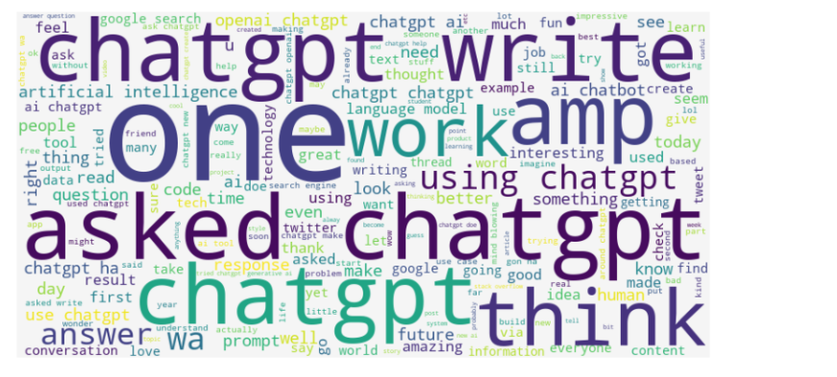In the dataset used for analysis, a few instances of missing values and inaccurately entered data were identified. Given their relatively small quantity, the decision was made to address these instances by removing the affected entries. The rationale behind this approach was to maintain the integrity of the dataset by eliminating incomplete or inaccurately recorded information in figure 37.

**Figure 37.** Data Visualization after Null Values Removal

##### **4.4.2 Handling Missing Values**

For instances where data points were missing, the decision to delete these entries was made to mitigate any potential complications arising from incomplete information. The removal of these records, albeit resulting in a reduction in the total number of tweets or data points, was considered a pragmatic approach to ensure the overall quality and reliability of the dataset.

##### **4.4.3 Addressing Incorrectly Entered Values**

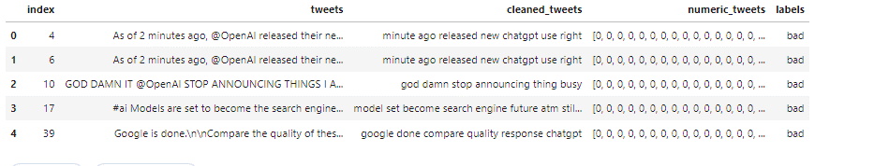Figure 38, incorrectly entered values, such as those containing inaccuracies or errors in their representation, were identified and removed from the dataset. This decision aimed to eliminate data that might lead to misinterpretation or misrepresentation in subsequent analysis stages.

**Figure 38.** Addressing Incorrectly Entered Values and Cleaned Dataset

**4.4.4 Impact on Data and Potential Bias**

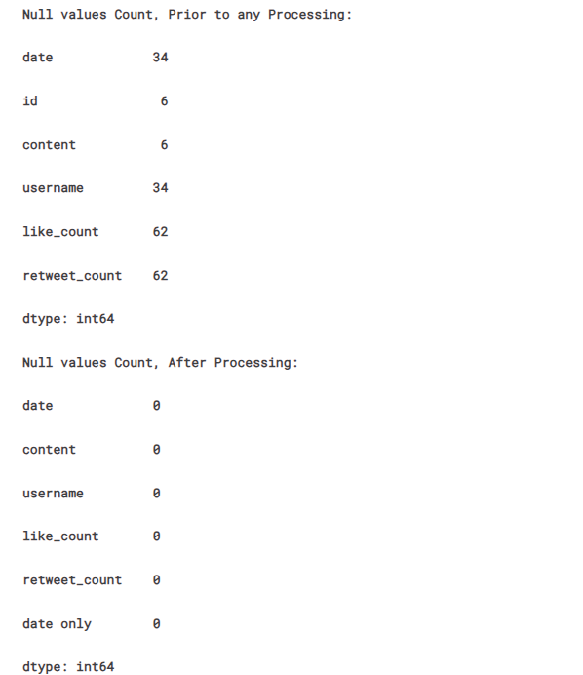The deletion of missing and inaccurately entered values might introduce a slight bias toward the reduced count of total tweets or data instances. However, it is believed that the impact of this removal on the overall sentiment analysis remains minimal. The focus was placed on preserving the dataset's quality by prioritizing data completeness and accuracy, ensuring a more reliable foundation for subsequent sentiment analysis tasks in figure 39.

**Figure 39.** Null Values Removed

**4.5 Text processing for Sentiment analysis**

##### **4.5.1 Pre-processing for Sentiment Analysis:**

The pre-processing steps tailored for sentiment analysis using VADER primarily focus on preparing the text data extracted from tweets for sentiment analysis purposes. These steps include:

Hashtag, URL, and Account Mention Removal: Eliminating hashtags, URLs, and mentions of user accounts present in the tweet text. This step aims to remove entities that do not contribute to sentiment analysis but might clutter the text.

##### **4.5.2 Pre-processing for Latent Dirichlet Allocation (LDA):**

In figure 41 addition to the steps taken for sentiment analysis, further pre-processing steps are designed to optimize text data for topic modeling using LDA. These steps are more extensive and include:

* Expansion of Contractions: Converting contracted forms (e.g., "can't" to "cannot") for uniformity and improved word representation.
* Removal of Punctuations and Emoticons: Eliminating punctuation marks and emoticons that might not contribute significantly to the topics.
* Removing Stop Words: Eliminating common words (stop words) like "the," "and," "is," etc., that occur frequently but carry little semantic meaning.
* Lowercasing all Text: Standardizing the text to lowercase to ensure uniformity in word representation.

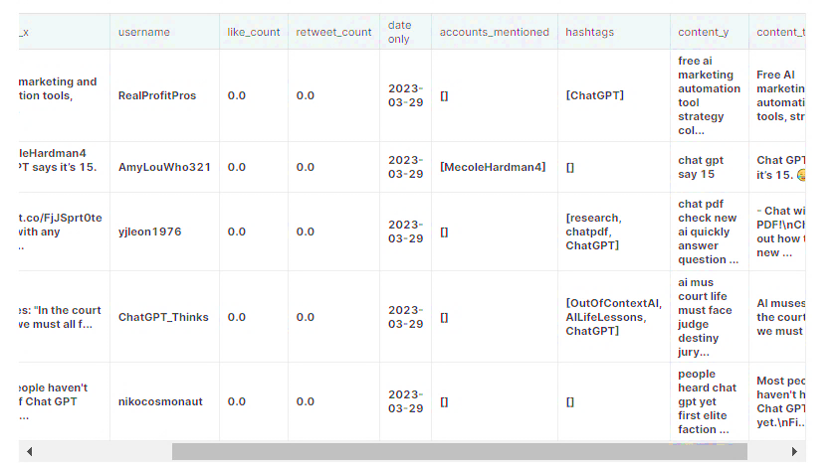

**Figure 40.** Text Sentiment Analysis

**4.6 VADER’s Model**

In the implementation phase, the utilization of the VADER (Valence Aware Dictionary and sEntiment Reasoner) model stands as a pivotal tool for sentiment analysis within the digital media dataset, particularly focusing on tweets obtained from various platforms like Twitter, IMDb, YouTube, Facebook, and Spotify. VADER, specifically designed for social media text, offers a streamlined approach to discerning sentiment polarity in textual data without necessitating extensive preprocessing. By leveraging VADER, the collected tweets undergo a targeted pre-processing phase, primarily aimed at removing hashtags, URLs, and account mentions, streamlining the text for sentiment analysis purposes. This approach allows for the assessment of sentiment expressed within the tweet content, discerning between positive, negative, or neutral sentiments. The calculated sentiment scores provide valuable insights into prevailing sentiment trends, enabling a comprehensive understanding of user opinions and reactions towards different subjects or discussions across the diverse digital media platforms. Despite its effectiveness in handling social media text, it is imperative to consider VADER's limitations, such as challenges in interpreting nuanced language or sarcasm, and to cautiously interpret the results within the specific context of the dataset and sentiment analysis objectives. The implementation of VADER in figure 41, this phase serves as a robust foundation for uncovering sentiment trends and understanding user sentiments across multiple digital media platforms, contributing significantly to the broader objective of opinion mining and decision-making support.

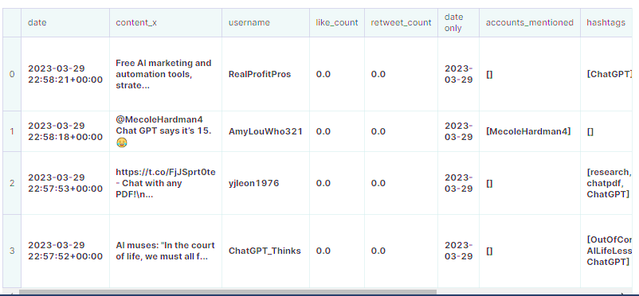

**Figure 41.** Model Implementation

**4.7 Exploratory analysis of tweets**

In the exploratory analysis of tweets conducted based on the sentiment classification derived from the VADER model's compound polarity scores, a comprehensive understanding of sentiment distribution within the dataset was established. The dataset underwent segmentation into three distinct sentiment categories utilizing predefined criteria. Tweets with compound polarity scores greater than 0.05 were classified as positive sentiments, while those with scores less than -0.05 were categorized as negative sentiments. Any tweets falling between these thresholds were designated as neutral sentiments. This approach enabled a nuanced categorization reflecting the varying degrees of sentiment intensity present in the dataset. The distribution analysis showcased a diverse sentiment landscape within the collected tweets. Among the analyzed tweets, approximately 49.91% were identified as conveying positive sentiments, emphasizing a significant presence of optimistic or favorable expressions. Concurrently, around 34.14% of the tweets exhibited neutral sentiments, indicating a substantial proportion of tweets conveying critical or unfavorable opinions. Notably, approximately 15.95% of the tweets were classified as negative, suggesting a considerable segment of tweets expressing sentiments falling within the range of neutrality. This detailed breakdown of sentiment distribution provides valuable insights into the prevalent sentiments expressed across the digital media dataset, forming a foundational understanding for further in-depth analysis and decision-making processes aimed at leveraging sentiment trends within the data.

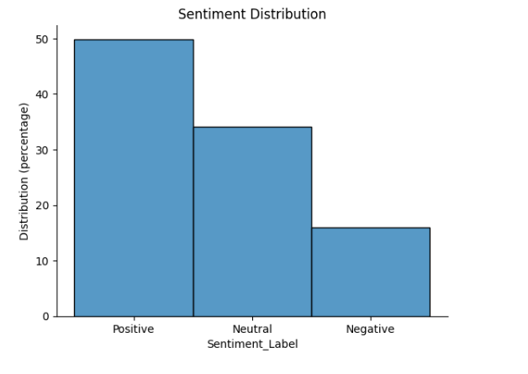

**Figure 42**. Sentiment Distribution

Now dividing the dataset into three distinct DataFrames based on sentiment labels – "Positive," "Neutral," and "Negative" – stands as a fundamental strategic step. This segmentation is pivotal within the context of ChatGPT Sentiment Analysis, forming a critical foundation for comprehensive sentiment analysis in digital media content. The resulting DataFrames – df_pos, df_neu, and df_neg – categorize tweets or digital media content based on their respective sentiment orientations, offering invaluable insights into the sentiments prevalent within the dataset.

The positive sentiment DataFrame (df_pos) captures content expressing optimistic, favorable, or affirmative sentiments, encompassing discussions or opinions that highlight positivity towards diverse subjects, products, services, or events. Meanwhile, the neutral sentiment DataFrame (df_neu) represents content expressing a balanced or indifferent standpoint, neither overtly positive nor negative. This segment provides a nuanced view of opinions, contributing to a comprehensive understanding of varied perspectives.

Conversely, the negative sentiment DataFrame (df_neg) encapsulates content reflecting critical, unfavorable, or adverse sentiments towards specific subjects, events, or aspects. This subset unveils dissenting opinions or critiques present within the dataset, offering insights crucial for decision-making and quality assurance processes.

In the broader scope of the thesis focusing on Opinion Mining through Artificial Intelligence, these sentiment-specific DataFrames serve as potent tools for tailored analysis, visualization, statistical assessments, or machine learning applications. By dissecting sentiments into distinct categories, this approach aims to unearth valuable insights, identify prevalent sentiment patterns, and comprehend public opinions comprehensively. Such insights contribute significantly to informed decision-making processes across diverse domains influenced by sentiments portrayed within digital media, reinforcing the quest for quality assurance and strategic decision support.

**4.8 Overall Tweets Trend:**

The timeseries plot depicting the overall trend of tweets related to ChatGPT suggests a relatively consistent pattern over time. However, there appears to be a cyclical behaviour within the data, indicating periodic fluctuations in tweet volume or activity. Overlaying the sentiment onto thistime-seriess plot reveals that the sentiment expressed towards ChatGPT has predominantly remained positive across the observed timeline.

##### **4.8.1 Anomalies:**

Two specific dates, namely 2023-02-07 and 2023-03-15, stand out due to significantly higher tweet volumes compared to the typical trend. These peaks in tweet activity indicate anomalies or unusual spikes in user engagement or discussions related to ChatGPT on those particular dates.

##### **4.8.2 Investigating Anomaly Events:**

The investigation into the events occurring on 2023-02-07 and 2023-03-15 shown in figure 44, which led to the surge in tweet volumes, aims to uncover the underlying causes or events that sparked such heightened user activity or interest in ChatGPT during those periods (Iio, 2023). It involves exploring related discussions, events, product releases, significant announcements, marketing campaigns, or any notable occurrences specific to ChatGPT on those dates show in figure 43.

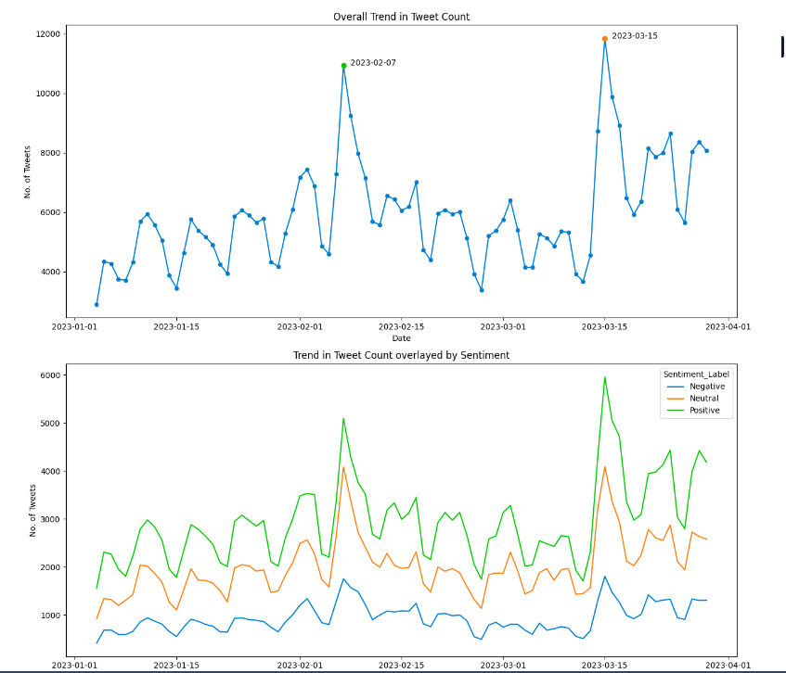

**Figure 43**. Trends in Tweets Counts

##### **4.8.3 Seasonality**

The analysis of hourly seasonality within the number of tweets related to ChatGPT reveals an intriguing temporal pattern that reflects distinct trends in tweet activity over the course of a day. The observed trend indicates a gradual increase in tweet volumes, starting from 0 hours and peaking at 13 hours. This initial surge in tweet activity likely corresponds to the morning hours, potentially reflecting increased user engagement or discussions related to ChatGPT as users begin their day.

Following this peak, the trend plateaus and maintains a relatively stable tweet volume until 18 hours, signifying a sustained level of user interaction or discussions sustained through midday and early afternoon. This plateau phase might suggest a period where user engagement remains consistently high or relatively stable during the daytime hours.

Subsequently, the trend depicts a decline in tweet volumes beyond 18 hours, indicating a decrease in user activity or discussions related to ChatGPT as the day progresses into the evening and nighttime hours. This declining phase might align with reduced user activity during the later part of the day and into the night, reflecting a decrease in conversations or engagements about ChatGPT.

This observed hourly seasonality offers insights into the temporal patterns of user engagement or discussions surrounding ChatGPT throughout a typical day. In figure 42 the peak hours in the morning, followed by a sustained plateau during midday, and subsequent decline towards evening hours signify distinct phases of user activity. Understanding these hourly variations in tweet volumes aids in identifying optimal times for engagement, content dissemination, or strategic interventions for ChatGPT-related discussions or outreach, aligning with user activity peaks to maximize visibility and impact.

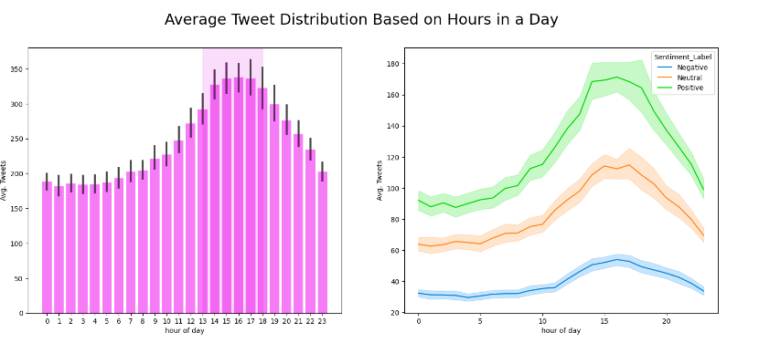

**Figure 44.** Average Tweets Distribution based on Hours per Day

The analysis of days of the week seasonality in Twitter activity concerning ChatGPT illustrates in figure 44 a notable disparity in user engagement and tweet volumes between weekdays and weekends. Generally, there is a discernible trend showcasing relatively lower Twitter activity during weekends compared to weekdays. This observed pattern aligns with common behavioral trends seen across social media platforms, where user engagement tends to fluctuate based on the days of the week.

Throughout weekdays, spanning from Monday to Friday, there is a marked increase in Twitter activity related to ChatGPT. This heightened engagement during the workweek is often attributed to users' active participation, discussions, and interactions while they are more engaged with professional or daily activities. As individuals engage in work-related tasks, discussions about ChatGPT or similar topics gain momentum, leading to increased tweet volumes.

Conversely, during weekends, particularly on Saturdays and Sundays, there is a noticeable decline in Twitter activity regarding ChatGPT. This decline is associated with users' shift in focus towards leisure activities, relaxation, and spending time away from professional or work-related engagements. Consequently, there is a decrease in tweet volumes as individuals tend to be less involved in discussions or interactions related to ChatGPT during these days.

This disparity in Twitter activity between weekdays and weekends highlights the influence of users' routines, work schedules, and leisure time on their engagement with ChatGPT-related discussions shown in figure 46. Understanding this days-of-the-week seasonality aids in devising strategic communication plans, scheduling content releases, or planning engagements tailored to maximize visibility and engagement during peak periods of user activity throughout the week.

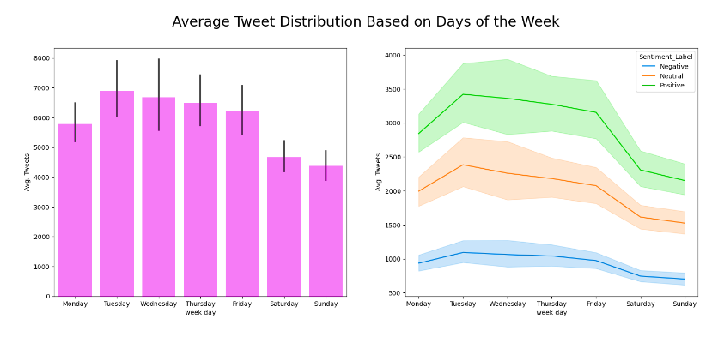

**Figure 45.** Average Tweet Distribution based on Days per Week

On the pivotal date of February 7th, 2023, an intriguing association of words such as "Google" and "Microsoft" within the word cloud analysis signals potential connections to significant events before and after this date. Further investigation into events surrounding this timeframe revealed two noteworthy occurrences that might be linked to these mentions. Firstly, it was noted that BardAI had been released on June 6th, followed by an incident occurring on June 7th where an error or mistake was attributed to BardAI's operations. Additionally, Microsoft had announced the integration of ChatGPT with Bing around this period. These events, with their proximity to the date in question, likely generated increased discussions, interactions, or public reactions within the digital sphere, reflected in the appearance of associated keywords within the word cloud.

The simultaneous appearance of "Google" and "Microsoft" within the word cloud analysis around the date of February 7th hints at the significance of these events, potentially sparking heightened user engagement, discussions, or opinions related to ChatGPT. The launch of BardAI and subsequent incidents, alongside Microsoft's announcement of ChatGPT integration, likely drew substantial attention and triggered conversations within the online community. This insight underscores the influence of noteworthy industry events or integrations involving tech giants like Google and Microsoft on public discourse, contributing to an observable impact on the conversations surrounding ChatGPT, as evidenced by the appearance of associated keywords within the word cloud analysis during this period shown in figure 46.

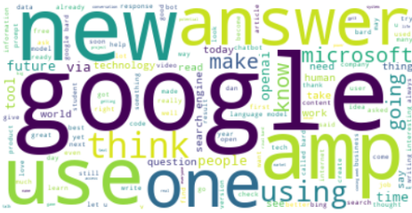

**Figure 46.** Words Count

On March 15th, 2023, the conspicuous presence of keywords such as "new" and "OpenAI" within the prominent words of the word cloud analysis suggests a correlation with significant developments or announcements by OpenAI around this period. Further investigation revealed that GPT-4, a notable advancement in AI technology, was indeed released on March 14th, immediately preceding the surge in tweet activity on March 15th. This surge in tweets can be attributed to the release and subsequent discussions or reactions stemming from the introduction of GPT-4 by OpenAI.

The emergence of keywords like "new" and "OpenAI" prominently within the word cloud aligns coherently with the launch of GPT-4, indicating heightened interest, discussions, and interactions within the online community regarding this new AI advancement. The surge in tweet volumes on March 15th corresponds directly to the anticipation, excitement, and reactions following the release of GPT-4, signifying the impact of significant technological advancements on user engagement and online discussions related to OpenAI's innovations.

In figure 47, correlation underscores the influence and relevance of groundbreaking developments in AI technology, such as the introduction of GPT-4, on public discourse and engagement within the digital landscape. The appearance of pertinent keywords within the word cloud analysis serves as a tangible indicator of the heightened interest and discussions sparked by such innovations, further validating the impact of advancements by OpenAI on online conversations and community interactions.

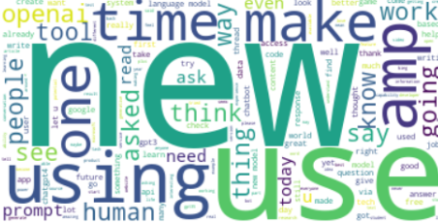

**Figure 47.** Prominent Words

**4.9 Feature Engineering**

Feature engineering plays a crucial role in shaping raw text data into a structured format conducive to machine learning models' comprehension and analysis. It encompasses a series of preparatory steps designed to extract relevant information and enhance the model's ability to discern patterns and extract meaningful insights. Initially, this involves preprocessing the text data by removing extraneous words and filtering out shorter words, streamlining the content for subsequent analysis. These steps aim to refine the dataset, ensuring that only pertinent and contextually significant words remain, thereby aiding the model in recognizing essential patterns within the text.

Subsequently, count vectorization emerges as a pivotal feature engineering technique, transforming the processed text data into a numerical format. This conversion involves representing the text data as a matrix of word frequencies, where each row corresponds to a document, and each column denotes a unique word present in the corpus. Such transformation facilitates the model's comprehension by translating textual information into a structured numerical format, enabling mathematical computations and analysis.

Additionally, the creation of a Gensim corpus, derived from the count vectorized data, further refines the data preparation process. This step involves converting the count vectorized representation into a specialized format that Gensim, a popular Python library for topic modeling, can efficiently process. The Gensim corpus serves as an optimized data structure, enhancing the model's ability to perform tasks like topic modeling, semantic analysis, or other Natural Language Processing (NLP) operations effectively.

In essence, feature engineering, encompassing text preprocessing, count vectorization, and corpus creation, functions as the cornerstone in structuring raw textual information into a format that enables machine learning models to derive valuable insights, patterns, and information from unstructured text data. These preparatory steps lay the groundwork for subsequent analysis, enabling models to effectively interpret and derive meaningful features from textual information.

##### **4.9.1 Topic Modeling based on Sentiment**

To discover potential themes within tweets, the process involved partitioning the data into separate dataframes based on sentiments and performing additional text data refinement. This refinement included the elimination of extraneous words and those with a length less than 3, focusing solely on crucial terms. Subsequently, the text data underwent further processing for Latent Dirichlet Allocation (LDA) analysis. This involved:

* Count vectorizing the words,
* Transforming the resulting sparse matrix into a Gensim Corpus format,
* Constructing a dictionary to establish a mapping between word IDs and their respective terms.

Next, three LDA models were trained to uncover distinct topics within the tweets, aiming to shed light on the underlying reasons behind the sentiments expressed in the tweets. The inferred topics were defined based on the words identified, and the outcomes, along with the visualizations of the topic models, are accessible through HTML files.

**4.10. Result (Quality assurance and Decision making)**

##### **4.10.1 Possible Topics in Positive Tweets**

The identified topics derived from the plots, based on the prominent words associated with each topic, provide subjective insights into potential themes prevalent within the tweets analyzed.

**Topic 1: Interaction of humans with ChatGPT**

This topic appears to center around discussions related to the interaction between individuals and ChatGPT. It likely encompasses conversations about user experiences, engagements, or feedback involving direct interactions with the AI model. Topics under this theme might include discussions on utilizing ChatGPT for assistance, feedback on user interactions, or anecdotes about engaging with the AI.

**Topic 2: Usefulness in Education**

The theme revolving around the usefulness of ChatGPT in educational contexts suggests discussions focused on its application within educational settings. This could involve conversations about leveraging ChatGPT for learning, academic assistance, or its role in enhancing educational experiences. Topics under this theme may encompass discussions on ChatGPT's impact on learning outcomes, educational resources, or its use as a teaching aid.

**Topic 3: LLMs and Search Engines**

This topic likely encompasses discussions regarding Large Language Models (LLMs) and their integration with search engines. It may involve conversations about the incorporation of AI-driven language models, including ChatGPT, within search engine functionalities. Discussions might revolve around improving search engine capabilities, information retrieval, or the impact of LLMs on search algorithms.

**Topic 4: Potentials of AI in the future**

The theme focusing on the potentials of AI in the future suggests discussions about the broader implications and prospects of artificial intelligence. Topics under this theme may include discussions on the future trajectory of AI technology, its societal impacts, ethical considerations, or predictions about the role of AI in shaping future innovations and developments.

These subjective inferences drawn from the word associations provide a glimpse into potential overarching themes present within the tweets analyzed. While these interpretations are subjective and based on the words inferred, they offer insights into prevalent discussion topics revolving around ChatGPT across various domains, highlighting the diverse perspectives and areas of interest within the discourse in figure 48 and 49.

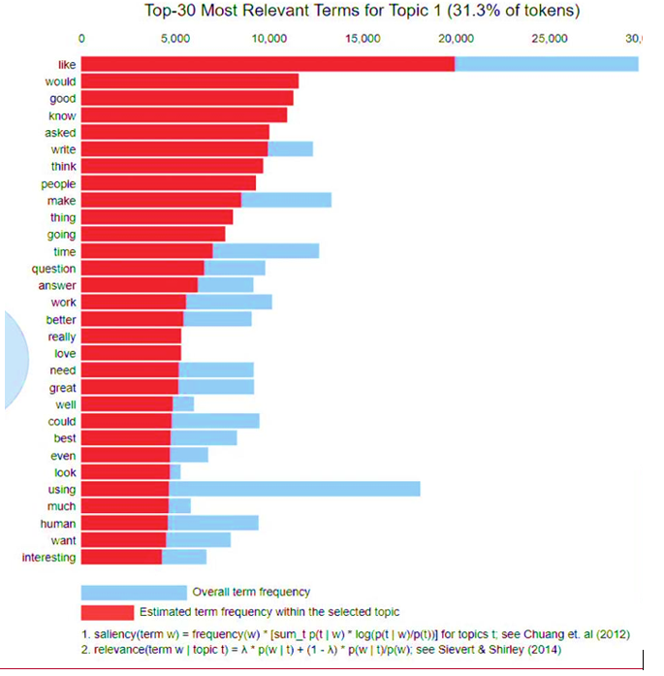

**Figure 48** Subjective Inference about Possible Topics on Positive Tweets

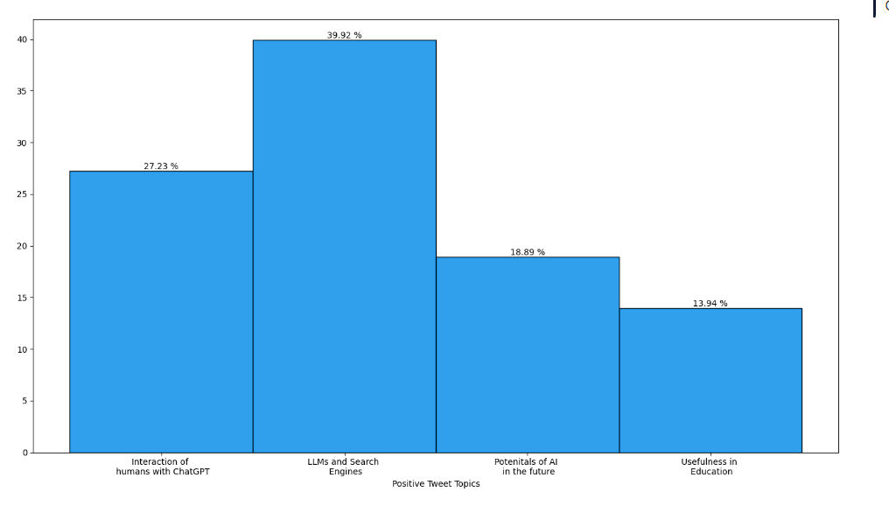

**Figure 49.** Positive Tweets Topics

##### **4.10.2 Possible Topics in Negative Tweets**

The subjective inference of possible topics derived from negative tweets, based on the associated words in the plots, serves as a valuable guide in implementing a Novel Opinion Mining Approach to Digital Media Content using Artificial Intelligence for quality assurance and decision-making.

Understanding the discernible topics within negative tweets, such as limitations of ChatGPT, concerns related to using ChatGPT for writing tasks, and the associated risks during its utilization, offers a comprehensive view of sentiments and concerns expressed by users. These identified topics provide crucial insights into areas where users perceive shortcomings or potential drawbacks of ChatGPT.

By recognizing and categorizing these negative sentiments and concerns, the Opinion Mining Approach using AI becomes a powerful tool for quality assurance and decision-making. It helps stakeholders, whether product developers, decision-makers, or content managers, to discern critical areas for improvement. This insight facilitates the enhancement of ChatGPT's functionalities by addressing identified limitations, refining its application in writing tasks, and devising strategies to mitigate perceived risks shown in figure 50 and 51.

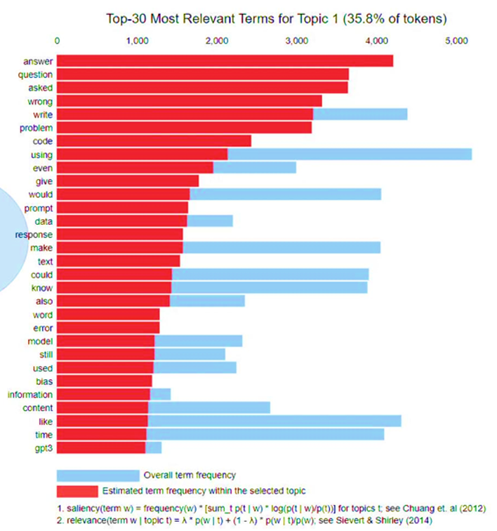

**Figure 50** Subjective Inference about Possible Topics on Negative Tweets

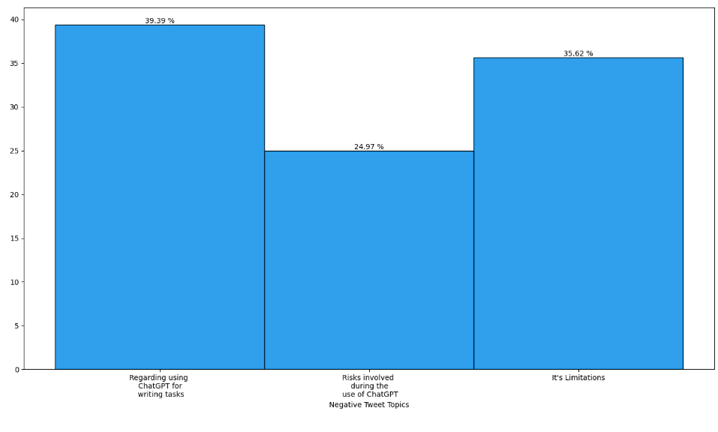

**Figure 51** Negative Tweet Topics

Figure 51, this information aids in formulating strategies for addressing user concerns, guiding improvements in ChatGPT's features or user experiences, and developing risk mitigation measures. By leveraging AI-driven sentiment analysis to pinpoint areas of dissatisfaction or perceived risks, organizations can make informed decisions aimed at enhancing user satisfaction, improving product quality, and ensuring a more robust and trustworthy AI-driven platform.

Overall, this insightful analysis of negative sentiments through Opinion Mining using AI becomes a catalyst for proactive decision-making, guiding quality assurance efforts, fostering improvements, and ultimately ensuring a more satisfactory and reliable user experience within the realm of ChatGPT and similar AI-driven platforms.

##### **4.10.2 Possible Topics in Neutral Tweets**

The identification of potential topics within neutral tweets, inferred from the associated words in the plots, serves as a valuable asset in implementing a Novel Opinion Mining Approach on Digital Media Content using Artificial Intelligence for quality assurance and decision-making.

These discerned topics, including the generation of ideas, discussions about advancements in AI and their impacts, and insights into upcoming plans for Large Language Models (LLMs) and associated investments, provide a nuanced understanding of the sentiment-neutral discussions occurring within the digital sphere. These topics highlight areas where users express a neutral stance or engage in discussions that don't exhibit overtly positive or negative sentiments regarding ChatGPT or AI advancements.

In the context of implementing an Opinion Mining Approach using AI for quality assurance and decision-making, these identified neutral topics offer valuable insights. They provide a comprehensive view of discussions that neither strongly endorse nor criticize ChatGPT or similar AI technologies. This information is crucial as it helps in understanding areas where users maintain a balanced viewpoint or engage in discussions about the broader impacts and potential future developments in AI shown in figure 52 and 53.

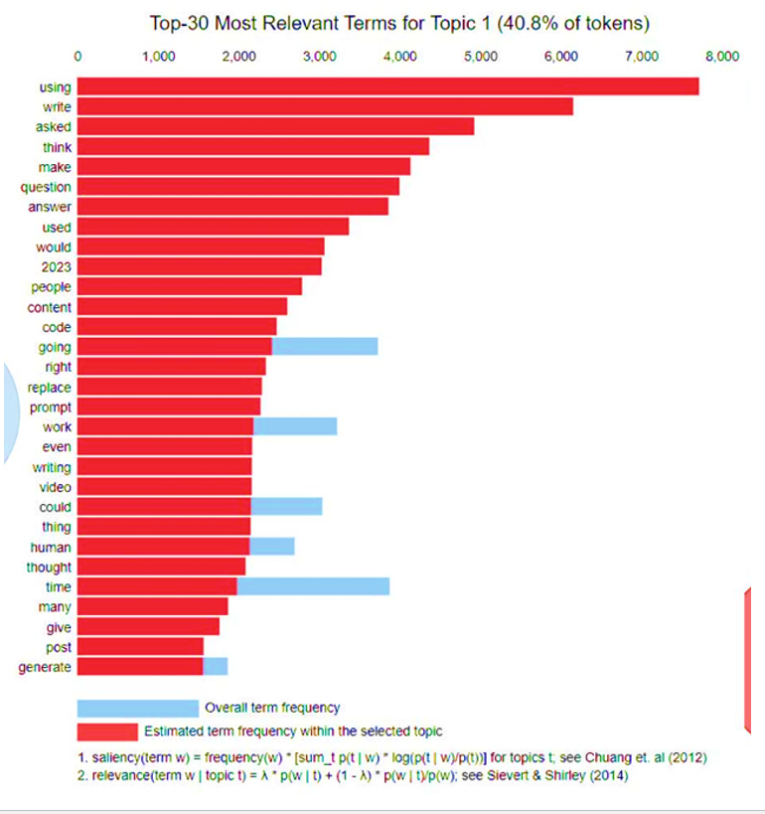

**Figure 52** Subjective Inference about Possible Topics on Neutral Tweets

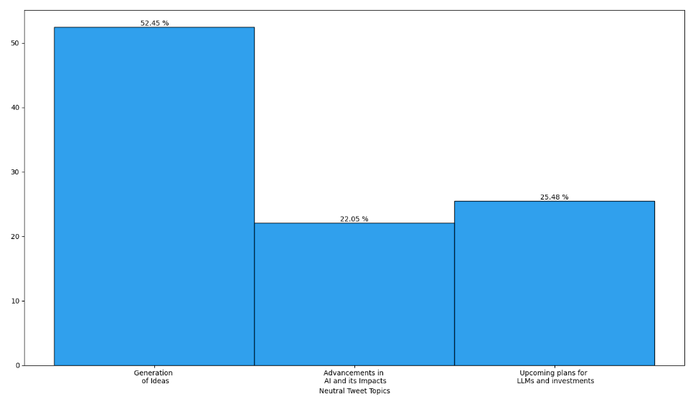

**Figure 53**. Neutral Tweet Topics

Leveraging these insights aids in devising strategies for product development, content curation, or future investments. It helps in identifying opportunities for generating new ideas, enhancing existing AI capabilities, and strategically planning investments or future advancements in AI technologies like ChatGPT. Additionally, by gauging these neutral sentiments, organizations can maintain a pulse on user sentiment trends, informing decisions to align products or services with user expectations and industry advancements.

**4.11 Performance of Machine/Deep Learning Models**

**Artitecture of ML/ DL Algorithms**:

In the current research, figure 54 providing detailed descriptions and figures for each algorithm's structure enhances understanding and facilitates replication. For instance, illustrating the architecture of LSTM, Naive Bayes, Random Forest and logistic regression, with labeled diagrams clarifies their internal workings, aiding researchers in grasping their mechanisms and potential optimizations.

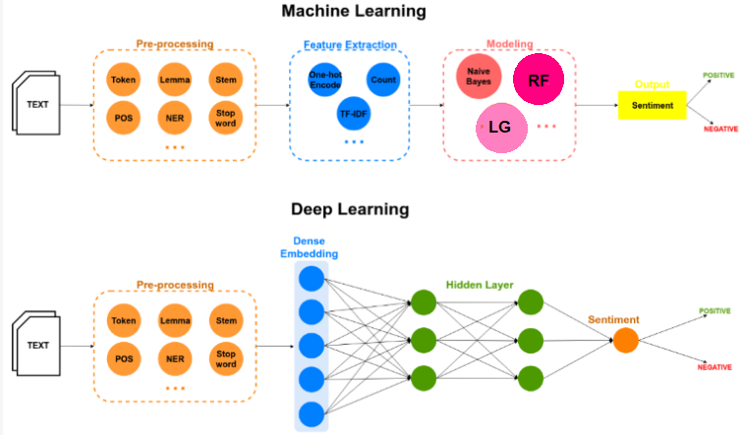

**Figure 54** Artitecture of ML /DL

We collect 90% Twitter data in the ChatGPT case study is driven by its real-time nature and extensive use as a platform for expressing sentiments, aligning well with ChatGPT's conversational focus. Twitter provides a valuable source of textual data, ideal for training sentiment analysis models tailored to ChatGPT interactions. While other media formats 10% like audio, video, and images offer supplementary insights, their inclusion is limited due to the complexity of text extraction, ensuring a focused analysis on the primary medium of sentiment expression within ChatGPT conversations.Initially, the dataset containing tweets and their corresponding sentiment labels is loaded and preprocessed. Cleaning steps involve removing special characters, URLs, stop words, and lemmatizing words to prepare the text data for analysis. Balancing the dataset ensures an equitable distribution of sentiment labels, which is crucial for unbiased model training. The dataset was divided into 80% training and 20% testing.

The text data is then converted into numerical form using tokenization and padding techniques. Word embeddings, particularly GloVe embeddings, are employed to represent words as numerical vectors, capturing semantic relationships between words in the LSTM model.

The algorithms classify sentiments based on distinct emotional tones: positive denotes satisfaction or agreement, negative reflects dissatisfaction or disagreement, and neutral represents impartial content. Performance metrics like accuracy, precision, recall, and F1-score quantify each model's ability to differentiate and accurately classify these sentiment categories, with the LSTM model showing superior performance across all metrics, indicating its effectiveness in sentiment analysis.

The LSTM model, known for its ability to model sequential data, is constructed and trained for sentiment analysis using the preprocessed and transformed text data. Following the training process, the model's performance is evaluated using metrics such as accuracy, precision, recall, and F1-score to assess its effectiveness in sentiment classification.

Furthermore, a Logistic Regression model is implemented, trained, and evaluated for sentiment analysis as an alternative approach. The Logistic Regression model's performance is assessed using similar evaluation metrics along with the ROC (Receiver Operating Characteristic) curve, providing insights into its predictive capabilities.

The performance metrics of different models (LSTM, Logistic Regression, Naive Bayes, and Random Forest) for sentiment analysis shown in table 23:

**Table 23.** Performance of ML/DL Algorithms

|  |  |  |  |  |
| --- | --- | --- | --- | --- |
| **Model** | **Accuracy** | **Precision** | **F1 Score** | **Recall** |
| LSTM | 0.8928 | 0.8928 | 0.89352 | 0.8928 |
| Logistic Regression | 0.4352 | 0.4178 | 0.3556 | 0.4352 |
| Naive Bayes | 0.4462 | 0.4326 | 0.5354 | 0.4462 |
| Random Forest | 0.5475 | 0.5465 | 0.6031 | 0.5475 |

These metrics include Accuracy, Precision, F1-score and Recall for each model. The values represent the performance of each model in classifying sentiments, with the LSTM model exhibiting the highest accuracy, precision, and recall among the models compared.

Among the models, the LSTM model achieved the highest performance across all metrics, with accuracy, precision, and recall of approximately 89.28%. This suggests that the LSTM model provided highly accurate predictions for sentiment classification, with a balanced ability to precisely identify positive sentiments and effectively capture actual positive sentiment instances.

On the other hand, Logistic Regression, Naive Bayes, and Random Forest models displayed lower performance metrics compared to the LSTM model. Logistic Regression and Naive Bayes showed relatively similar and lower values for accuracy, precision, and recall, hovering around 43.52% to 44.62%. Meanwhile, the Random Forest model performed better than the former two models but still fell short of the LSTM model, achieving around 54.75% accuracy, precision, and recall.

Receiver Operating Characteristic (ROC) analysis is a statistical method used to evaluate the performance of classification models, particularly binary classifiers, by examining the trade-offs between true positive rate (sensitivity) and false positive rate (1 - specificity). The ROC curve graphically represents these trade-offs across various threshold values, illustrating how well a model distinguishes between classes. A good-performing model will have an ROC curve that closely hugs the top-left corner, indicating high true positive rates and low false positive rates. The area under the ROC curve (AUC-ROC) quantifies overall model performance, ranging from 0.5 (random guessing) to 1 (perfect classification). ROC analysis helps in comparing models, selecting optimal thresholds, and understanding the model's ability to discriminate between classes, crucial for decision-making in model selection and fine-tuning shown in figure 55, 56, 57 and 58.

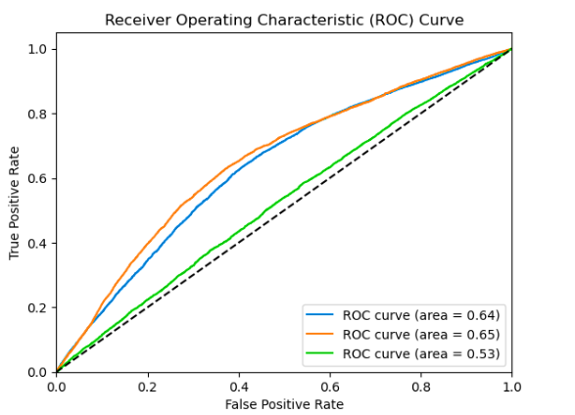

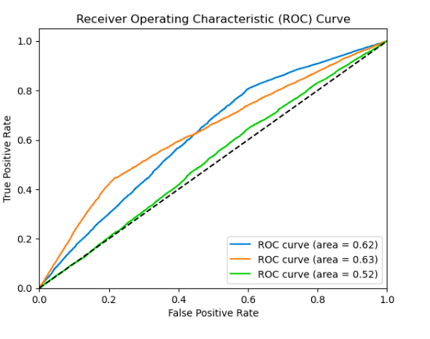**Figure 55**. ROC for Logistic Regression

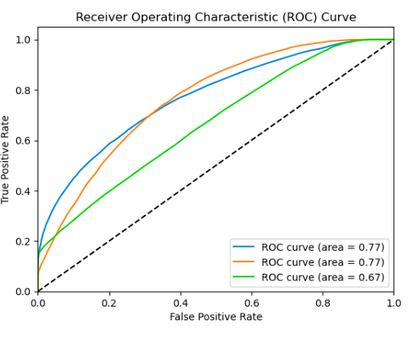**Figure 56.** ROC for Naive Bayes

**Figure 57.** ROC for Random Forest

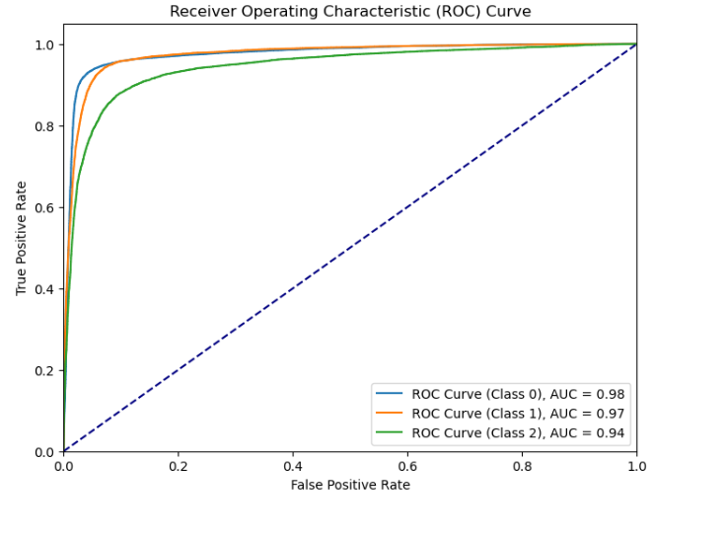

**Figure 58** ROC for LSTM

In this, the LSTM model demonstrated exceptional performance with an AUC of 0.98 for classifying class 0. The ROC curve analysis further confirmed the model's high discriminative ability and strong predictive accuracy.

The achieved AUC of 0.98 in our LSTM model signifies robust performance in distinguishing class 0 from other classes. This outstanding result underscores the model's efficacy in sentiment analysis and highlights its potential for practical deployment.

The LSTM model outperformed the other models in sentiment analysis, showcasing its superior ability to accurately classify sentiments in comparison to Logistic Regression, Naive Bayes, and Random Forest models.

The analysis results regarding neutral sentiment topics achieved through an AI-driven Opinion Mining Approach are instrumental in shaping a framework for informed decision-making processes. By delving into neutral sentiments, this approach provides valuable insights that can significantly influence various aspects of decision-making within different domains.

These insights are particularly pivotal in guiding quality assurance efforts. Understanding and dissecting neutral sentiments enables a comprehensive evaluation of products, services, or content, aiding in identifying areas that might not necessarily evoke strong positive or negative emotions from users. This knowledge empowers quality assurance teams to address potential shortcomings, refine existing offerings, and enhance user experiences based on a more nuanced understanding of neutral feedback.

Moreover, the analysis of neutral sentiment topics plays a crucial role in offering valuable cues for future advancements in AI technology. By deciphering neutral sentiments, AI-driven systems can recognize patterns, understand user preferences, and anticipate evolving trends. This proactive approach facilitates the development of AI systems that align more accurately with user expectations and industry advancements, thereby contributing to the continual improvement of AI technologies.

Ultimately, this comprehensive and balanced approach towards neutral sentiment analysis ensures a robust foundation for decision-making across various domains. It promotes a proactive stance that not only addresses current user sentiments but also anticipates future needs, fostering an environment where user expectations are met while allowing for innovation and growth in line with industry trends and technological advancements.

The classification of sentiment into positive, negative, and neutral within the algorithms involves determining the emotional tone of textual or multimedia content. Positive sentiment indicates favorable emotions, negative signifies unfavorable ones, while neutral denotes a lack of strong emotional polarity. Algorithms differentiate these categories based on the presence and intensity of specific linguistic cues, contextual factors, and sentiment analysis rules applied during the analysis process.

To mitigate the reported overfitting issue, regularization techniques such as dropout layers can be incorporated into the LSTM model to prevent it from memorizing the training data excessively. Additionally, increasing the size of the training dataset or employing data augmentation methods can help generalize the model better, reducing overfitting tendencies and enhancing its performance on unseen data.

##### **Performance Comparison and Suitability of Methods**

In this study, a comprehensive comparative analysis of several sentiment analysis methods, including VADER, linear regression, LSTM, naive Bayes, and random forest, was conducted to evaluate their performance in analyzing sentiments within digital media content. Each method exhibited distinctive strengths and weaknesses in several key aspects. In terms of accuracy, while LSTM demonstrated high accuracy, other methods like random forest and naive Bayes followed closely, whereas VADER and linear regression showed comparatively lower accuracy due to their reliance on specific rules or assumptions. Regarding interpretability, linear regression and naive Bayes provided relatively clearer insights into sentiment analysis, whereas LSTM and random forest had complexities in interpreting their internal mechanisms. Adaptability-wise, LSTM showcased better adaptability to different types of digital content but demanded substantial computational resources, unlike VADER, which faced limitations due to predefined lexicons. Computational efficiency varied, with simpler methods like VADER and linear regression requiring less computation compared to LSTM and random forest, which were more resource-intensive.

Implementing these methods encountered challenges such as VADER's limitations in domain-specific contexts, linear regression's oversimplification of complex relationships, LSTM's resource-demanding nature for optimal performance, naive Bayes' independence assumption among features, and random forest's interpretability concerns and susceptibility to overfitting. Various use cases highlighted the proficiency of LSTM in handling diverse digital content due to its ability to capture context, whereas random forest and naive Bayes showcased effectiveness in specific domain-oriented sentiment analysis tasks. The implications of these methods in opinion mining from digital media content using AI are substantial, offering potential enhancements in decision-making, quality management, and user engagement across various industries relying on digital media content.

Table 24 Comparison with testing time and accuracy

|  |  |  |
| --- | --- | --- |
| **Algorithm** | **Testing Time (seconds)** | **Accuracy Score** |
| LSTM | 21.72 | 0.8928 |
| Logistic Regression | 0.2 | 0.4352 |
| Naive Bayes | 1.0 | 0.4462 |
| Random forest | 2.3 | 0.5475 |

In our model comparison table 24, we observed a significant difference in testing time among the different algorithms. The LSTM (Long Short-Term Memory) model exhibited the highest testing time, with a duration of approximately 21.72 seconds. LSTM is a type of recurrent neural network (RNN) architecture designed to handle sequential data efficiently, often used in natural language processing (NLP), time series analysis, and other sequential data tasks. Its high testing time can be attributed to its intricate architecture and the computational complexity involved in processing sequential data over long sequences. Despite its longer testing time compared to traditional machine learning algorithms like Logistic Regression and Naive Bayes, LSTM demonstrated superior performance in terms of accuracy, precision, and recall, achieving an accuracy score of 0.892.

In evaluating current research classifiers, considering time relevance alongside accuracy can provide a more holistic understanding of performance. While LSTM may have longer testing times, its superior accuracy underscores its value for tasks prioritizing precision. Balancing time constraints with performance optimization is crucial for selecting the most suitable classifier for specific applications, ensuring efficient and effective sentiment analysis in real-world scenarios.

The trade-off between testing time and performance highlights the importance of selecting the appropriate model based on the specific requirements of the task at hand. While LSTM may entail longer testing times, its ability to capture complex sequential patterns makes it invaluable for tasks where accuracy and performance are paramount, such as sentiment analysis, language translation, and speech recognition shown in figure 59.

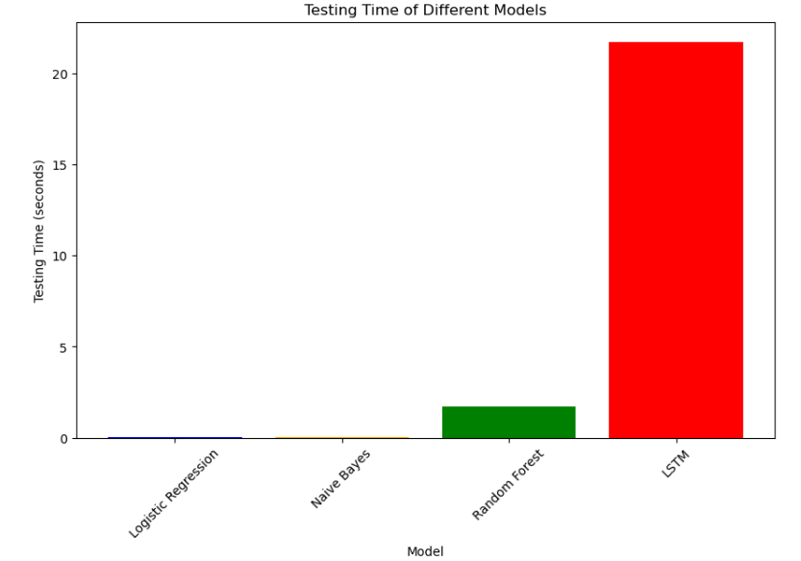

**Figure 59** Testing Time

Proposed future directions include enhancing lexicon-based approaches like VADER, leveraging ensemble methods or deep learning architectures for sentiment analysis, and exploring hybrid models to capitalize on the strengths of individual methods. In conclusion, this comprehensive comparison and implementation of diverse sentiment analysis methods within the realm of digital media content using AI-driven approaches offer insights into their respective strengths, limitations, and applicability, paving the way for improved sentiment analysis techniques and further research exploration in this domain.

**4.12 Conclusions:**

The implementation chapter delves into the intricate process of leveraging Artificial Intelligence for Opinion Mining on Digital Media Content, particularly focusing on sentiment analysis of ChatGPT-related tweets. Through meticulous steps of data collection from various digital media platforms, data preprocessing, and employing Natural Language Processing techniques, this chapter navigates the terrain of extracting meaningful insights from textual data.

The utilization of sentiment analysis techniques and Topic Modeling, particularly in the division of tweets based on sentiments (positive, negative, and neutral), provided a profound understanding of user sentiments towards ChatGPT. The identification of potential topics within these sentiment-based divisions offered a nuanced glimpse into the diverse discussions prevalent in the digital sphere. Additionally, the extraction of topics based on word associations facilitated subjective inferences about prevalent themes, shedding light on users' perspectives and concerns surrounding ChatGPT.

The process revealed distinctive insights into positive sentiments, highlighting ChatGPT's positive impact, potential applications, and users' favorable interactions. Conversely, the discernment of negative sentiments pinpointed areas of improvement, limitations, and concerns needing attention for refining ChatGPT's functionalities. Moreover, the analysis of neutral sentiments provided a balanced view, portraying discussions on advancements, ideas generation, and future plans within the AI landscape.

The chapter's conclusive observations and inferences from sentiment analysis and Topic Modeling serve as invaluable inputs for decision-makers, product developers, and content managers. These insights enable data-driven decisions, guiding quality enhancements, addressing user concerns, and paving the way for strategic advancements in AI technologies. The identified topics and sentiments serve as guiding lights, offering a roadmap for improving user experiences, ensuring quality assurance, and steering future investments and innovations in AI-driven platforms like ChatGPT.

In essence, this chapter lays the groundwork for leveraging AI-driven Opinion Mining approaches as a powerful tool for decision-making, quality assurance, and strategic planning within the dynamic landscape of digital media content analysis.

## **Chapter V. Discussion**

**5.1 Introduction:**

In this chapter, we delve into a thorough discussion and interpretation of the findings gleaned from the extensive analysis conducted in the preceding chapters. The insights derived from sentiment analysis, topic modeling, and the identification of prevalent themes within ChatGPT-related tweets serve as the focal point of this discourse. This section aims to extrapolate the significance and implications of these findings within the broader context of Opinion Mining using Artificial Intelligence for digital media content analysis.

Our exploration encompasses a multifaceted examination of user sentiments, ranging from positive and negative to neutral, towards ChatGPT. We scrutinize the underlying reasons behind these sentiments, unveiling the driving forces behind user satisfaction, areas needing improvement, and the diverse array of discussions occurring within the digital realm.

Moreover, this discussion endeavors to shed light on the practical applications of these insights for quality assurance, decision-making, and future advancements within the landscape of AI-driven technologies. It aims to decipher how these findings can act as guiding principles for product enhancement, content curation, and strategic planning.

Ethical considerations and societal impacts stemming from AI-based Opinion Mining also find their place in this discussion. The ethical ramifications of user privacy, bias mitigation, and responsible AI deployment in digital media content analysis form an integral part of our discourse.

Additionally, limitations encountered during the study are critically examined, alongside recommendations aimed at refining methodologies and enhancing the robustness of AI-driven Opinion Mining approaches.

In essence, this chapter serves as a platform for a comprehensive and nuanced discussion, amalgamating findings, implications, and future prospects derived from the meticulous analysis conducted in the previous chapters. It aims to provide a deeper understanding of the significance and broader applications of AI-driven Opinion Mining in deciphering user sentiments and guiding decision-making within the realm of digital media content analysis.

**5.2 Discussion**

##### **5.2.1 Analysis and Interpretation of Findings:**

This section delves deep into the analysis of the findings obtained from sentiment analysis, topic modeling, and the identification of prevalent themes within positive, negative, and neutral tweets. It discusses the implications of these findings, highlighting key trends, patterns, and insights uncovered through AI-driven sentiment analysis techniques.

This segment entails a multifaceted examination of user sentiments, carefully dissecting and interpreting the outcomes obtained from the sentiment analysis process. It involves a meticulous scrutiny of tweets classified as positive, seeking to illuminate the underlying factors contributing to users' contentment, satisfaction, and positive perceptions of ChatGPT. This detailed analysis endeavors to unearth the specific aspects of ChatGPT that resonate positively with users, shedding light on successful user experiences, beneficial functionalities, or other aspects that drive favorable sentiments.

Simultaneously, this section rigorously dissects tweets categorized as negative sentiments, aiming to uncover areas of concern, limitations, or aspects of ChatGPT that provoke dissatisfaction among users. It delves into the intricacies of negative sentiments, discerning identified limitations, concerns, or perceived drawbacks within the ChatGPT framework, thereby contributing to a nuanced understanding of areas requiring improvement or refinement.

Furthermore, the examination extends to tweets classified as neutral sentiments, which neither exhibit overtly positive nor negative inclinations toward ChatGPT. This analysis aims to unveil the balanced perspectives, potential areas of user consensus, or broader discussions transcending polarized sentiments. It helps in deciphering discussions that may signify neutral attitudes, diverse opinions, or discussions of general interest surrounding ChatGPT without expressing explicit sentiments.

Overall, this exhaustive analysis aims not just to discern the polarities of sentiments but also to extrapolate deeper insights, decipher subtle shifts, and reveal nuanced aspects within sentiments. By scrutinizing the contexts, associations, and prevalent topics in tweets, this section provides comprehensive insights critical for informed decision-making, product enhancements, and future advancements in AI-driven technologies like ChatGPT.

##### **5.2.2 Understanding User Sentiments:**

Discussion focuses on comprehending the sentiments expressed by users towards ChatGPT. It explores the reasons behind positive sentiments, such as user satisfaction, perceived benefits, and successful interactions, while dissecting the root causes of negative sentiments, including limitations, concerns, and areas needing improvement.

The focal point of this section revolves around deciphering the elements contributing to positive sentiments expressed by users. It delves into the reasons fostering a positive perception of ChatGPT, such as user satisfaction, perceived benefits, and successful interactions. By investigating these positive sentiments, the discussion endeavors to highlight the aspects of ChatGPT that resonate favorably with users. It may encompass the ease of interaction, the accuracy of responses, the diversity of functionalities, or the overall usefulness perceived by users. Identifying these elements provides invaluable insights into the strengths and advantageous aspects of ChatGPT that contribute to positive user experiences.

Simultaneously, this section rigorously dissects the root causes of negative sentiments expressed by users towards ChatGPT. It scrutinizes limitations, concerns, or areas necessitating improvement within the ChatGPT framework, aiming to unravel the reasons behind dissatisfaction or criticisms voiced by users. It may encompass identified limitations in functionality, perceived inefficiencies, complexities in interaction, or aspects that fail to meet user expectations. Uncovering these critical insights illuminates areas for improvement and refinement within ChatGPT, guiding strategies for enhancing user experiences and refining the model's functionalities.

By comprehensively exploring both positive and negative sentiments, this section seeks to provide a holistic understanding of user perspectives towards ChatGPT. It aims to identify the strengths and weaknesses perceived by users, thereby facilitating informed decision-making, targeted improvements, and strategic enhancements in AI-driven technologies like ChatGPT. Ultimately, this understanding serves as a foundation for refining user experiences and guiding future developments to align with user expectations and preferences.

**5.2.3 Contributions to Sentiment Analysis Research: Leveraging Emerging Technologies and Diverse Datasets**

The papers contribute significantly to the current research landscape by addressing key challenges and advancements in sentiment analysis, particularly within the context of emerging technologies like ChatGPT. By leveraging diverse datasets and employing state-of-the-art machine learning and natural language processing techniques, the research extends our understanding of sentiment analysis methodologies and their applications in real-world scenarios, such as monitoring public perceptions during events like the COVID-19 pandemic and assessing sentiments within conversational AI systems like ChatGPT. These contributions not only enrich the existing literature but also offer practical insights and frameworks for enhancing sentiment analysis in various domains, thereby advancing the field's methodologies and applications.

The advancements in sentiment analysis methodologies, particularly within the context of emerging technologies like ChatGPT, contribute significantly to decision-making processes and quality assurance efforts across various domains. By accurately monitoring public perceptions during events like the COVID-19 pandemic and assessing sentiments within conversational AI systems, decision-makers gain valuable insights into public opinion, enabling informed decision-making strategies. Additionally, the ability to analyze sentiments effectively aids in quality assurance efforts by providing comprehensive evaluations of products, services, or content, based on user feedback. This knowledge empowers organizations to address potential shortcomings, refine offerings, and enhance user experiences, ultimately improving overall quality and ensuring alignment with user expectations.

##### **5.2.4 Implications for Quality Assurance and Decision-Making:**

This section explores how the identified sentiments and topics can guide quality assurance measures, product enhancements, and strategic decisions. It elaborates on how insights derived from Opinion Mining can inform improvements in ChatGPT's functionalities, content curation, and user experiences.

**Quality Assurance Measures:** This section navigates through the implications drawn from sentiments and topics identified in ChatGPT-related discussions. It scrutinizes how these insights can be instrumental in shaping and bolstering quality assurance measures. By discerning the strengths and weaknesses highlighted in user sentiments, quality assurance protocols can be tailored to address identified concerns, refine functionalities, and ensure the model's efficacy and accuracy. For instance, identifying patterns of dissatisfaction or limitations in specific functionalities could prompt targeted testing and quality assurance efforts to rectify these issues, thereby enhancing ChatGPT's performance and reliability.

**Product Enhancements:** The discussion elaborates on how insights gleaned from Opinion Mining can steer product enhancement strategies for ChatGPT. By analyzing prevalent themes and sentiments, it identifies potential areas for improvement or innovation. For instance, if positive sentiments center around specific functionalities or user experiences, product enhancement efforts can be channeled towards augmenting those features. Similarly, addressing concerns highlighted in negative sentiments can drive targeted improvements in areas needing refinement, thereby elevating the overall quality of the ChatGPT model.

**Strategic Decision-Making:** This section outlines how insights derived from Opinion Mining can guide strategic decisions concerning ChatGPT. It delves into how the identified sentiments and prevailing topics can be leveraged to make informed decisions on future directions, investments, or innovations. Understanding user sentiments and preferences aids in aligning strategic goals with user expectations, thus enabling organizations to make proactive decisions regarding product development, marketing strategies, or resource allocation based on identified user needs and sentiments.

**User Experience Refinement:** Insights from sentiment analysis and topic identification can serve as a roadmap for refining user experiences within ChatGPT. By understanding what resonates positively with users and rectifying concerns voiced by them, efforts can be directed towards ensuring a seamless and satisfactory user journey. Enhancing user experiences based on these insights contributes to increased user satisfaction and engagement.

In essence, how insights derived from Opinion Mining hold substantial implications for elevating quality assurance, driving product enhancements, facilitating strategic decision-making, and refining user experiences within AI-driven technologies like ChatGPT. Leveraging these insights offers a comprehensive understanding of user sentiments, thereby paving the way for informed and effective decision-making processes.

**5.2.5 Leveraging Insights for Future Development:**

Discussion highlights the forward-looking aspect, utilizing insights from Opinion Mining to forecast future trends, technological advancements, and potential applications of ChatGPT. It explores how these insights can guide future research, innovations, and investments in AI-driven technologies. This forward-looking perspective aims to extrapolate from the insights gained through sentiment analysis and topic identification to forecast potential trends, anticipate technological advancements, and identify prospective applications of ChatGPT in diverse domains.

**Forecasting Future Trends:** By analyzing the prevalent sentiments, emerging themes, and discussions surrounding ChatGPT, this section endeavors to forecast future trends in AI-driven technologies. Identifying patterns and trajectories in user sentiments can provide valuable indicators of evolving user preferences, expectations, and demands. These insights aid in predicting the direction of technological advancements and potential shifts in user behavior, thereby enabling organizations to anticipate and adapt to future trends in the AI landscape.

**Guiding Future Research and Innovations:** The discussion explores how insights derived from Opinion Mining can act as guiding beacons for future research endeavors and innovations in the realm of AI-driven technologies. By identifying areas of user interest, unmet needs, or potential enhancements highlighted in sentiments and topics, researchers and innovators can direct their efforts towards addressing these areas. This proactive approach aids in fostering innovation, pushing the boundaries of technology, and exploring novel avenues for the development of ChatGPT and similar AI models.

**Informing Strategic Investments:** Insights from Opinion Mining serve as a compass for strategic investments in AI-driven technologies. Organizations can use these insights to make informed decisions regarding resource allocation, R&D investments, and strategic partnerships. Understanding user sentiments and emerging themes guides investments towards areas of high user interest or areas needing improvement, ensuring that investments are aligned with user needs and market demands.

**Identifying Potential Applications:** The discussion also delves into exploring potential applications of ChatGPT based on the identified sentiments and prevalent topics. By understanding the contexts in which ChatGPT resonates positively or areas where improvements are desired, stakeholders can identify diverse applications across industries. These applications span from customer service and content generation to healthcare and education, thereby expanding the scope of AI-driven technologies and exploring new frontiers.

In summary, this section elucidates how leveraging insights from Opinion Mining can serve as a catalyst for driving future developments, innovations, and investments in AI-driven technologies like ChatGPT. By utilizing these insights proactively, organizations can steer their efforts towards aligning with evolving user needs, anticipating future trends, and fostering advancements that push the boundaries of AI technology.

**5.2.6 Ethical and Societal Implications:**

This segment delves into the ethical considerations arising from AI-based Opinion Mining and its impact on society. It discusses issues concerning user privacy, bias in sentiment analysis, and the responsible deployment of AI in digital media content analysis.

This segment aims to scrutinize various ethical concerns and societal impacts arising from the deployment of AI in analyzing user sentiments, guiding decisions, and shaping digital content.

**User Privacy Concerns:** This discussion delves into the ethical implications related to user privacy, emphasizing the importance of safeguarding user data while conducting Opinion Mining. It raises concerns about the collection, storage, and utilization of user-generated data in sentiment analysis processes. Analyzing user sentiments necessitates access to substantial user data, thus raising concerns about data privacy, consent, and ensuring compliance with privacy regulations. The discussion underscores the significance of ethical data handling practices and the imperative need to prioritize user privacy while conducting AI-driven content analysis.

**Bias in Sentiment Analysis:** Ethical considerations regarding bias in sentiment analysis algorithms are thoroughly explored in this segment. It delves into the challenges surrounding bias mitigation, ensuring fairness, and preventing algorithmic biases that may skew sentiment analysis results. Bias in AI models can lead to inaccurate analyses, perpetuate stereotypes, or result in unfair representations of certain demographics or opinions. Consequently, the discussion underscores the need for transparency, accountability, and continual monitoring to mitigate biases in AI-driven sentiment analysis algorithms.

**Responsible AI Deployment:** The ethical implications of responsibly deploying AI in digital media content analysis form a significant part of this discourse. It addresses the responsible use of AI in decision-making, content curation, and user interaction. It highlights the importance of ethical AI design, ensuring that AI models are deployed responsibly, transparently, and in a manner that upholds societal values, fairness, and human rights. Moreover, considerations regarding the impact of AI on societal discourse, public perceptions, and information dissemination are addressed, emphasizing the ethical responsibilities associated with deploying AI in digital media content analysis.

In summary, this section meticulously examines the ethical dimensions and societal implications arising from the utilization of AI-driven Opinion Mining in digital media content analysis. It aims to provoke thoughtful deliberation and encourages responsible practices, ethical considerations, and societal awareness in deploying AI for analyzing user sentiments, thereby ensuring that the benefits of AI are harnessed while mitigating potential ethical risks and societal impacts.

**5.2.7 Limitations and Recommendations:**

Acknowledging the limitations encountered during the study, this section discusses constraints in data collection, model accuracy, or interpretation of results. It offers recommendations for refining methodologies, improving data collection, and enhancing the robustness of AI-driven Opinion Mining approaches.

**Limitations Encountered:**

The discussion begins by acknowledging and scrutinizing various limitations encountered throughout the study. These limitations might encompass constraints in data collection, potential biases in the dataset, inaccuracies in sentiment analysis algorithms, or challenges in the interpretation of results. For instance, limitations in data collection methods, such as the unavailability of certain data sources or the inability to access comprehensive datasets, could impact the comprehensiveness and representativeness of the analyses. Additionally, constraints related to model accuracy, including the presence of biases or inaccuracies in sentiment analysis algorithms, may have influenced the interpretations drawn from the data.

**Insights from Previous Research:**

Drawing insights from previous research studies in similar domains, this section correlates the encountered limitations with findings from existing literature. For instance, previous studies might have addressed challenges related to data biases, model inaccuracies, or interpretational issues in sentiment analysis within AI-driven content analysis. Referencing these studies helps provide context and further understanding of similar limitations and challenges faced in this research, establishing a continuum of knowledge and insights within the field.

**Recommendations for Refinement:**

Building upon the identified limitations, this segment offers strategic recommendations aimed at refining methodologies and improving the robustness of AI-driven Opinion Mining approaches. These recommendations could span diverse areas, such as refining data collection strategies, enhancing algorithmic accuracy, improving model interpretability, or augmenting the overall reliability of sentiment analysis. For example, suggestions may include employing diverse data sources to mitigate biases, fine-tuning sentiment analysis models for greater accuracy, or incorporating advanced techniques for bias detection and mitigation.

**Synthesis of Recommendations with Previous Research:**

The recommendations put forth in this section are substantiated by insights garnered from prior research. This synthesis bridges the gap between encountered limitations, previous research findings, and the proposed recommendations. By aligning the recommendations with proven strategies and methodologies suggested in existing literature, this section provides a robust framework for addressing limitations and improving the methodologies employed in AI-driven Opinion Mining.

In essence, this section not only acknowledges the limitations faced but also offers valuable recommendations that draw from previous research findings. These recommendations serve as guiding principles for refining methodologies, mitigating challenges, and advancing the reliability and effectiveness of AI-driven Opinion Mining approaches within digital media content analysis.

**5.3 Bridging Research Gaps with Innovative Contributions**  
The research contributions outlined in the report aim to address the identified gaps in sentiment analysis methodologies, particularly within the context of evolving user-generated content across multimedia platforms. Here's how each contribution aligns with and addresses the research gaps:

1. **Addressing the Shift Towards Multimedia Content:**
   * Research Gap: The literature gap highlighted the need for exploration in incorporating multi-modal data sources.
   * Contribution: The study proposes innovative methodologies to extract sentiments from diverse multimedia formats like images, videos, and audio feedback. This approach fills the gap by providing a comprehensive framework for sentiment analysis across various media types.
2. **Enriching Decision-Making Processes:**
   * Research Gap: Limited research on the impact of Opinion Mining models on decision-making processes and quality assurance.
   * Contribution: By leveraging AI and machine learning techniques, the research aims to empower decision-makers with enriched insights crucial for strategic decision-making. It fills the gap by providing refined product specifications, enhancing operational efficiency, and unlocking valuable consumer insights.
3. **Holistic Data Collection and Analysis:**
   * Research Gap: Lack of comprehensive frameworks applicable across diverse industries and platforms.
   * Contribution: Incorporating data from multiple digital media platforms enriches the dataset with a wide array of user-generated content. This approach addresses the gap by facilitating nuanced analyses and informed decision-making across various platforms.
4. **Addressing Research Gaps and Real-World Relevance:**
   * Research Gap: Identified gaps in sentiment analysis within digital media.
   * Contribution: The focus on advanced sentiment analysis methodologies tailored to multimedia content fills a critical research gap. Emphasizing practical applications underscores the study's real-world relevance and necessity.
5. **Contribution to Methodological Advancements:**
   * Research Gap: Lack of advanced sentiment analysis methodologies.
   * Contribution: The study contributes to methodological advancements by introducing innovative techniques for handling diverse data formats. It sets a precedent for future research endeavors aimed at enhancing sentiment analysis methodologies.

Overall, each research contribution directly addresses specific gaps identified in the literature, ensuring alignment between the research objectives and the identified research needs.

**5.4 Significant Contributions of the Research: Advancing Theory, Academia, Industry, and National Priorities**

**Contribution to Theory:** The research significantly advances theoretical frameworks in sentiment analysis by introducing novel methodologies for analyzing and interpreting user-generated content across multimedia platforms. By refining existing models and proposing innovative approaches, the study extends theoretical boundaries, offering deeper insights into the complexities of sentiment analysis in modern digital media environments. The development of new theoretical concepts and frameworks further enriches the theoretical landscape of sentiment analysis, paving the way for future theoretical advancements in the field.

**Contribution to Academia:** Through rigorous empirical investigations and scholarly dissemination, the research contributes substantially to academic knowledge and scholarship in sentiment analysis. The publication of research findings in reputable peer-reviewed journals, conference proceedings, and academic forums enhances the visibility and impact of the study within the academic community. Collaborations with fellow researchers and institutions foster intellectual exchange and stimulate further research endeavors, thereby enriching the academic discourse on sentiment analysis methodologies.

**Contribution to Industry:** The research delivers tangible benefits to industry stakeholders by introducing practical tools, technologies, and methodologies that improve sentiment analysis practices in real-world settings. By addressing industry-specific challenges and requirements, such as enhancing customer engagement, improving brand reputation management, and optimizing marketing strategies, the study directly impacts the operational efficiency and competitiveness of businesses. Collaborations with industry partners facilitate the adoption of research findings, driving innovation and driving industry-wide improvements in sentiment analysis practices.

**Contribution to the Nation:** The research contributes to national priorities and societal well-being by addressing pressing issues and challenges within the digital media landscape. By promoting technological innovation, fostering economic growth, and enhancing national competitiveness, the study aligns with broader national development agendas. Moreover, the societal impacts of the research, such as improving public discourse, promoting cultural understanding, and safeguarding digital ethics and privacy, underscore its significance in shaping a more inclusive and sustainable digital society.

Through these substantial contributions to theory, academia, industry, and the nation, the research demonstrates its significance and impact in advancing the field of sentiment analysis and addressing critical challenges in the digital age.

Top of Form

**5.5 Concluding Remarks:**

The Discussion chapter culminates with a comprehensive summary, drawing together the main findings, implications, and future prospects highlighted throughout the study. It provides conclusive remarks, emphasizing the significance of AI-powered Opinion Mining in understanding user sentiments, guiding decision-making, and shaping the future of digital media content analysis.

This chapter serves as a critical platform to synthesize and critically analyze the study's outcomes, paving the way for a comprehensive understanding of the implications and broader significance of the findings in the realm of AI-driven Opinion Mining for digital media content analysis.

# **Chapter VI.**

# **Conclusion**

**6.1 Introduction**

The final chapter of this thesis encapsulates the culminating insights and reflections derived from the comprehensive study undertaken to explore the application of Opinion Mining in analyzing digital media content, with a specific focus on ChatGPT Tweets Sentiment Analysis. This conclusive section consolidates the key takeaways, recommendations, and areas for future exploration distilled from the extensive examination of user sentiments, topic modeling, ethical considerations, and limitations encountered during the research.

The Introduction section sets the stage for the concluding remarks, providing an overview of the essential elements addressed in this chapter. It outlines the primary objectives of the thesis, briefly recaps the methodologies employed, and previews the subsequent sections devoted to conclusions, limitations, and future prospects. Within this framework, the chapter aims to present comprehensive closure by synthesizing the study's outcomes, implications, and avenues for further inquiry in the dynamic field of AI-driven Opinion Mining.

**6.2 Conclusions and Recommendations**

The implementation of a novel Opinion Mining Approach utilizing Artificial Intelligence to dissect sentiments within digital media content, particularly in the case of ChatGPT Sentiment Analysis, has brought forth an array of noteworthy findings and insights. This study sought to address several objectives, each contributing to a comprehensive understanding of sentiment analysis in social media platforms and the efficacy of AI-driven approaches in decision-making and quality assurance.

##### **6.2.1 Summary of Achieved Objectives:**

The research embarked on a journey to justify the significance of sentiment analysis in social media platforms, delve into existing literature, and propose an innovative approach for predicting sentiments from user reviews. Objective 1 illuminated the criticality of sentiment analysis in decoding user opinions, laying the foundation for improved decision-making processes. Objective 2 deepened our insights by exploring the diverse landscape of existing methodologies, paving the way for an inventive approach. Objective 3 culminated in a proposed framework involving sentiment extraction from text, audio, and video data, followed by the strategic clustering of sentiments into positive, negative, and neutral categories, ultimately enhancing the quality assurance and decision-making paradigms.

##### **6.2.2 Addressing the Research Questions:**

The research questions were meticulously addressed throughout the study. The importance of sentiment analysis was reaffirmed, highlighting the diverse applications it holds across social media platforms, underscoring its indispensable role in understanding user sentiments. The study also scrutinized existing methods, showcasing the potential for enhancements and advancements in sentiment analysis techniques, promising a more nuanced and precise approach. Determining data collection sources and methodologies emerged as pivotal queries, guiding the research towards comprehensive data aggregation and extraction methodologies. Furthermore, the process of converting multi-modal user reviews, from video, audio, and image formats into text, was explored, presenting innovative possibilities for text-based sentiment analysis. The study successfully delved into methods for in-depth sentiment labeling and classification of tweets, enriching the analysis and providing nuanced insights into user sentiments.

##### **6.2.3 Implications for Decision Making and Quality Assurance:**

The findings of this research bear significant implications for decision-making processes and quality assurance within digital media content. The novel approach to Opinion Mining through AI offers a more refined understanding of user sentiments, thereby facilitating more informed decision-making processes. Additionally, the enhanced sentiment analysis techniques bring forth opportunities for quality assurance measures, ensuring improved content curation, and user satisfaction across various platforms.

The conclusive segment of this thesis synthesizes the key findings and insights drawn from the comprehensive exploration of Opinion Mining techniques applied to digital media content, specifically focusing on ChatGPT Tweets Sentiment Analysis. The conclusions encapsulate the core implications derived from sentiment analysis, topic modeling, and the ethical considerations highlighted in previous chapters. Based on these insights, recommendations are proposed for enhancing AI-driven Opinion Mining methodologies, refining ChatGPT functionalities, and guiding future research and development.

**6.3 Limitations of the Study**

Acknowledging the boundaries and constraints encountered during this research, this section delineates the limitations that influenced the study's scope, data collection, methodology, and analyses. The discussion revolves around data limitations, potential biases, model constraints, and interpretational challenges that might have impacted the depth or comprehensiveness of the study's outcomes. Acknowledging these limitations is crucial for understanding the study's context and the boundaries of its implications.

It's crucial to acknowledge the limitations encountered during this research journey. Challenges pertaining to data collection, model accuracy, and interpretational nuances warrant further attention. Future studies could focus on refining data collection strategies, improving model accuracy, and exploring diverse sentiment analysis approaches to mitigate these limitations and augment the robustness of AI-driven Opinion Mining methodologies.

**6.4 Future Work**

This segment presents a forward-looking perspective, outlining potential avenues for future research, advancements, and applications in the realm of AI-driven Opinion Mining and digital media content analysis. It discusses unexplored areas, opportunities for methodological improvements, and potential enhancements in AI technologies like ChatGPT. These suggestions pave the way for further exploration, innovation, and advancements in leveraging Opinion Mining for insightful analysis of digital media content.

The Implementation of Novel Opinion Mining Approach on Digital Media Content using Artificial Intelligence has offered valuable insights and avenues for further exploration. This study has expanded the horizons of sentiment analysis methodologies, emphasizing its pivotal role in decision-making and quality assurance in the digital landscape. As the field continues to evolve, the opportunities for leveraging AI in deciphering user sentiments and enhancing content analysis are both promising and boundless.

**References**

Ahmad, M. S. (2017). Sentiment analysis of tweets using svm. *Int. J. Comput. Appl 177, no. 5*.

al, M. A. (2020). Energy Choices in Alaska: Mining people’s Perception and Attitudes from Geotagged Tweets,. *Renewable and Sustainable Energy Reviews, vol. 124, p. 109781, May 2020*.

Albahri, A. S.-Q. (2020). Role of biological data mining and machine learning techniques in detecting and diagnosing the novel coronavirus (COVID-19): a systematic review. *Journal of medical systems 44 (*.

Alomari, E. S. (2023). Malware detection using deep learning and correlation-based feature selection. *Symmetry 15, no. 1* .

Alotaibi, A. a. (2023). Enhancing the Sustainability of Deep-Learning-Based Network Intrusion Detection Classifiers against Adversarial Attacks. *Sustainability 15, no. 12* .

AlShahrani, B. M. (2021). Classification of cyber-attack using Adaboost regression classifier and securing the network. *Turkish Journal of Computer and Mathematics Education (TURCOMAT) 12, no. 10*.

Al-Shareeda, M. A. (2023). DDoS attacks detection using machine learning and deep learning techniques: Analysis and comparison. *Bulletin of Electrical Engineering and Informatics 12, no. 2*.

Alslaity, A. a. (2022). Machine learning techniques for emotion detection and sentiment analysis: current state, challenges, and future directions. *Behaviour & Information Technology* .

Archak, N. A. (2007). Show me the money! Deriving the pricing power of product features by mining consumer reviews. *In Proceedings of the 13th ACM SIGKDD international conference on Knowledge discovery and data mining, pp. 56-65.*

Aslan, S. S. (2023). TSA-CNN-AOA: Twitter sentiment analysis using CNN optimized via arithmetic optimization algorithm. *Neural Computing and Applications*.

Azam, Z. M. (2023). Comparative analysis of intrusion detection systems and machine learning based model analysis through decision tree. *IEEE*.

Barry, J. (2017). Sentiment Analysis of Online Reviews Using Bag-of-Words and LSTM Approaches. *In AICS, pp. 272-274.*

Bibi, M. W. (2022). A novel unsupervised ensemble framework using concept-based linguistic methods and machine learning for twitter sentiment analysis. *Pattern Recognition Letters 158*.

Binali, H. V. (2009). A state of the art opinion mining and its application domains. *In 2009 IEEE International Conference on Industrial Technology, pp. 1-6. IEEE*.

Bock, F. E. (2019). A review of the application of machine learning and data mining approaches in continuum materials mechanics. *Frontiers in Materials 6*.

Boumans, J. W. (2018). Taking stock of the toolkit: An overview of relevant automated content analysis approaches and techniques for digital journalism scholars. *Rethinking Research Methods in an Age of Digital Journalism*.

Braig, N. A. (2023). Machine Learning Techniques for Sentiment Analysis of COVID-19-Related Twitter Data. *IEEE Access 11*.

Butt, U. A. (2023). Cloud-based email phishing attack using machine and deep learning algorithm. *Complex & Intelligent Systems 9, no. 3* .

Cambria, E. B. (2013). New avenues in opinion mining and sentiment analysis. *IEEE Intelligent systems 28, no. 2*.

Capatina, A. A.‐E.‐N. (2019). Knowledge maps for large‐scale group decision making in social media content analysis. *Expert Systems: e13509.*

Carvache-Franco, O. M.-F.-F. (2023). Topic and sentiment analysis of crisis communications about the COVID-19 pandemic in Twitter’s tourism hashtags. *Tourism and Hospitality Research 23, no. 1* .

Castelo-Branco, F. J. (2020). Business intelligence and data mining to support sales in retail. *In Marketing and Smart Technologies: Proceedings of ICMarkTech 2019, pp. 406-419. Springer Singapore*.

Catelli, R. S. (2023). Lexicon-based sentiment analysis to detect opinions and attitude towards COVID-19 vaccines on Twitter in Italy. *Computers in Biology and Medicine 158*.

Chaturvedi, I. E. (2018). Distinguishing between facts and opinions for sentiment analysis: Survey and challenges. *Information Fusion 44*.

Chee, R. M. (2023). The impact of social media influencers on pregnancy, birth, and early parenting experiences: A systematic review. *Midwifery*.

Dogan, A. a. (2021). Machine learning and data mining in manufacturing. *Expert Systems with Applications 166*.

E. Cambria, Y. L. (2020). SenticNet 6: Ensemble Application of Symbolic and Subsymbolic AI for Sentiment Analysis. *Proceedings of the 29th ACM International Conference on Information & Knowledge Management, vol. 28,*.

Elmitwally, A. a. (2020). A Comprehensive Study for Arabic Sentiment Analysis (Challenges and Applications),. *EgyptianInformaticsJournal,vol.21,no.1,pp.7–12,Mar.2020,doi: https://doi.org/10.1016/j.eij.2019.06.001*.

Fanni, S. C. (2023). Natural language processing. *In Introduction to Artificial Intelligence, pp. 87-99. Cham: Springer International Publishing*.

Ghermandi, A. a. (2019). Passive crowdsourcing of social media in environmental research: A systematic map. *Global environmental change 55*.

Gholami, M. J. (2024). The rise of thinking machines: A review of artificial intelligence in contemporary communication. *Journal of Business, Communication & Technology* .

Gui, M. T. (2023). Mobile media education as a tool to reduce problematic smartphone use: Results of a randomised impact evaluation. *Computers & Education 194*.

Guo, Y. W. (2023). Intelligent manufacturing management system based on data mining in artificial intelligence energy-saving resources. *Soft Computing 27, no. 7* .

Hackman, J. R. (1995). Total quality management: Empirical, conceptual, and practical issues. *Administrative science quarterly* .

Hamad, E. O. (2016). Toward a mixed-methods research approach to content analysis in the digital age: the combined content-analysis model and its applications to health care Twitter feeds. *Journal of medical Internet research 18, no. 3 (*.

Hasan, M. R. (2019). Sentiment analysis with NLP on Twitter data. *In 2019 international conference on computer, communication, chemical, materials and electronic engineering (IC4ME2), pp. 1-4*.

Iio, J. (2023). Analysi s of Critical Comments on ChatGPT. *In International Conference on Network-Based Information Systems, pp. 455-463. Cham: Springer Nature Switzerland*.

Imran, M. H. (2023). A performance overview of machine learning-based defense strategies for advanced persistent threats in industrial control systems. *Computers & Security 134*.

Iparraguirre-Villanueva, O. A.-R.-C.-P.-C. (2023). The public health contribution of sentiment analysis of Monkeypox tweets to detect polarities using the CNN-LSTM model. *Vaccines 11, no. 2*.

Joloudari, J. H. (2019). "BERT-deep CNN: State of the art for sentiment analysis of COVID-19 tweets. *Social Network Analysis and Mining 13, no. 1*.

Kabiri, M. E. (2019). HOMPer: A New Hybrid System for Opinion Mining in the Persian Language. *Journal of Information Science, vol. 46, no. 1, pp. 101–117,* .

Kaur, G. a. (2023). A deep learning-based model using hybrid feature extraction approach for consumer sentiment analysis. *Journal of Big Data 10, no. 1*.

Korkmaz, A. C. (2023). Analyzing the User's Sentiments of ChatGPT Using Twitter Data. *Iraqi Journal For Computer Science and Mathematics 4, no*.

KORKMAZ, A. C. (2023). Sentiment Analysis of ChatGPT Using Twitter Data.

Küçük, D. a. (2019). Deep Learning-Based Sentiment and Stance Analysis of Tweets About Vaccination. *International Journal on Semantic Web and Information Systems (IJSWIS) 19*.

Kumar, M. R. (2021). Data mining and machine learning in retail business: developing efficiencies for better customer retention. *Journal of Ambient Intelligence and Humanized Computing*.

Kumari, R. a. (2023). Twitter Sentiment Analysis using Machine Learning Techniques: A Case Study of ChatGPT. *In 2023 IEEE International Conference on Contemporary Computing and Communications (InC4), vol. 1, pp. 1-5. IEEE*.

Leelawat, N. S. (2022). Twitter data sentiment analysis of tourism in Thailand during the COVID-19 pandemic using machine learning. *Heliyon 8*.

Li, J. A. (2020). Blockchain for supply chain quality management: challenges and opportunities in context of open manufacturing and industrial internet of things. *International Journal of Computer Integrated Manufacturing 33, no. 12* .

Li, R. Y.-Q.-Q.-N.-Y. (2023). Sentiment mining of online reviews of peer-to-peer accommodations: Customer emotional heterogeneity and its influencing factors. *Tourism Management 96* .

Lian, Y. H. (2024). Public attitudes and sentiments toward ChatGPT in China: A text mining analysis based on social media. *Technology in Society 76* .

Ling, C. X. (1998). Data mining for direct marketing: Problems and solutions. *In Kdd, vol. 98, pp. 73-79.*

M. Anwer, S. M. (2021). Attack Detection in IoT using Machine Learning. *Eng. Technol. Appl. Sci. Res., vol. 11, no. 3, pp. 7273–7278*.

M. D. Nguyen, P. Q. (2023). An Application of Analytic Network Process (ANP) to Assess Critical Risks of Bridge Projects in the Mekong Delta Region”. *Eng. Technol. Appl. Sci. Res., vol. 13, no. 3, pp. 10622–10629*.

Madhu, H. S. (2023). Detecting offensive speech in conversational code-mixed dialogue on social media: A contextual dataset and benchmark experiments. *Expert Systems with Applications 215*.

Mann, S. J. (2022). Twitter sentiment analysis using enhanced BERT. *In Intelligent Systems and Applications: Select Proceedings of ICISA 2022,*.

Mardjo, A. a. (2022). HyVADRF: Hybrid VADER–Random Forest and GWO for Bitcoin Tweet Sentiment Analysis. *IEEE Access 10``*.

Martínez-Plumed, F. L.-O.-O.-Q. (2019). CRISP-DM twenty years later: From data mining processes to data science trajectories. *IEEE Transactions on Knowledge and Data Engineering 33, no. 8* .

Mathur, M. K. (2023). Digital Marketing and Its Effect on Startups. *European Economic Letters (EEL) 13, no. 1s*.

Mertala, P. S.-P. (2024). Digital natives in the scientific literature: A topic modeling approach. *Computers in Human Behavior 152*.

Messaoudi, C. Z. (2022). Opinion mining in online social media: a survey. *Social Network Analysis and Mining 12, no. 1*.

Msughter, A. E. (2023). Artificial Intelligence and the Media: Revisiting Digital Dichotomy Theory. *In Information Systems Management. IntechOpen*.

Mujahid, M. F. (2023). Analyzing Sentiments Regarding ChatGPT Using Novel BERT: A Machine Learning Approach. *Information 14, no. 9*.

Musleh, D. M. (2023). Intrusion Detection System Using Feature Extraction with Machine Learning Algorithms in IoT. *Journal of Sensor and Actuator Networks 12, no. 2*.

Naderi, H. a. (2023). Digital twinning of civil infrastructures: Current state of model architectures, interoperability solutions, and future prospects. *Automation in Construction 149*.

Neethu, M. S. (2013). Sentiment analysis in twitter using machine learning techniques. *n 2013 fourth international conference on computing, communications and networking technologies (ICCCNT)*.

Ning He, Q. W. (n.d.). Applied Energy, 2024, Volume 353, Page 122048. *2023*.

O. Araque, I. C.-P.-R. (2017). Enhancing Deep Learning Sentiment Analysis with Ensemble Techniques in Social Applications. *Expert Systems with Applications, vol. 77,*.

Pang, B. a. (2008). Opinion mining and sentiment analysis. *Foundations and Trends® in information retrieval 2, no. 1–2* .

Parvin, S. A. (2023). A Novel Approach to Classify Sentiments on Different Datasets Using Hybrid Approaches of Sentiment Analysis. *Indian Journal of Science and Technology 16, no. 44* .

Polat, H. O. (2020). Detecting DDoS attacks in software-defined networks through feature selection methods and machine learning models. *Sustainability 12, no. 3* .

Radaideh, A. F. (2020). A novel approach to predict the real time sentimental analysis by naive bayes & rnn algorithm during the covid pandemic in uae. *In 2020 International Conference on Communications, Computing, Cybersecurity, and Informatics (CCCI), pp. 1-5. IEEE,*.

Ramasangu, S. R. (2023). Classification of Cognitive States using Task-Specific Connectivity Features. *Eng. Technol. Appl. Sci. Res., vol. 13, no. 3, pp. 10675–10679*.

Rastogi, R. a. (2023). Diabetes prediction model using data mining techniques. *Measurement: Sensors 25*.

Ravi, K. a. (2015). A survey on opinion mining and sentiment analysis: tasks, approaches and applications. *Knowledge-based systems 89* .

Rigaki, M. a. (2023). A survey of privacy attacks in machine learning. *ACM Computing Surveys 56, no. 4*.

Rudkowsky, E. M. (2018). More than bags of words: Sentiment analysis with word embeddings. *Communication Methods and Measures 12, no. 2-3*.

Sarker, I. H. (2023). Machine learning for intelligent data analysis and automation in cybersecurity: current and future prospects. *Annals of Data Science 10, no. 6*.

Shamrat, F. M. (2021). Sentiment analysis on twitter tweets about COVID-19 vaccines using NLP and supervised KNN classification algorithm. *Indonesian Journal of Electrical Engineering and Computer Science 23, no. 1* .

Sharma, S. R. (2023). "Mining Twitter for Insights into ChatGPT Sentiment: A Machine Learning Approach. *In 2023 International Conference on Distributed Computing and Electrical Circuits and Electronics (ICDCECE), pp. 1-6. IEEE,*.

Shrivastav, S. K. (2023). Exploring the application of analytics in supply chain during COVID-19 pandemic: a review and future research agenda. *Journal of Global Operations and Strategic Sourcing 16, no. 2*.

Srinita, S. a. (2023). Investigating the resilience of micro, small and medium enterprises in entering the digital market us-ing social media: Evidence from Aceh province, Indonesia. *International Journal of Data and Network Science 7, no. 4*.

Stalder, U. (n.d.). Digital out-of-home media: means and effects of digital media in public space. *2011*.

Stieglitz, S. M. (2018). The Adoption of social media analytics for crisis management–Challenges and Opportunities.

Su, Y. a. (2022). Public Perception of ChatGPT and Transfer Learning for Tweets Sentiment Analysis Using Wolfram Mathematica. *Data 8, no. 12* .

Sufi, F. (2022). Algorithms in low-code-no-code for research applications: a practical review. *Algorithms 16, no. 2*.

Tsui, K.-L. V. (2023). "Data mining methods and applications. *In Springer handbook of engineering statistics, pp. 797-816. London: Springer London*.

Wang, Z. Q. (2023). Is ChatGPT a good sentiment analyzer? A preliminary study. *arXiv preprint arXiv:2304.04339*.

Wang, Z. X. (2023). "Intrusion detection and network information security based on deep learning algorithm in urban rail transit management system. *IEEE Transactions on Intelligent Transportation Systems 24, no. 2*.

Waqas, M. S. (2022). The role of artificial intelligence and machine learning in wireless networks security: Principle, practice and challenges. *Artificial Intelligence Review 55, no. 7*.

Xu, A. M. (2023). Sentiment Analysis On Twitter Posts About The Russia and Ukraine War With Long Short-Term Memory. *Sinkron: jurnal dan penelitian teknik informatika 8, no. 2* .

Xu, H. Z. (2023). A data-driven approach for intrusion and anomaly detection using automated machine learning for the Internet of Things. *Soft Computing 27, no. 19 (2023): 14469-14481.*

Yadav, V. P. (2023). Long short term memory (LSTM) model for sentiment analysis in social data for e-commerce products reviews in Hindi languages. *International Journal of Information Technology 15, no. 2* .

Yulchieva, S. M. (2023). MEDIA CULTURE AND ITS PERVASIVE INFLUENCE ON SOCIETY. *Academic research in educational sciences 4, no. CSPU Conference 1*.

Zonnenshain, A. a. (2020). Quality 4.0—the challenging future of quality engineering. *Quality Engineering 32, no. 4*.

## **APPENDICES**

#### **Appendix A Novel method for Detection of ChatGPT**

data **=** pd.read_csv("digitalmedia.csv")

data **=** data.drop([data.columns[0]], axis**=**1)

data.values[:5].tolist()

[2]:

[['ChatGPT: Optimizing Language Models for Dialogue <https://t.co/K9rKRygYyn> @OpenAI',

'neutral'],

['Try talking with ChatGPT, our new AI system which is optimized for dialogue. Your feedback will help us improve it. <https://t.co/sHDm57g3Kr>',

'good'],

['ChatGPT: Optimizing Language Models for Dialogue <https://t.co/GLEbMoKN6w> #AI #MachineLearning #DataScience #ArtificialIntelligence\\n\\nTrending AI/ML Article Identified &amp; Digested via Granola; a Machine-Driven RSS Bot by Ramsey Elbasheer <https://t.co/RprmAXUp34>',

'neutral'],

['THRILLED to share that ChatGPT, our new model optimized for dialog, is now public, free, and accessible to everyone. <https://t.co/dyvtHecYbd> <https://t.co/DdhzhqhCBX> <https://t.co/l8qTLure71>',

'good'],

['As of 2 minutes ago, @OpenAI released their new ChatGPT. \\n\\nAnd you can use it right now 👇 <https://t.co/VyPGPNw988> <https://t.co/cSn5h6h1M1>',

'bad']]

data.head()

**Word Cloud of data, before cleaning**

**from** wordcloud **import** WordCloud

​

text_data **=** data['tweets'].str.cat(sep**=**' ')

​

*# Create a WordCloud object*

wordcloud **=** WordCloud(width**=**800, height**=**400, background_color**=**'#F5F5F5').generate(text_data)

​

*# Display the word cloud using Matplotlib*

plt.figure(figsize**=**(10, 5))

plt.imshow(wordcloud, interpolation**=**'bilinear')

plt.axis('off')

plt.show()

add Codeadd Markdown

**Drop duplicated values**

print("Duplicated values: " , data.duplicated().sum())

​

data.drop_duplicates(inplace**=True**)

data **=** data.dropna(axis**=**0)

print(data.info())

Duplicated values: 1671

<class 'pandas.core.frame.DataFrame'>

Int64Index: 217623 entries, 0 to 219293

Data columns (total 2 columns):

# Column Non-Null Count Dtype

--- ------ -------------- -----

0 tweets 217623 non-null object

1 labels 217623 non-null object

dtypes: object(2)

memory usage: 5.0+ MB

None

add Codeadd Markdown

**balance data**

**cleaning dataset**

**import** nltk

**from** nltk.corpus **import** wordnet **as** wn

**from** nltk.stem **import** WordNetLemmatizer,PorterStemmer

​

nltk.download('wordnet')

nltk.download('punkt')

nltk.download('stopwords')

​

stop_words **=** set(stopwords.words('english'))

st **=** PorterStemmer()

lem **=** WordNetLemmatizer()

​

**def** is_alpha(word):

**for** part **in** word.split('-'):

**if** **not** part.isalpha():

**return** **False**

**return** **True**

​

**def** clean_dataset(text):

text **=** re.sub(r'http\S+', '', text) *# removing links*

text **=** re.sub(r'\\n', ' ', text) *# removing \\n*

text **=** re.sub(r"\s*#\S+", "", text) *# removing hash tags*

text **=** re.sub(r"\s*@\S+", "", text) *# removing @*

text **=** text.lower()

words **=** [word **for** word **in** word_tokenize(text) **if** is_alpha(word)]

*#words = [st.stem(word) for word in words]*

words **=** [lem.lemmatize(word) **for** word **in** words]

*# text = " ".join([word for word in text.split(" ") if is_alpha(word)])*

*# text = re.sub(r'[^a-zA-Z\s]', '', text, re.I|re.A)*

words **=** [w **for** w **in** words **if** **not** w **in** stop_words]

text **=** " ".join(words)

**return** text.strip()

​

**Word Cloud of data, after cleaning**

**from** wordcloud **import** WordCloud

​

text_data **=** data['cleaned_tweets'].str.cat(sep**=**' ')

​

*# Create a WordCloud object*

wordcloud **=** WordCloud(width**=**800, height**=**400, background_color**=**'#F5F5F5').generate(text_data)

​

*# Display the word cloud using Matplotlib*

plt.figure(figsize**=**(10, 5))

plt.imshow(wordcloud, interpolation**=**'bilinear')

plt.axis('off')

plt.show()

add Codeadd Markdown

**Converting dataset in numerical form**

*\*\**

**import** math

**import** collections

​

**def** convert_text_to_numerical(text):

num_words **=** 7000

tokenizer **=** Tokenizer(num_words**=**num_words)

tokenizer.fit_on_texts(text)

sequences **=** tokenizer.texts_to_sequences(text)

*#maxlen = max(45, math.ceil(np.average([len(seq) for seq in sequences])))*

maxlen **=** 140

pad_seqs **=** pad_sequences(sequences, maxlen**=**maxlen)

pad_seqs_todrop **=** []

**for** i, p **in** enumerate(pad_seqs):

**if** sum(p) **==** sum(sorted(p, reverse**=True**)[0:2]):

pad_seqs_todrop.append(i)

​

**return** pad_seqs, pad_seqs_todrop, tokenizer, num_words, maxlen

​

data **=** data.reset_index()

numeric_tweets, rows_todrop, tokenizer, num_words, maxlen **=** convert_text_to_numerical(data['cleaned_tweets'])

data.insert(len(data.columns)**-**1, "numeric_tweets", numeric_tweets.tolist())

data.head()

**Splitting Data: taining 80% and 20% for testing**

*#@title ***Splitting the dataset into training and testing sets\*\*\**

inputs **=** final_data[['tweets', 'cleaned_tweets', 'numeric_tweets']]

outputs **=** final_data[['labels', 'encoded_labels']]

​

in_train, in_test, out_train, out_test **=** train_test_split(inputs, outputs, test_size**=**0.2, shuffle**=True**, random_state**=**42)

​

X_train **=** in_train['numeric_tweets']

X_test **=** in_test['numeric_tweets']

y_train **=** out_train['encoded_labels']

y_test **=** out_test['encoded_labels']

add Codeadd Markdown

**Saving training and testing data into csv files**

*#training_df = pd.concat([in_train, out_train], axis=1)*

*#training_df.to_csv('training_data.csv', encoding='utf-8', index=False)*

*#testing_df = pd.concat([in_test, out_test], axis=1)*

*#testing_df.to_csv('testing_data.csv', encoding='utf-8', index=False)*

X_train **=** X_train.astype(np.int32)

X_test **=** np.asarray(X_test.tolist()).astype(np.int32)

y_train **=** np.asarray(y_train.tolist()).astype(np.int32)

y_test **=** np.asarray(y_test.tolist()).astype(np.int32)

type(X_train)

[17]:

numpy.ndarray

**Lstm**

**from** keras.preprocessing.text **import** Tokenizer

**from** keras.utils **import** pad_sequences

​

*# Tokenize the input text*

tokenizer **=** Tokenizer(num_words**=**7000)

tokenizer.fit_on_texts(data["tweets"])

​

​

*# Pad the sequences to a fixed length*

max_len **=** 140

add Codeadd Markdown

**word embeding**

**import** numpy **as** np

**from** keras.utils **import** to_categorical

​

*# Load pre-trained word embeddings*

embedding_dim **=** 100

embeddings_index **=** {}

**with** open('/kaggle/input/glove6b100dtxt/glove.6B.100d.txt', encoding**=**'utf8') **as** f:

**for** line **in** f:

values **=** line.split()

word **=** values[0]

coefs **=** np.asarray(values[1:], dtype**=**'float32')

embeddings_index[word] **=** coefs

​

*# Create an embedding matrix for the tokenizer*

word_index **=** tokenizer.word_index

*#num_words = min(len(word_index), 7000)*

num_words **=** 7000

embedding_matrix **=** np.zeros((num_words, embedding_dim))

**for** word, i **in** word_index.items():

**if** i **>=** num_words:

**continue**

embedding_vector **=** embeddings_index.get(word)

**if** embedding_vector **is** **not** **None**:

embedding_matrix[i] **=** embedding_vector

​

*# Convert the output labels to one-hot encoded vectors*

y_train_en **=** to_categorical(y_train)

y_test_en **=** to_categorical(y_test)

add Codeadd Markdown

**training model**

**from** keras.models **import** Sequential

**from** keras.layers **import** Embedding, LSTM, Dense

**from** keras.callbacks **import** EarlyStopping

​

*# Create the model*

model2 **=** Sequential()

model2.add(Embedding(num_words, embedding_dim, input_length**=**max_len, weights**=**[embedding_matrix], trainable**=True**))

model2.add(LSTM(64, dropout**=**0.3, recurrent_dropout**=**0.3))

model2.add(Dense(3, activation**=**'softmax'))

*#model2.add(Dense(3, activation='relu'))*

​

*# Compile the model*

model2.compile(loss**=**'categorical_crossentropy', optimizer**=**'adam', metrics**=**['accuracy'])

​

*# Train the model*

*#model2.fit(X_train, y_train_onehot, validation_data=(X_test, y_test_onehot), epochs=10, batch_size=1024)*

history2 **=** model2.fit(X_train, y_train_en, epochs**=**10, batch_size**=**1024, validation_split**=**0.1, callbacks**=**[EarlyStopping(monitor**=**'val_loss', patience**=**3, min_delta**=**0.001)])

**def** get_measurements(true_y, pred_y, average**=**'micro'):

**return** {

"accuracy": accuracy_score(true_y, pred_y),

"recall": recall_score(true_y, pred_y, average**=**average),

"precision": precision_score(true_y, pred_y, average**=**average),

"fscore": f1_score(true_y, pred_y, average**=**average),

}

​

predicted_labels **=** model2.predict(X_test, verbose**=**1)

{'accuracy': 0.8919144621074294,

'recall': 0.8919144621074294,

'precision': 0.8919144621074294,

'fscore': 0.8919144621074294}

**def** predict_user_input(tweets , model):

data **=** pd.DataFrame({ 'Tweets': tweets })

cleaned_data **=** data['Tweets'].apply(clean_dataset)

sequences **=** tokenizer.texts_to_sequences(cleaned_data)

pad_seqs **=** pad_sequences(sequences, maxlen**=**maxlen)

predicted_labels **=** model.predict(pad_seqs)

data['labels'] **=** [ label_encoder.classes_[label_num] **for** label_num **in** np.argmax(predicted_labels, axis**=**1)]

*#print(data)*

**return** predicted_labels, data

​

print(predict_user_input([

'chatgpt is very crazy !',

'chatgpt is kind a dangerous',

'woooow, chatgt is really impressive !!!',

"chatgpt is an AI tool",

"good results"] , model2))

​

print("")

​

*#x = [1 , 2 , 3 , 4]*

x**=** np.array([1, 2 , 3 , 4])

y **=** [52 , 86 , 75 , 88]

y**=** np.array([52 , 86 , 75 , 88])

*#plt.plot(x)*

plt.plot(x,y)

​

plt.xlabel("Trial")

plt.ylabel("Accuracy")

plt.show()

x **=** [1 , 2 , 3 , 4]

y **=** [40 , 86 , 89, 89]

*#plt.plot(x)*

plt.plot(x,y)

​

plt.xlabel("Trial")

plt.ylabel("Accuracy")

plt.show()

plot_graphs(history2, "accuracy")

plot_graphs(history2, "loss")

**def** userIn(model):

x**=**input("enter sentence or x for exit: ")

**while** x **!=** "x":

predict_user_input([x] , model)

x**=**input("enter sentence or x for exit: ")

userIn(model2)

**LOGISTC REGRESSION**

add Codeadd Markdown

**Scaling data to train**

**from** sklearn.preprocessing **import** StandardScaler

scaler **=** StandardScaler()

X_train_scaled **=** scaler.fit_transform(X_train)

X_test_scaled **=** scaler.transform(X_test)

add Codeadd Markdown

**Model training**

**from** sklearn.linear_model **import** LogisticRegression

​

log**=**LogisticRegression()

log.fit(X_train_scaled,y_train)

add Codeadd Markdown

**Prediction**

log_pred **=** log.predict(X_test_scaled)

add Codeadd Markdown

**Calculating Metrics**

*# Calculate accuracy*

accuracy **=** accuracy_score(y_test, log_pred)

​

*# Calculate precision*

precision **=** precision_score(y_test, log_pred, average**=**'weighted')

​

*# Calculate recall*

recall **=** recall_score(y_test, log_pred, average**=**'weighted')

​

print("Accuracy : ",accuracy)

print("Precision : ",precision)

print('Recall : ',recall)

**import** numpy **as** np

**from** sklearn.metrics **import** accuracy_score, precision_score, recall_score, f1_score, roc_curve, auc

**from** sklearn.preprocessing **import** label_binarize

​

*# Convert y_test to binary labels*

y_test_binary **=** label_binarize(y_test, classes**=**np.unique(y_test))

​

*# Calculate the scores for each class*

y_pred_scores **=** log.predict_proba(X_test_scaled)

​

*# Compute the false positive rate (fpr), true positive rate (tpr), and area under the ROC curve (auc) for each class*

fpr **=** dict()

tpr **=** dict()

roc_auc **=** dict()

n_classes **=** y_test_binary.shape[1]

​

**for** i **in** range(n_classes):

fpr[i], tpr[i], _ **=** roc_curve(y_test_binary[:, i], y_pred_scores[:, i])

roc_auc[i] **=** auc(fpr[i], tpr[i])

​

*# Plot ROC curve for each class*

plt.figure()

**for** i **in** range(n_classes):

plt.plot(fpr[i], tpr[i], label**=**'ROC curve (area = %0.2f)' **%** roc_auc[i])

​

plt.plot([0, 1], [0, 1], 'k--') *# Diagonal line*

plt.xlim([0.0, 1.0])

plt.ylim([0.0, 1.05])

plt.xlabel('False Positive Rate')

plt.ylabel('True Positive Rate')

plt.title('Receiver Operating Characteristic (ROC) Curve')

plt.legend(loc**=**"lower right")

plt.show()

​

add Codeadd Markdown

**Naive Bayes**

add Codeadd Markdown

**Scaling data using min-max**

**from** sklearn.preprocessing **import** MinMaxScaler

​

scaler **=** MinMaxScaler()

X_train_scaled **=** scaler.fit_transform(X_train)

X_test_scaled **=** scaler.transform(X_test)

**from** sklearn.naive_bayes **import** MultinomialNB

nb_classifier **=** MultinomialNB()

​

*# Train the classifier*

nb_classifier.fit(X_train_scaled, y_train)

​

​

*# Predict on the test set*

y_pred **=** nb_classifier.predict(X_test)

*# Calculate accuracy*

accuracy **=** accuracy_score(y_test, y_pred)

​

*# Calculate precision*

precision **=** precision_score(y_test, y_pred, average**=**'weighted')

​

*# Calculate recall*

recall **=** recall_score(y_test, y_pred, average**=**'weighted')

​

print("Accuracy : ",accuracy)

print("Precision : ",precision)

print('Recall : ',recall)

**import** numpy **as** np

**from** sklearn.metrics **import** accuracy_score, precision_score, recall_score, f1_score, roc_curve, auc

**from** sklearn.preprocessing **import** label_binarize

​

*# Convert y_test to binary labels*

y_test_binary **=** label_binarize(y_test, classes**=**np.unique(y_test))

​

*# Calculate the scores for each class*

y_pred_scores **=** nb_classifier.predict_proba(X_test_scaled)

​

*# Compute the false positive rate (fpr), true positive rate (tpr), and area under the ROC curve (auc) for each class*

fpr **=** dict()

tpr **=** dict()

roc_auc **=** dict()

n_classes **=** y_test_binary.shape[1]

​

**for** i **in** range(n_classes):

fpr[i], tpr[i], _ **=** roc_curve(y_test_binary[:, i], y_pred_scores[:, i])

roc_auc[i] **=** auc(fpr[i], tpr[i])

​

*# Plot ROC curve for each class*

plt.figure()

**for** i **in** range(n_classes):

plt.plot(fpr[i], tpr[i], label**=**'ROC curve (area = %0.2f)' **%** roc_auc[i])

​

plt.plot([0, 1], [0, 1], 'k--') *# Diagonal line*

plt.xlim([0.0, 1.0])

plt.ylim([0.0, 1.05])

plt.xlabel('False Positive Rate')

plt.ylabel('True Positive Rate')

plt.title('Receiver Operating Characteristic (ROC) Curve')

plt.legend(loc**=**"lower right")

plt.show()

​

add Codeadd Markdown

**Random Forest**

**from** sklearn.ensemble **import** RandomForestClassifier

**from** sklearn.metrics **import** classification_report

​

​

*# Train the Random Forest model*

random_forest_model **=** RandomForestClassifier()

random_forest_model.fit(X_train, y_train)

​

*# Evaluate the model*

y_pred **=** random_forest_model.predict(X_test)

report **=** classification_report(y_test, y_pred)

print(report)

*# Calculate accuracy*

accuracy **=** accuracy_score(y_test, y_pred)

​

*# Calculate precision*

precision **=** precision_score(y_test, y_pred, average**=**'weighted')

​

*# Calculate recall*

recall **=** recall_score(y_test, y_pred, average**=**'weighted')

​

print("Accuracy : ",accuracy)

print("Precision : ",precision)

print('Recall : ',recall)

**import** numpy **as** np

**from** sklearn.metrics **import** accuracy_score, precision_score, recall_score, f1_score, roc_curve, auc

**from** sklearn.preprocessing **import** label_binarize

​

*# Convert y_test to binary labels*

y_test_binary **=** label_binarize(y_test, classes**=**np.unique(y_test))

​

*# Calculate the scores for each class*

y_pred_scores **=** random_forest_model.predict_proba(X_test)

​

*# Compute the false positive rate (fpr), true positive rate (tpr), and area under the ROC curve (auc) for each class*

fpr **=** dict()

tpr **=** dict()

roc_auc **=** dict()

n_classes **=** y_test_binary.shape[1]

​

**for** i **in** range(n_classes):

fpr[i], tpr[i], _ **=** roc_curve(y_test_binary[:, i], y_pred_scores[:, i])

roc_auc[i] **=** auc(fpr[i], tpr[i])

​

*# Plot ROC curve for each class*

plt.figure()

**for** i **in** range(n_classes):

plt.plot(fpr[i], tpr[i], label**=**'ROC curve (area = %0.2f)' **%** roc_auc[i])

​

plt.plot([0, 1], [0, 1], 'k--') *# Diagonal line*

plt.xlim([0.0, 1.0])

plt.yli

*# data analysis and manipulation libraries*

**import** numpy **as** np

**import** pandas **as** pd

**from** datetime **import** timedelta

*# data visualization libraries*

**import** matplotlib.pyplot **as** plt

**import** seaborn **as** sns

**import** plotly.express **as** px

**from** wordcloud **import** WordCloud

*# libraries for nlp tasks*

**import** nltk

**import** re

**from** nltk.tokenize **import** word_tokenize

**from** nltk.stem **import** WordNetLemmatizer

*# Model used for Sentiment Analysis*

**from** nltk.sentiment **import** SentimentIntensityAnalyzer

*# For topic modelling*

**import** gensim

**from** sklearn.feature_extraction.text **import** CountVectorizer

**import** pyLDAvis.gensim

**from** gensim.corpora.dictionary **import** Dictionary

**from** sklearn.feature_extraction.text **import** TfidfVectorizer

**from** sklearn.decomposition **import** PCA

*# for storing objects as pickle files*

**import** pickle

*# Counting items in a list and returning as a dictionary*

**from** collections **import** Counter

*# library for statistical analysis*

**from** scipy **import** stats

*# Disable all warnings*

**import** warnings

warnings.filterwarnings("ignore")

*#import imaging Library*

**from** PIL **import** Image

add Codeadd Markdown

*# importing the dataset*

df **=** pd.read_csv("Twitter Jan Mar.csv")

**def** convert_to_datetime(x):

**try**:

**return** pd.to_datetime(x)

**except**:

**return** np.nan

df['date'] **=** df['date'].apply(**lambda** x: convert_to_datetime(x))

print("Null values Count, Prior to any Processing:")

print(df.isnull().sum())

df **=** df.dropna()

df["date only"] **=** df["date"].dt.date

df **=** df.drop("id", axis**=**1) *#id not providing any useful information*

print("Null values Count, After Processing:")

print(df.isnull().sum())

df.head(5)

**Text processing for Sentiment analysis**

For the Sentiment Analysis of the tweets, we have decided to use the VADER(Valence Aware Dictionary for Sentiment Reasoning) which has been designed for Social Media Sentiment Analysis. Another advantage it posseses is that it does not require a lot of preprocessing. However, the text data will be processed to use for Topic Modelling later.

* Pre-processing for Sentiment Analysis: hastag, url, account mention removal
* Pre-processing for LDA: same as Sentiment analysis + expand contractions, remove punctuations and emoticons, remove stop words, lowercase all text

*# Extract out hashtags in the tweets*

df["accounts_mentioned"] **=** df["content"].apply(**lambda** x: re.findall("(?<=^|(?<=[^a-zA-Z0-9-_\.]))@([A-Za-z]+[A-Za-z0-9_]+)", x) )

*# Extract out mentioned accounts in the tweets*

df["hashtags"] **=** df["content"].apply(**lambda** x: re.findall("#(\w+)",x))

tweets **=** df["content"] *#df with only tweets*

*# remove urls*

tweets **=** tweets.apply(**lambda** x: re.sub('http\S+', '', x))

*# remove mentions*

tweets **=** tweets.apply(**lambda** x: re.sub("(?<=^|(?<=[^a-zA-Z0-9-_\.]))@([A-Za-z]+[A-Za-z0-9_]+)", '', x))

*# remove hashtags*

tweets **=** tweets.apply(**lambda** x: re.sub("#(\w+)", '', x))

*# expand contractions*

**import** contractions

tweets **=** tweets.apply(**lambda** x: contractions.fix(x))

*# remove punctuations and emoticons*

tweets **=** tweets.apply(**lambda** x: re.sub('[^\w\s]', '', x))

*# remove stop words*

**from** nltk.corpus **import** stopwords

stop_words **=** set(stopwords.words('english'))

tweets **=** tweets.apply(**lambda** x: " ".join([w **for** w **in** x.split() **if** w.lower() **not** **in** stop_words]) )

*# lower case all words*

tweets **=** tweets.apply(**lambda** x: x.lower() )

df **=** pd.merge(df, tweets, how**=**"inner", left_index**=True**, right_index**=True**)

*# lemmatize the words after tokenizing*

df['content_y'] **=** df['content_y'].apply(**lambda** x: word_tokenize(x))

lemmatizer **=** WordNetLemmatizer()

df['content_y'] **=** df['content_y'].apply(**lambda** x: " ".join([lemmatizer.lemmatize(i) **for** i **in** x]) )

*# remove hashtags, urls and accounts mentioned*

df["content_to_input"] **=** df["content_x"]

df["content_to_input"] **=** df["content_to_input"].apply(**lambda** x: re.sub('http\S+', '', x))

df["content_to_input"] **=** df["content_to_input"].apply(**lambda** x: re.sub("(?<=^|(?<=[^a-zA-Z0-9-_\.]))@([A-Za-z]+[A-Za-z0-9_]+)", '', x))

df["content_to_input"] **=** df["content_to_input"].apply(**lambda** x: re.sub("#(\w+)", '', x))

df.head(5)

ax **=** sns.histplot(data**=**df, x**=**"Sentiment_Label", stat**=**"percent" )

plt.title("Sentiment Distribution")

plt.ylabel("Distribution (percentage)")

ax.spines[['right', 'top']].set_visible(**False**)

​

add Codeadd Markdown

Divide the dataframe into 3 child dataframes based on sentiment.

df_pos **=** df[df["Sentiment_Label"]**==**"Positive"]

df_neu **=** df[df["Sentiment_Label"]**==**"Neutral"]

df_neg **=** df[df["Sentiment_Label"]**==**"Negative"]

add Codeadd Markdown

**Trend in Tweet Sentiment**

**Anomalies**

df_grouped_date_sentiment **=** df.groupby(by**=**["date only","Sentiment_Label"],as_index**=False**).count()

df_grouped_date **=** df.groupby(by**=**["date only"],as_index**=False**).count()

df_grouped_date **=** df_grouped_date[["date only","content_x"]]

df_grouped_date_sentiment **=** df_grouped_date_sentiment[["date only","Sentiment_Label","content_x"]]

max_2 **=** df_grouped_date.sort_values(by**=**"content_x",ascending**=False**).iloc[:2]

fig **=** plt.subplots(2,1,figsize**=**(13,12))

plt.subplot(2,1,1)

sns.lineplot(data**=**df_grouped_date , x**=**"date only",y**=**"content_x")

sns.scatterplot(data**=**df_grouped_date , x**=**"date only",y**=**"content_x")

plt.ylabel("No. of Tweets")

plt.xlabel("Date")

plt.title("Overall Trend in Tweet Count")

plt.text(max_2["date only"].iloc[1]**+**timedelta(days**=**1), max_2["content_x"].iloc[1], str(max_2["date only"].iloc[1]))

plt.text(max_2["date only"].iloc[0]**+**timedelta(days**=**1), max_2["content_x"].iloc[0], str(max_2["date only"].iloc[0]))

plt.plot(max_2["date only"].iloc[0], max_2["content_x"].iloc[0],marker**=**'o')

plt.plot(max_2["date only"].iloc[1], max_2["content_x"].iloc[1],marker**=**'o')

plt.tight_layout()

plt.subplot(2,1,2)

sns.lineplot(data**=**df_grouped_date_sentiment , x**=**"date only",y**=**"content_x", hue**=**"Sentiment_Label", legend**=**"full")

plt.ylabel("No. of Tweets")

plt.xlabel("Date")

plt.title("Trend in Tweet Count overlayed by Sentiment")

plt.tight_layout()

add Codeadd Markdown

**Seasonality**

add Codeadd Markdown

*Hourly Seasonality*

There is an observable trend in the number of tweets that grow from 0 to 13 hours and plateus till 18 hours and then decreases with time.

time **=**df[["date", 'date only', "Sentiment_Label"]]

time["hour of day"] **=** time["date"].dt.hour

*# pandas df representing number of tweets every hour grouped by day and sentiment label.*

hourly **=** time.groupby(by**=**["date only",'hour of day',"Sentiment_Label"],as_index**=False**).count()

hourly["Tweet Count"] **=**hourly["date"]

hourly_sentiment **=** hourly.drop(["date","date only"], axis**=**1)

*# group by df without sentiment label*

hourly_non_sentiment **=** time.groupby(by**=**["date only",'hour of day'],as_index**=False**).count()

hourly_non_sentiment ["Tweet Count"] **=**hourly_non_sentiment ["date"]

hourly_non_sentiment **=** hourly_non_sentiment.drop(["date","date only","Sentiment_Label"], axis**=**1)

fig, axes **=** plt.subplots(1,2,figsize**=**(18,7))

plt.suptitle("Average Tweet Distribution Based on Hours in a Day", size**=**22)

plt.subplot(1,2,1)

ax1 **=** sns.barplot(data**=**hourly_non_sentiment, x**=**'hour of day', y**=**"Tweet Count", color**=**"violet")

plt.axvspan(13, 18, color**=**'purple', alpha**=**0.1)

plt.ylabel("Avg. Tweets")

plt.subplot(1,2,2)

ax2 **=** sns.lineplot(data**=**hourly_sentiment, x**=**'hour of day', y**=**"Tweet Count", hue**=**"Sentiment_Label")

plt.ylabel("Avg. Tweets")

plt.show()

add Codeadd Markdown

*Days of the Week Seasonality*

Twitter activity tends to be relatively lower during weekends, compared to week days.

time **=**df[["date", 'date only', "Sentiment_Label"]]

time["week day"] **=** time["date"].dt.day_of_week

*# pandas df representing number of tweets every hour grouped by day and sentiment label.*

week_day **=** time.groupby(by**=**["date only",'week day',"Sentiment_Label"],as_index**=False**).count()

week_day["Tweet Count"] **=**week_day["date"]

week_day **=** week_day.drop(["date","date only"], axis**=**1)

*#week_day_sentiment = week_day.groupby(by=['week day',"Sentiment_Label"],as_index=False).mean()*

*# group by df without sentiment label*

week_day_non_sentiment **=** time.groupby(by**=**["date only",'week day'],as_index**=False**).count()

week_day_non_sentiment ["Tweet Count"] **=**week_day_non_sentiment ["date"]

week_day_non_sentiment **=** week_day_non_sentiment.drop(["date","date only","Sentiment_Label"], axis**=**1)

*#week_day_non_sentiment = week_day_non_sentiment.groupby(by=['week day'],as_index=False).mean()*

fig, axes **=** plt.subplots(1,2,figsize**=**(18,7))

plt.suptitle("Average Tweet Distribution Based on Days of the Week", size**=**22)

plt.subplot(1,2,1)

ax1 **=** sns.barplot(data**=**week_day_non_sentiment , x**=**'week day', y**=**"Tweet Count", color**=**"violet")

plt.xticks([0, 1, 2, 3, 4, 5, 6], ["Monday","Tuesday","Wednesday","Thursday","Friday","Saturday","Sunday"])

plt.ylabel("Avg. Tweets")

plt.subplot(1,2,2)

ax2 **=** sns.lineplot(data**=**week_day , x**=**'week day', y**=**"Tweet Count", hue**=**"Sentiment_Label")

plt.xticks([0, 1, 2, 3, 4, 5, 6], ["Monday","Tuesday","Wednesday","Thursday","Friday","Saturday","Sunday"])

plt.ylabel("Avg. Tweets")

plt.show()

​

extra_words **=** ["chat", "gpt", "ai", "artificial", "intelligence", "chatgpt", "gpt4"]

b **=** x.split()

c **=**[]

**for** i **in** b:

**if** i.lower() **in** extra_words:

**continue**

c.append(i)

**return** " ".join(c)

df_7feb **=** df[df["date only"] **==** pd.to_datetime("2023-02-07").date() ]

df_7feb["content_y"] **=** df_7feb["content_y"].apply(remove_extra_words)

long_text **=** " ".join([i **for** i **in** df_7feb["content_y"].values])

w_cloud **=** WordCloud(background_color**=**"white", max_words**=**3000, contour_width**=**5, contour_color**=**'steelblue')

w_cloud.generate(long_text)

plt.imshow(w_cloud, interpolation**=**'bilinear')

plt.axis('off')

df_15mar **=** df[df["date only"] **==** pd.to_datetime("2023-03-15").date() ]

df_15mar["content_y"] **=** df_15mar["content_y"].apply(remove_extra_words)

long_text **=** " ".join([i **for** i **in** df_15mar["content_y"].values])

w_cloud **=** WordCloud(background_color**=**"white", max_words**=**3000, contour_width**=**5, contour_color**=**'steelblue')

w_cloud.generate(long_text)

plt.imshow(w_cloud, interpolation**=**'bilinear')

plt.axis('off')

add Codeadd Markdown

**Topic Modelling based on Sentiment**

pos_tweet **=** df_pos["content_y"]

neg_tweet **=** df_neg["content_y"]

neu_tweet **=** df_neu["content_y"]

*# remove all words containg chat, gpt, ai, artificial, intelligence*

**def** remove_extra_words(x):

extra_words **=** ["chat", "gpt", "ai", "artificial", "intelligence", "chatgpt", "gpt4"]

b **=** x.split()

c **=**[]

**for** i **in** b:

**if** i.lower() **in** extra_words:

**continue**

c.append(i)

**return** " ".join(c)

pos_tweet **=** pos_tweet.apply(**lambda** x: remove_extra_words(x))

neg_tweet **=** neg_tweet.apply(**lambda** x: remove_extra_words(x))

neu_tweet **=** neu_tweet.apply(**lambda** x: remove_extra_words(x))

*# remove words less than 3 letters in length*

**def** rless3(x):

b **=** x.split()

c **=**[]

**for** i **in** b:

**if** len(i)**<=**3:

**continue**

c.append(i)

**return** " ".join(c)

pos_tweet **=** pos_tweet.apply(**lambda** x: rless3(x))

neg_tweet **=** neg_tweet.apply(**lambda** x: rless3(x))

neu_tweet **=** neu_tweet.apply(**lambda** x: rless3(x))

*# Count vectorization*

vect_pos **=** CountVectorizer(min_df**=**20, ngram_range **=** (1,1))

vect_neg **=** CountVectorizer(min_df**=**20, ngram_range **=** (1,1))

vect_neu **=** CountVectorizer(min_df**=**20, ngram_range **=** (1,1))

*# Fit and transform*

X_pos **=** vect_pos.fit_transform(pos_tweet)

X_neg **=** vect_neg.fit_transform(neg_tweet)

X_neu **=** vect_neu.fit_transform(neu_tweet)

*# Convert sparse matrix to gensim corpus.*

corpus_pos **=** gensim.matutils.Sparse2Corpus(X_pos, documents_columns**=False**)

corpus_neg **=** gensim.matutils.Sparse2Corpus(X_neg, documents_columns**=False**)

corpus_neu **=** gensim.matutils.Sparse2Corpus(X_neu, documents_columns**=False**)

*# Mapping from word IDs to words (To be used in LdaModel's id2word parameter)*

id_map_pos **=** dict((v, k) **for** k, v **in** vect_pos.vocabulary_.items())

id_map_neg **=** dict((v, k) **for** k, v **in** vect_neg.vocabulary_.items())

id_map_neu **=** dict((v, k) **for** k, v **in** vect_neu.vocabulary_.items())

*# Training LDA Models*

topic_num_pos **=** 4

topic_num_neg **=** 3

topic_num_neu **=** 3ldamodel_pos **=** gensim.models.ldamodel.LdaModel(corpus**=**corpus_pos, id2word**=**id_map_pos,num_topics**=**topic_num_pos, random_state**=**23,passes**=**15)

ldamodel_neg **=** gensim.models.ldamodel.LdaModel(corpus**=**corpus_neg, id2word**=**id_map_neg,num_topics**=**topic_num_neg, random_state**=**3,passes**=**15)

ldamodel_neu **=** gensim.models.ldamodel.LdaModel(corpus**=**corpus_neu, id2word**=**id_map_neu,num_topics**=**topic_num_neu, random_state**=**5,passes**=**15)

dict **=** {"pos": [ldamodel_pos, vect_pos ] , "neg": [ldamodel_neg, vect_neg ], "neu":[ldamodel_neu, vect_neu] }

**def** topic_model(x, sentiment):

x_l **=** []

x_l.append(x)

x_vect **=** dict[sentiment][1].transform(x_l)

corpus **=** gensim.matutils.Sparse2Corpus(x_vect, documents_columns**=False**)

topic **=** dict[sentiment][0].get_document_topics(corpus)

max_p **=** 0

mp_topic **=** 0

**for** i **in** topic[0]:

**if** i[1]**>**max_p:

max_p **=** i[1]

mp_topic **=** i[0]

**return** mp_topic

​

pos_tweet_df **=** pd.DataFrame(pos_tweet)

neg_tweet_df **=** pd.DataFrame(neg_tweet)

neu_tweet_df **=** pd.DataFrame(neu_tweet)

pos_tweet_df["Topic"] **=** pos_tweet_df["content_y"].apply(**lambda** x: topic_model(x,"pos"))

neg_tweet_df["Topic"] **=** neg_tweet_df["content_y"].apply(**lambda** x: topic_model(x,"neg"))

neu_tweet_df["Topic"] **=** neu_tweet_df["content_y"].apply(**lambda** x: topic_model(x,"neu"))

add Codeadd Markdown

**Possible Topics in Postive Tweets**

corpus_dict **=** Dictionary.from_corpus(corpus_pos, id2word**=**ldamodel_pos.id2word)

vis **=** pyLDAvis.gensim.prepare(ldamodel_pos, corpus_pos, dictionary**=**corpus_dict )

pyLDAvis.save_html(vis, 'lda_pos.html')*# Can be viewed in html file*

topics_pos **=** {0:"Interaction of \n humans with ChatGPT", 1:"Usefulness in \n Education", 2:"LLMs and Search \n Engines", 3:"Potenitals of AI \n in the future"}

pos_tweet_df["Topic"] **=** pos_tweet_df["Topic"].apply(**lambda** x: topics_pos[x])

plt.figure(figsize**=**(14,8))

ax1 **=** sns.histplot(data**=**pos_tweet_df, x**=**"Topic", stat**=**"percent" )

plt.tight_layout()

plt.ylabel("")

plt.xlabel("Positive Tweet Topics")

rects **=** ax1.patches

**for** rect **in** rects:

height **=** rect.get_height()

ax1.text(

rect.get_x() **+** rect.get_width() **/** 2, height, str(height)[:5] **+** " %", ha**=**"center", va**=**"bottom"

corpus_dict **=** Dictionary.from_corpus(corpus_neg, id2word**=**ldamodel_neg.id2word)

vis **=** pyLDAvis.gensim.prepare(ldamodel_neg, corpus_neg, dictionary**=**corpus_dict )

pyLDAvis.save_html(vis, 'lda_neg.html')*# Can be viewed in html file*

Image.open("contact_neg.jpg")

​topics_neg **=** {0:"It's Limitations", 1:"Regarding using \n ChatGPT for \n writing tasks", 2:"Risks involved \n during the \n use of ChatGPT"}

neg_tweet_df["Topic"] **=** neg_tweet_df["Topic"].apply(**lambda** x: topics_neg[x])

plt.figure(figsize**=**(14,8))

ax2 **=** sns.histplot(data**=**neg_tweet_df, x**=**"Topic", stat**=**"percent" )

plt.tight_layout()

plt.ylabel("")

plt.xlabel("Negative Tweet Topics")

rects **=** ax2.patches

**for** rect **in** rects:

height **=** rect.get_height()

ax2.text(

rect.get_x() **+** rect.get_width() **/** 2, height, str(height)[:5] **+** " %", ha**=**"center", va**=**"bottom"

)

add Codeadd Markdown

corpus_dict **=** Dictionary.from_corpus(corpus_neu, id2word**=**ldamodel_neu.id2word)

vis **=** pyLDAvis.gensim.prepare(ldamodel_neu, corpus_neu, dictionary**=**corpus_dict )

pyLDAvis.save_html(vis, 'lda_neu.html')*# Can be viewed in html file*

Image.open("contact_neu.jpg")

add Codeadd Markdown

Distribution of the Topics in Tweets:

topics_neu **=** {0:"Generation \n of Ideas", 1:"Advancements in \n AI and its Impacts", 2:"Upcoming plans for \n LLMs and investments"}

neu_tweet_df["Topic"] **=** neu_tweet_df["Topic"].apply(**lambda** x: topics_neu[x])

plt.figure(figsize**=**(14,8))

ax3 **=** sns.histplot(data**=**neu_tweet_df, x**=**"Topic", stat**=**"percent" )

plt.tight_layout()

plt.ylabel("")

plt.xlabel("Neutral Tweet Topics")

rects **=** ax3.patches

**for** rect **in** rects:

height **=** rect.get_height()

ax3.text(

rect.get_x() **+** rect.get_width() **/** 2, height, str(height)[:5] **+** " %", ha**=**"center", va**=**"bottom"

)

add Codeadd Markdown

#### **Appendix B: Paper LSTM with RNN implementation**

!wget https://dl.fbaipublicfiles.com/fasttext/vectors-crawl/cc.en.300.vec.gz

!gunzip "/content/cc.en.300.vec.gz"

from gensim.models import KeyedVectors

filepath = "cc.en.300.vec"

w2v = KeyedVectors.load_word2vec_format(filepath, binary=False)

print(len(w2v.vocab))

MAX_SEQUENCE_LENGTH = 85 #176 # based on our inputs; TODO: remove outliers? dynamically calculate!

MAX_NB_WORDS = len(w2v.vocab)

EMBEDDING_DIM = 300 # w2v, fastText; GloVe=50

sample = w2v["Hassan"]

print(sample.shape)

print(w2v.most_similar("Hassan"))

import pandas as pd

import numpy as np

import tensorflow as tf

df = pd.read_csv('train.csv')

df.head()

conditions = [

(df['sentiment'] == 'positive'),

(df['sentiment'] == 'negative'),

(df['sentiment'] == 'neutral'),

]

values = [0, 1, 2]

classes = ["positive", "negative", "neutral"]

df['sentiment_classes'] = np.select(conditions, values)

df.head()

df.drop('selected_text',1,inplace= True)

df.drop('sentiment',1,inplace= True)

df.drop('textID',1,inplace= True)

df.head()

df.dropna(axis=0, inplace=True)

texts = list(df.text)

labels = list(df.sentiment_classes)

print('Found %s texts.' % len(texts))

print(texts[0], labels[0])

from keras.preprocessing.text import Tokenizer

from keras.preprocessing.sequence import pad_sequences

# from keras.utils import to_categorical

from tensorflow.keras.utils import to_categorical

MAX_NUM_WORDS = 200

# finally, vectorize the text samples into a 2D integer tensor

tokenizer = Tokenizer(num_words=MAX_NUM_WORDS)

tokenizer.fit_on_texts(texts)

sequences = tokenizer.texts_to_sequences(texts)

print("sequence***", len(sequences[0]), sequences[0])

word_index = tokenizer.word_index

print('Found %s unique tokens.' % len(word_index))

MAX_SEQUENCE_LENGTH = 1000

data = pad_sequences(sequences, maxlen=MAX_SEQUENCE_LENGTH)

labels = to_categorical(np.asarray(labels))

print('Shape of data tensor:', data.shape)

print('Shape of label tensor:', labels.shape)

from sklearn.model_selection import train_test_split

x_train, x_val, y_train, y_val = train_test_split(data, labels, test_size=0.2, random_state=42)

x_test, x_val, y_test, y_val = train_test_split(data, labels, test_size=0.5, random_state=42)

EMBEDDING_DIM = 300

print('Preparing embedding matrix.')

# prepare embedding matrix

num_words = min(MAX_NUM_WORDS, len(word_index) + 1)

embedding_matrix = np.zeros((num_words, EMBEDDING_DIM))

for word, i in word_index.items():

if i >= MAX_NUM_WORDS:

continue

if word in w2v.vocab:

embedding_vector = w2v[word]

embedding_vector = np.array(embedding_vector)

if embedding_vector is not None:

# words not found in embedding index will be all-zeros.

embedding_matrix[i] = embedding_vector

print(embedding_matrix.shape)

from keras.models import Sequential

from keras.layers import Dense, Embedding, Bidirectional, LSTM

from keras.layers import Flatten

from keras.initializers import Constant

print('Training model.')

# define the model

model = Sequential()

model.add(Embedding(num_words,

EMBEDDING_DIM,

embeddings_initializer=Constant(embedding_matrix),

input_length=MAX_SEQUENCE_LENGTH,

trainable=False))

model.add(Flatten())

model.add(Dense(512, activation='relu'))

model.add(tf.keras.layers.Dropout(0.1))

model.add(Dense(256, activation='relu'))

model.add(tf.keras.layers.Dropout(0.1))

model.add(Dense(128, activation='relu'))

model.add(tf.keras.layers.Dropout(0.1))

model.add(Dense(3, activation='softmax'))

# compile the model

model.compile(loss='categorical_crossentropy',

optimizer='rmsprop',

metrics=['acc'])

# summarize the model

model.summary()

history = model.fit(x_train, y_train,

batch_size=512,

epochs=30,

validation_data=(x_val, y_val))

loss, accuracy = model.evaluate(x_test, y_test, verbose=1)

print('Accuracy: %f' % (accuracy))

print('Loss: %f' % (loss))

import matplotlib.pyplot as plt

acc = history.history['acc']

val_acc = history.history['val_acc']

loss=history.history['loss']

val_loss=history.history['val_loss']

#epochs_range = range(22)

plt.figure(figsize=(15, 15))

plt.subplot(1, 2, 1)

plt.plot(acc, label='Training Accuracy')

plt.plot(val_acc, label='Validation Accuracy')

plt.legend(loc='lower right')

plt.title('Training and Validation Accuracy')

plt.subplot(1, 2, 2)

plt.plot(loss, label='Training Loss')

plt.plot(val_loss, label='Validation Loss')

plt.legend(loc='upper right')

plt.title('Training and Validation Loss')

plt.show()

#### **Appendix Paper C: Paper “Sentiment Analysis Predictions in Digital Media Content using NLP Techniques”**

import numpy as np

import pandas as pd

data = pd.read_csv('/content/drive/My Drive/Data Visualization/Internet Calling.csv')

data.head()

reviews = np.array(data['Text'])[:1000]

labels = np.array(data['Sentiment'])[:1000]

len(reviews)

data['Text'].loc[139]

data['Sentiment'].loc[139]

from collections import Counter

Counter(labels)

punctuation = '!"#$%&\'()*+,-./:;<=>?[\\]^_`{|}~'

# get rid of punctuation

all_reviews = 'separator'.join(reviews)

all_reviews = all_reviews.lower()

all_text = ''.join([c for c in all_reviews if c not in punctuation])

# split by new lines and spaces

reviews_split = all_text.split('separator')

all_text = ' '.join(reviews_split)

# create a list of words

words = all_text.split()

# get rid of web address, twitter id, and digit

new_reviews = []

for review in reviews_split:

review = review.split()

new_text = []

for word in review:

if (word[0] != '@') & ('http' not in word) & (~word.isdigit()):

new_text.append(word)

new_reviews.append(new_text)

## Build a dictionary that maps words to integers

counts = Counter(words)

vocab = sorted(counts, key=counts.get, reverse=True)

vocab_to_int = {word: ii for ii, word in enumerate(vocab, 1)}

## use the dict to tokenize each review in reviews_split

## store the tokenized reviews in reviews_ints

reviews_ints = []

for review in new_reviews:

reviews_ints.append([vocab_to_int[word] for word in review])

# stats about vocabulary

print('Unique words: ', len((vocab_to_int))) # should ~ 74000+

print()

# print tokens in first review

print('Tokenized review: \n', reviews_ints[:1])

# 1=positive, 1=neutral, 0=negative label conversion

encoded_labels = []

for label in labels:

if label == 'neutral':

encoded_labels.append(1)

elif label == 'negative':

encoded_labels.append(0)

else:

encoded_labels.append(1)

encoded_labels = np.asarray(encoded_labels)

def pad_features(reviews_ints, seq_length):

''' Return features of review_ints, where each review is padded with 0's

or truncated to the input seq_length.

'''

# getting the correct rows x cols shape

features = np.zeros((len(reviews_ints), seq_length), dtype=int)

# for each review, I grab that review and

for i, row in enumerate(reviews_ints):

features[i, -len(row):] = np.array(row)[:seq_length]

return features

# Test implementation!

seq_length = 30

features = pad_features(reviews_ints, seq_length=seq_length)

## test statements

assert len(features)==len(reviews_ints), "The features should have as many rows as reviews."

assert len(features[0])==seq_length, "Each feature row should contain seq_length values."

# print first 10 values of the first 30 batches

print(features[:10,:10])

split_frac = 0.8

## split data into training, validation, and test data (features and labels, x and y)

split_idx = int(len(features)*split_frac)

train_x, remaining_x = features[:split_idx], features[split_idx:]

train_y, remaining_y = encoded_labels[:split_idx], encoded_labels[split_idx:]

test_idx = int(len(remaining_x)*0.5)

val_x, test_x = remaining_x[:test_idx], remaining_x[test_idx:]

val_y, test_y = remaining_y[:test_idx], remaining_y[test_idx:]

## print out the shapes of the resultant feature data

print("\t\t\tFeature Shapes:")

print("Train set: \t\t{}".format(train_x.shape),

"\nValidation set: \t{}".format(val_x.shape),

"\nTest set: \t\t{}".format(test_x.shape))

import torch

from torch.utils.data import TensorDataset, DataLoader

# create Tensor datasets

train_data = TensorDataset(torch.from_numpy(train_x), torch.from_numpy(train_y))

valid_data = TensorDataset(torch.from_numpy(val_x), torch.from_numpy(val_y))

test_data = TensorDataset(torch.from_numpy(test_x), torch.from_numpy(test_y))

# dataloaders

batch_size = 50

# make sure the SHUFFLE the training data

train_loader = DataLoader(train_data, shuffle=True, batch_size=batch_size)

valid_loader = DataLoader(valid_data, shuffle=True, batch_size=batch_size)

test_loader = DataLoader(test_data, shuffle=True, batch_size=batch_size)

# obtain one batch of training data

dataiter = iter(train_loader)

sample_x, sample_y = dataiter.next()

print('Sample input size: ', sample_x.size()) # batch_size, seq_length

print('Sample input: \n', sample_x)

print()

print('Sample label size: ', sample_y.size()) # batch_size

print('Sample label: \n', sample_y)

# First checking if GPU is available

train_on_gpu=torch.cuda.is_available()

if(train_on_gpu):

print('Training on GPU.')

else:

print('No GPU available, training on CPU.')

import torch.nn as nn

class SentimentRNN(nn.Module):

"""

The RNN model that will be used to perform Sentiment analysis.

"""

def __init__(self, vocab_size, output_size, embedding_dim, hidden_dim, n_layers, drop_prob=0.5):

"""

Initialize the model by setting up the layers.

"""

super(SentimentRNN, self).__init__()

self.output_size = output_size

self.n_layers = n_layers

self.hidden_dim = hidden_dim

# embedding and LSTM layers

self.embedding = nn.Embedding(vocab_size, embedding_dim)

self.lstm = nn.LSTM(embedding_dim, hidden_dim, n_layers,

dropout=drop_prob, batch_first=True)

# dropout layer

self.dropout = nn.Dropout(0.3)

# linear and sigmoid layers

self.fc = nn.Linear(hidden_dim, output_size)

self.sig = nn.Sigmoid()

def forward(self, x, hidden):

"""

Perform a forward pass of our model on some input and hidden state.

"""

batch_size = x.size(0)

# embeddings and lstm_out

x = x.long()

embeds = self.embedding(x)

lstm_out, hidden = self.lstm(embeds, hidden)

# stack up lstm outputs

lstm_out = lstm_out.contiguous().view(-1, self.hidden_dim)

# dropout and fully-connected layer

out = self.dropout(lstm_out)

out = self.fc(out)

# sigmoid function

sig_out = self.sig(out)

# reshape to be batch_size first

sig_out = sig_out.view(batch_size, -1)

sig_out = sig_out[:, -1] # get last batch of labels

# return last sigmoid output and hidden state

return sig_out, hidden

def init_hidden(self, batch_size):

''' Initializes hidden state '''

# Create two new tensors with sizes n_layers x batch_size x hidden_dim,

# initialized to zero, for hidden state and cell state of LSTM

weight = next(self.parameters()).data

if (train_on_gpu):

hidden = (weight.new(self.n_layers, batch_size, self.hidden_dim).zero_().cuda(),

weight.new(self.n_layers, batch_size, self.hidden_dim).zero_().cuda())

else:

hidden = (weight.new(self.n_layers, batch_size, self.hidden_dim).zero_(),

weight.new(self.n_layers, batch_size, self.hidden_dim).zero_())

return hidden

# Instantiate the model w/ hyperparams

vocab_size = len(vocab_to_int)+1 # +1 for the 0 padding + our word tokens

output_size = 1

embedding_dim = 200

hidden_dim = 128

n_layers = 2

net = SentimentRNN(vocab_size, output_size, embedding_dim, hidden_dim, n_layers)

print(net)

# loss and optimization functions

lr=0.001

criterion = nn.BCELoss()

optimizer = torch.optim.Adam(net.parameters(), lr=lr)

# training params

epochs = 10

counter = 0

print_every = 100

clip=5 # gradient clipping

# move model to GPU, if available

if(train_on_gpu):

net.cuda()

net.train()

# train for some number of epochs

for e in range(epochs):

# initialize hidden state

h = net.init_hidden(batch_size)

# batch loop

for inputs, labels in train_loader:

counter += 1

if(train_on_gpu):

inputs, labels = inputs.cuda(), labels.cuda()

# Creating new variables for the hidden state, otherwise

# we'd backprop through the entire training history

h = tuple([each.data for each in h])

# zero accumulated gradients

net.zero_grad()

# get the output from the model

output, h = net(inputs, h)

# calculate the loss and perform backprop

loss = criterion(output.squeeze(), labels.float())

loss.backward()

# `clip_grad_norm` helps prevent the exploding gradient problem in RNNs / LSTMs.

nn.utils.clip_grad_norm_(net.parameters(), clip)

optimizer.step()

# loss stats

if counter % print_every == 0:

# Get validation loss

val_h = net.init_hidden(batch_size)

val_losses = []

net.eval()

for inputs, labels in valid_loader:

# Creating new variables for the hidden state, otherwise

# we'd backprop through the entire training history

val_h = tuple([each.data for each in val_h])

if(train_on_gpu):

inputs, labels = inputs.cuda(), labels.cuda()

output, val_h = net(inputs, val_h)

val_loss = criterion(output.squeeze(), labels.float())

val_losses.append(val_loss.item())

net.train()

print("Epoch: {}/{}...".format(e+1, epochs),

"Step: {}...".format(counter),

"Loss: {:.6f}...".format(loss.item()),

"Val Loss: {:.6f}".format(np.mean(val_losses)))

# Get test data loss and accuracy

test_losses = [] # track loss

num_correct = 0

# init hidden state

h = net.init_hidden(batch_size)

net.eval()

# iterate over test data

for inputs, labels in test_loader:

# Creating new variables for the hidden state, otherwise

# we'd backprop through the entire training history

h = tuple([each.data for each in h])

if(train_on_gpu):

inputs, labels = inputs.cuda(), labels.cuda()

# get predicted outputs

output, h = net(inputs, h)

# calculate loss

test_loss = criterion(output.squeeze(), labels.float())

test_losses.append(test_loss.item())

# convert output probabilities to predicted class (0 or 1)

pred = torch.round(output.squeeze()) # rounds to the nearest integer

# compare predictions to true label

correct_tensor = pred.eq(labels.float().view_as(pred))

correct = np.squeeze(correct_tensor.numpy()) if not train_on_gpu else np.squeeze(correct_tensor.cpu().numpy())

num_correct += np.sum(correct)

# -- stats! -- ##

# avg test loss

print("Test loss: {:.3f}".format(np.mean(test_losses)))

# accuracy over all test data

test_acc = num_correct/len(test_loader.dataset)

print("Test accuracy: {:.3f}".format(test_acc))

# negative test review

test_review = " Any other suggestions than zoom so I can make my commitment??"

def tokenize_review(test_review):

test_review = test_review.lower() # lowercase

# get rid of punctuation

test_text = ''.join([c for c in test_review if c not in punctuation])

# splitting by spaces

test_words = test_text.split()

# get rid of web address, twitter id, and digit

new_text = []

for word in test_words:

if (word[0] != '@') & ('http' not in word) & (~word.isdigit()):

new_text.append(word)

# tokens

test_ints = []

test_ints.append([vocab_to_int[word] for word in new_text])

return test_ints

# test code and generate tokenized review

test_ints = tokenize_review(test_review)

print(test_ints)

# test sequence padding

seq_length=30

features = pad_features(test_ints, seq_length)

print(features)

# test conversion to tensor and pass into your model

feature_tensor = torch.from_numpy(features)

print(feature_tensor.size())

def predict(net, test_review, sequence_length=30):

net.eval()

# tokenize review

test_ints = tokenize_review(test_review)

# pad tokenized sequence

seq_length=sequence_length

features = pad_features(test_ints, seq_length)

# convert to tensor to pass into your model

feature_tensor = torch.from_numpy(features)

batch_size = feature_tensor.size(0)

# initialize hidden state

h = net.init_hidden(batch_size)

if(train_on_gpu):

feature_tensor = feature_tensor.cuda()

# get the output from the model

output, h = net(feature_tensor, h)

# convert output probabilities to predicted class (0 or 1)

pred = torch.round(output.squeeze())

# printing output value, before rounding

print('Prediction value, pre-rounding: {:.6f}'.format(output.item()))

# print custom response

if(pred.item()==1):

print("Non-negative review detected.")

else:

print("Negative review detected.")

seq_length = 30 # good to use the length that was trained on

# call function on negative review

test_review_neg = "you have my money, Any other suggestions so I can make my commitment??"

predict(net, test_review_neg, seq_length)

# call function on positive review

test_review_pos = "@India thank you we got on a different vision to world."

predict(net, test_review_pos, seq_length)

# call function on neutral review

test_review_neu = "i need someone to help me out"

predict(net, test_review_neu, seq_length)

import pickle

model_pkl_file='sentimental_model.pkl'

with open(model_pkl_file,'wb')as file:

pickle.dump(SentimentRNN(vocab_size, output_size, embedding_dim, hidden_dim, n_layers),file)

with open(model_pkl_file, 'rb') as file:

pickle_model = pickle.load(file)

pickle_model.train

df = pd.read_csv('./train.csv', encoding = 'latin')

df = df.dropna()

df.head()

remove_text = "@\S+|https?:\S+|http?:\S|[^A-Za-z0-9]+"

stop_words = stopwords.words("english")

stemmer = SnowballStemmer("english")

def preprocess(text, stem=False):

text = re.sub(remove_text, ' ', str(text).lower()).strip()

tokens = []

for token in text.split():

if token not in stop_words:

if stem:

tokens.append(stemmer.stem(token))

else:

tokens.append(token)

return " ".join(tokens)

df.text = df.text.apply(lambda x: preprocess(x))

df.sentiment = df.sentiment.map({"neutral": 1, "negative":0, "positive":2 })

df.head()

msg = df['text']

from sklearn.feature_extraction.text import TfidfVectorizer

from sklearn.cluster import KMeans

from sklearn.metrics import adjusted_rand_score

vectorizer = TfidfVectorizer()

X = vectorizer.fit_transform(msg)

tf_idf = pd.DataFrame(data = X.toarray(), columns=vectorizer.get_feature_names())

final_df = tf_idf

print("{} rows".format(final_df.shape[0]))

#final_df.T.nlargest(5, 0)

def run_KMeans(max_k, data):

max_k += 1

kmeans_results = dict()

for k in range(2 , max_k):

kmeans = KMeans(n_clusters = k

, init = 'k-means++'

, n_init = 10

, tol = 0.0001

, n_jobs = -1

, random_state = 1

, algorithm = 'full')

kmeans_results.update( {k : kmeans.fit(data)} )

return kmeans_results

def printAvg(avg_dict):

for avg in sorted(avg_dict.keys(), reverse=True):

print("Avg: {}\tK:{}".format(avg.round(4), avg_dict[avg]))

def plotSilhouette(df, n_clusters, kmeans_labels, silhouette_avg):

fig, ax1 = plt.subplots(1)

fig.set_size_inches(8, 6)

ax1.set_xlim([-0.2, 1])

ax1.set_ylim([0, len(df) + (n_clusters + 1) * 10])

ax1.axvline(x=silhouette_avg, color="red", linestyle="--") # The vertical line for average silhouette score of all the values

ax1.set_yticks([]) # Clear the yaxis labels / ticks

ax1.set_xticks([-0.2, 0, 0.2, 0.4, 0.6, 0.8, 1])

plt.title(("Silhouette analysis for K = %d" % n_clusters), fontsize=10, fontweight='bold')

y_lower = 10

sample_silhouette_values = silhouette_samples(df, kmeans_labels) # Compute the silhouette scores for each sample

for i in range(n_clusters):

ith_cluster_silhouette_values = sample_silhouette_values[kmeans_labels == i]

ith_cluster_silhouette_values.sort()

size_cluster_i = ith_cluster_silhouette_values.shape[0]

y_upper = y_lower + size_cluster_i

color = cm.nipy_spectral(float(i) / n_clusters)

ax1.fill_betweenx(np.arange(y_lower, y_upper), 0, ith_cluster_silhouette_values, facecolor=color, edgecolor=color, alpha=0.7)

ax1.text(-0.05, y_lower + 0.5 * size_cluster_i, str(i)) # Label the silhouette plots with their cluster numbers at the middle

y_lower = y_upper + 10 # Compute the new y_lower for next plot. 10 for the 0 samples

plt.show()

def silhouette(kmeans_dict, df, plot=False):

df = df.to_numpy()

avg_dict = dict()

for n_clusters, kmeans in kmeans_dict.items():

kmeans_labels = kmeans.predict(df)

silhouette_avg = silhouette_score(df, kmeans_labels) # Average Score for all Samples

avg_dict.update( {silhouette_avg : n_clusters} )

if(plot): plotSilhouette(df, n_clusters, kmeans_labels, silhouette_avg)

# Running Kmeans

k = 3

kmeans_results = run_KMeans(k, final_df)

# Plotting Silhouette Analysis

#silhouette(kmeans_results, final_df, plot=True)

def get_top_features_cluster(tf_idf_array, prediction, n_feats):

labels = np.unique(prediction)

dfs = []

for label in labels:

id_temp = np.where(prediction==label) # indices for each cluster

x_means = np.mean(tf_idf_array[id_temp], axis = 0) # returns average score across cluster

sorted_means = np.argsort(x_means)[::-1][:n_feats] # indices with top 20 scores

features = vectorizer.get_feature_names()

best_features = [(features[i], x_means[i]) for i in sorted_means]

df = pd.DataFrame(best_features, columns = ['features', 'score'])

dfs.append(df)

return dfs

def plotWords(dfs, n_feats):

plt.figure(figsize=(8, 4))

for i in range(0, len(dfs)):

plt.title(("Most Common Words in Cluster {}".format(i)), fontsize=10, fontweight='bold')

sns.barplot(x = 'score' , y = 'features', orient = 'h' , data = dfs[i][:n_feats])

plt.show()

import matplotlib.pyplot as plt

import seaborn as sns

best_result = 3

kmeans = kmeans_results.get(best_result)

final_df_array = final_df.to_numpy()

prediction = kmeans.predict(final_df)

n_feats = 20

dfs = get_top_features_cluster(final_df_array, prediction, n_feats)

plotWords(dfs, 13)

# Transforms a centroids dataframe into a dictionary to be used on a WordCloud.

def centroidsDict(centroids, index):

a = centroids.T[index].sort_values(ascending = False).reset_index().values

centroid_dict = dict()

for i in range(0, len(a)):

centroid_dict.update( {a[i,0] : a[i,1]} )

return centroid_dict

def generateWordClouds(centroids):

wordcloud = WordCloud(max_font_size=100, background_color = 'white')

for i in range(0, len(centroids)):

centroid_dict = centroidsDict(centroids, i)

wordcloud.generate_from_frequencies(centroid_dict)

plt.figure()

plt.title('Cluster {}'.format(i))

plt.imshow(wordcloud)

plt.axis("off")

plt.show()

from wordcloud import WordCloud

centroids = pd.DataFrame(kmeans.cluster_centers_)

centroids.columns = final_df.columns

generateWordClouds(centroids)

from sklearn.decomposition import PCA

kmeans = KMeans(n_clusters = 3, init = 'k-means++', random_state = 0)

kmean_indices = kmeans.fit_predict(final_df)

pca = PCA(n_components=2)

scatter_plot_points = pca.fit_transform(final_df)

colors = ["red", "blue", "green"]

x_axis = [o[0] for o in scatter_plot_points]

y_axis = [o[1] for o in scatter_plot_points]

fig, ax = plt.subplots(figsize=(20,10))

ax.scatter(x_axis, y_axis, c=[colors[d] for d in kmean_indices])

#ax.legend()

df['cluster'] = kmeans.labels_

df.head()

df3 = df[['text', 'cluster']]

df3.head()

twt = df['text']

sent = df['sentiment']

x_train, x_test, y_train, y_test = train_test_split(twt, sent, test_size = 0.2, random_state = 0)

train = []

test = []

for i in x_train.index:

temp=x_train[i]

train.append(temp)

for j in x_test.index:

temp1=x_test[j]

test.append(temp1)

cv = CountVectorizer()

x_train = cv.fit_transform(x_train)

x_test = cv.transform(x_test)

from sklearn.neighbors import KNeighborsClassifier

from sklearn.naive_bayes import MultinomialNB

from sklearn.tree import DecisionTreeClassifier

from sklearn.ensemble import RandomForestClassifier

from sklearn.svm import LinearSVC

from sklearn.ensemble import VotingClassifier

from sklearn.metrics import accuracy_score

knn = KNeighborsClassifier(n_neighbors=3)

knn.fit(x_train,y_train)

#After training we test the algorithm on test data.

y_pred_knn = knn.predict(x_test)

acc = accuracy_score(y_test, y_pred_knn)

acc

nb = MultinomialNB()

nb.fit(x_train,y_train)

y_pred_nb = nb.predict(x_test)

acc = accuracy_score(y_test, y_pred_nb)

acc

dt = DecisionTreeClassifier(random_state=0)

dt.fit(x_train,y_train)

y_pred_dt=dt.predict(x_test)

acc = accuracy_score(y_test, y_pred_dt)

acc

forest = RandomForestClassifier(n_estimators=500, min_samples_leaf=2)

forest.fit(x_train,y_train)

y_pred_rf = forest.predict(x_test)

acc = accuracy_score(y_test, y_pred_rf)

acc

svc=LinearSVC(random_state= 0 ,max_iter=15000)

svc.fit(x_train,y_train)

y_pred_svc=svc.predict(x_test)

acc = accuracy_score(y_test, y_pred_svc)

acc

estimator = []

estimator.append(('KNN', KNeighborsClassifier(n_neighbors=3)))

estimator.append(('MNB', MultinomialNB()))

estimator.append(('DTC', DecisionTreeClassifier(random_state=0)))

estimator.append(('SVC', LinearSVC(random_state= 0 ,max_iter=15000)))

estimator.append(('RFC', RandomForestClassifier(n_estimators=500, min_samples_leaf=2)))

vot_hard = VotingClassifier(estimators = estimator, voting ='hard')

vot_hard.fit(x_train, y_train)

y_pred_hard = vot_hard.predict(x_test)

acc = accuracy_score(y_test, y_pred_hard)

acc

## LSTM

from keras.models import Sequential

from keras.preprocessing.text import Tokenizer

from keras.preprocessing.sequence import pad_sequences

from keras.layers import Dense, Embedding, LSTM, SpatialDropout1D

df = pd.read_csv('./train.csv')

df.head()

def preprocess(message):

"""

This function takes a string as input, then performs these operations:

- lowercase

- remove URLs

- remove ticker symbols

- removes punctuation

- tokenize by splitting the string on whitespace

- removes any single character tokens

Parameters

----------

message : The text message to be preprocessed.

Returns

-------

tokens: The preprocessed text into tokens.

"""

# Lowercase the twit message

text = str(message).lower()

# Replace URLs with a space in the message

text = re.sub(r'https?:\/\/.*[\r\n]*', ' ', text)

# Replace ticker symbols with a space. The ticker symbols are any stock symbol that starts with $.

text = re.sub(r'[$][A-Za-z][\S]*', ' ', text)

# Replace StockTwits usernames with a space. The usernames are any word that starts with @.

text = re.sub(r'[@][A-Za-z][\S]*', ' ', text)

# Replace everything not a letter with a space

text = re.sub(r'[\W_]+', ' ', text)

# Tokenize by splitting the string on whitespace into a list of words

tokens = text.split()

# Lemmatize words using the WordNetLemmatizer. You can ignore any word that is not longer than one character.

wnl = nltk.stem.WordNetLemmatizer()

tokens = [wnl.lemmatize(token) for token in tokens if len(token) > 1]

return tokens

df.text = df.text.apply(lambda x: preprocess(x))

df.sentiment = df.sentiment.map({"neutral": 1, "negative":0, "positive":2 })

df.head()

tokenizer = Tokenizer(num_words=500, split=' ')

tokenizer.fit_on_texts(df['text'].values)

X = tokenizer.texts_to_sequences(df['text'].values)

X = pad_sequences(X)

y=pd.get_dummies(df['sentiment'])

X_train, X_test, y_train, y_test = train_test_split(X,y, test_size = 0.2, random_state = 42)

model = Sequential()

model.add(Embedding(500, 120, input_length = X.shape[1]))

model.add(SpatialDropout1D(0.4))

model.add(LSTM(500, dropout=0.2, recurrent_dropout=0.2))

model.add(Dense(3,activation='softmax'))

model.compile(loss = 'categorical_crossentropy', optimizer='adam', metrics = ['accuracy'])

print(model.summary())

batch_size=64

model.fit(X_train, y_train, epochs = 30, batch_size=batch_size, validation_data=(X_test, y_test), verbose = 'auto')

import pandas as pd

import numpy as np

import seaborn as sns

import matplotlib.pyplot as plt

%matplotlib inline

import warnings

warnings.filterwarnings('ignore')

import torch

from torch.utils.data import Dataset

from transformers import DistilBertTokenizerFast,DistilBertForSequenceClassification

from transformers import Trainer,TrainingArguments

train_texts = train['text'].values.tolist()

train_labels = train['sentiment'].values.tolist()

train_texts, val_texts, train_labels, val_labels = train_test_split(train_texts, train_labels, test_size=.2,random_state=42,stratify=train_labels)

model_name = 'distilbert-base-uncased'

tokenizer = DistilBertTokenizerFast.from_pretrained('distilbert-base-uncased',num_labels=3)

train_encodings = tokenizer(train_texts, truncation=True, padding=True,return_tensors = 'pt')

val_encodings = tokenizer(val_texts, truncation=True, padding=True,return_tensors = 'pt')

class SentimentDataset(torch.utils.data.Dataset):

def __init__(self, encodings, labels):

self.encodings = encodings

self.labels = labels

def __getitem__(self, idx):

item = {key: torch.tensor(val[idx]) for key, val in self.encodings.items()}

item['labels'] = torch.tensor(self.labels[idx])

return item

def __len__(self):

return len(self.labels)

def compute_metrics(p):

pred, labels = p

pred = np.argmax(pred, axis=1)

accuracy = accuracy_score(y_true=labels, y_pred=pred)

return {"accuracy": accuracy}

training_args = TrainingArguments(

output_dir='./res', # output directory

evaluation_strategy="steps",

num_train_epochs=15, # total number of training epochs

per_device_train_batch_size=64, # batch size per device during training

per_device_eval_batch_size=64, # batch size for evaluation

warmup_steps=500, # number of warmup steps for learning rate scheduler

weight_decay=0.01, # strength of weight decay

logging_dir='./logs4', # directory for storing logs

#logging_steps=10,

load_best_model_at_end=True,)

model = DistilBertForSequenceClassification.from_pretrained("distilbert-base-uncased",num_labels=3)

trainer = Trainer(

model=model,# the instantiated Transformers model to be trained

args=training_args, # training arguments, defined above

train_dataset=train_dataset,# training dataset

eval_dataset=val_dataset , # evaluation dataset

compute_metrics=compute_metrics,

)

trainer.train()

#### **Appendix Paper D: Conference Paper “A Novel Approach to Predict the Real Time Sentimental Analysis by Naive Bayes & RNN Algorithm during the COVID Pandemic in UAE”**

from tweepy import OAuthHandler

from tweepy.streaming import StreamListener

import tweepy

import json

import pandas as pd

import csv

import re

from textblob import TextBlob

import string

#import preprocessor as p

import os

import time

from datetime import datetime

from retrying import retry

from tweepy import Stream

import json

import seaborn as sns

from nltk.corpus import stopwords

from nltk.tokenize import word_tokenize

from sklearn.feature_extraction.text import TfidfVectorizer

from sklearn.model_selection import train_test_split

from nltk.stem import PorterStemmer

from nltk.stem import WordNetLemmatizer

# ML Libraries

from sklearn.metrics import accuracy_score

from sklearn.naive_bayes import MultinomialNB

from sklearn.linear_model import LogisticRegression

from sklearn.svm import SVC

# Global Parameters

stop_words = set(stopwords.words('english'))

# Twitter credentials

consumer_key = 'UWUE5DUi8I0FCzXTmJIetHvjT'

consumer_key_secret = 'Ajn5CKRYc4X8SVNEUbTjcP0Hkvi4arEPJeWjBlQtjizzMw6Oo9'

access_token = '712590332966273024-yeLdqwE9CSmlQ7V8TUB8UYN0Ihj3yUu'

access_token_secret = 'xTWhbEn9jN2cI0gN7yI0u5Sk3luqbX3WeSRg6ixMRzUb0'

auth = tweepy.OAuthHandler(consumer_key, consumer_key_secret)

auth.set_access_token(access_token, access_token_secret)

api = tweepy.API(auth)

search_words = ["india"]

date_since = "2019-01-21"

number_of_tweets=1000

tweets = tweepy.Cursor(api.search,q =search_words,

geocode="20.5937,78.9629,300km",

lang="en", since=date_since).items(number_of_tweets)

#tweets=api.search(search_words,geocode="20.5937,78.9629,300km",lang="en", since=date_since,count=1000)

## the geocode is for India; format for geocode="lattitude,longitude,radius"

## radius should be in miles or km

data_tweets=[]

for tweet in tweets:

dict={"Created_At":tweet.created_at,"User_Name":tweet.user.screen_name,"Text":tweet.text,"Location":tweet.user.location}

data_tweets.append(dict)

print (data_tweets)

tweet_df=pd.DataFrame(data_tweets,columns=['Created_At','User_Name','Text','Location'])

print('Dataset size:',tweet_df.shape)

print('Columns are:',tweet_df.columns)

tweet_df.info()

tweet_df.dropna(subset=['Text'],inplace=True)

tweet_df.isnull().sum()

def remove_punct(text):

text = "".join([char for char in text if char not in string.punctuation])

text = re.sub('[0-9]+', '', text)

return text

tweet_df['Tweet_punct'] = tweet_df['Text'].apply(lambda x: remove_punct(x))

tweet_df.head(10)

import pandas as pd

import numpy as np

import json

import re

import string

import nltk

nltk.download('punkt')

nltk.download('stopwords')

from nltk.corpus import stopwords

from nltk.tokenize import word_tokenize

def tokenization(text):

text = re.split('\W+', text)

return text

tweet_df['Tweet_tokenized'] = tweet_df['Tweet_punct'].apply(lambda x: tokenization(x.lower()))

tweet_df.head()

stopword = nltk.corpus.stopwords.words('english')

def remove_stopwords(text):

text = [word for word in text if word not in stopword]

return text

tweet_df['Tweet_nonstop'] = tweet_df['Tweet_tokenized'].apply(lambda x: remove_stopwords(x))

tweet_df.head(10)

ps = nltk.PorterStemmer()

def stemming(text):

text = [ps.stem(word) for word in text]

return text

tweet_df['Tweet_stemmed'] = tweet_df['Tweet_nonstop'].apply(lambda x: stemming(x))

tweet_df.head()

nltk.download('wordnet')

wn = nltk.WordNetLemmatizer()

def lemmatizer(text):

text = [wn.lemmatize(word) for word in text]

return text

tweet_df['Tweet_lemmatized'] = tweet_df['Tweet_nonstop'].apply(lambda x: lemmatizer(x))

tweet_df.head()

def clean_text(text):

text_lc = "".join([word.lower() for word in text if word not in string.punctuation]) # remove puntuation

text_rc = re.sub('[0-9]+', '', text_lc)

tokens = re.split('\W+', text_rc) # tokenization

text = [ps.stem(word) for word in tokens if word not in stopword] # remove stopwords and stemming

return text

from sklearn.feature_extraction.text import CountVectorizer

countVectorizer = CountVectorizer(analyzer=clean_text)

countVector = countVectorizer.fit_transform(tweet_df['Text'])

print('{} Number of tweets has {} words'.format(countVector.shape[0], countVector.shape[1]))

count_vect_df = pd.DataFrame(countVector.toarray(), columns=countVectorizer.get_feature_names())

count_vect_df.head()

def remove_pattern(text,pattern):

# re.findall() finds the pattern i.e @user and puts it in a list for further task

r = re.findall(pattern,text)

# re.sub() removes @user from the sentences in the dataset

for i in r:

text = re.sub(i,"",text)

return text

tweet_df['Tidy_Tweets'] = np.vectorize(remove_pattern)(tweet_df['Text'], "@[\w]*")

tweet_df.head()

tweet_df['Tidy_Tweets'] = tweet_df['Tidy_Tweets'].apply(lambda x: ' '.join([w for w in x.split() if len(w)>3]))

tweet_df.head(10)

from textblob import TextBlob

def clean_tweet(tweet):

'''

Utility function to clean tweet text by removing links, special characters

using simple regex statements.

'''

return ' '.join(re.sub("(@[A-Za-z0-9]+)|([^0-9A-Za-z \t])|(\w+:\/\/\S+)", " ", tweet).split())

def get_tweet_sentiment(tweet):

'''

Utility function to classify sentiment of passed tweet

using textblob's sentiment method

'''

# create TextBlob object of passed tweet text

analysis = TextBlob(clean_tweet(tweet))

# set sentiment

if analysis.sentiment.polarity > 0:

return 'positive'

elif analysis.sentiment.polarity == 0:

return 'neutral'

else:

return 'negative'

tweet_df['Sentiment'] = tweet_df['Text'].apply(lambda x: get_tweet_sentiment(x))

from wordcloud import WordCloud,ImageColorGenerator

from PIL import Image

import urllib

import requests

all_words_positive = ' '.join(text for text in tweet_df['Tidy_Tweets'][tweet_df['Sentiment']=='positive'])

# combining the image with the dataset

Mask = np.array(Image.open(requests.get('http://clipart-library.com/image_gallery2/Twitter-PNG-Image.png', stream=True).raw))

# We use the ImageColorGenerator library from Wordcloud

# Here we take the color of the image and impose it over our wordcloud

image_colors = ImageColorGenerator(Mask)

wc = WordCloud(background_color='black', height=1500, width=4000,mask=Mask).generate(all_words_positive)

import matplotlib.pyplot as plt

# Size of the image generated

plt.figure(figsize=(10,20))

# Here we recolor the words from the dataset to the image's color

# recolor just recolors the default colors to the image's blue color

# interpolation is used to smooth the image generated

plt.imshow(wc.recolor(color_func=image_colors),interpolation="hamming")

plt.axis('off')

plt.show()

all_words_negative = ' '.join(text for text in tweet_df['Tidy_Tweets'][tweet_df['Sentiment']=='negative'])

# combining the image with the dataset

Mask = np.array(Image.open(requests.get('http://clipart-library.com/image_gallery2/Twitter-PNG-Image.png', stream=True).raw))

# We use the ImageColorGenerator library from Wordcloud

# Here we take the color of the image and impose it over our wordcloud

image_colors = ImageColorGenerator(Mask)

# Now we use the WordCloud function from the wordcloud library

wc = WordCloud(background_color='black', height=1500, width=4000,mask=Mask).generate(all_words_negative)

# Size of the image generated

plt.figure(figsize=(10,20))

# Here we recolor the words from the dataset to the image's color

# recolor just recolors the default colors to the image's blue color

# interpolation is used to smooth the image generated

plt.imshow(wc.recolor(color_func=image_colors),interpolation="gaussian")

plt.axis('off')

plt.show()

def Hashtags_Extract(x):

hashtags=[]

# Loop over the words in the tweet

for i in x:

ht = re.findall(r'#(\w+)',i)

hashtags.append(ht)

return hashtags

ht_positive = Hashtags_Extract(tweet_df['Text'][tweet_df['Sentiment']=='positive'])

ht_positive

ht_positive_unnest = sum(ht_positive,[])

ht_negative = Hashtags_Extract(tweet_df['Text'][tweet_df['Sentiment']=='negative'])

ht_negative

ht_negative_unnest = sum(ht_negative,[])

word_freq_positive = nltk.FreqDist(ht_positive_unnest)

word_freq_positive

df_positive = pd.DataFrame({'Hashtags':list(word_freq_positive.keys()),'Count':list(word_freq_positive.values())})

df_positive.head(10)

import seaborn as sns

df_positive_plot = df_positive.nlargest(20,columns='Count')

sns.barplot(data=df_positive_plot,y='Hashtags',x='Count')

sns.despine()

word_freq_negative = nltk.FreqDist(ht_negative_unnest)

word_freq_negative

df_negative = pd.DataFrame({'Hashtags':list(word_freq_negative.keys()),'Count':list(word_freq_negative.values())})

df_negative.head(10)

df_negative_plot = df_negative.nlargest(20,columns='Count')

sns.barplot(data=df_negative_plot,y='Hashtags',x='Count')

sns.despine()

def Get_label(tweet):

if tweet=='positive':

return 4

elif tweet=='negative':

return 0

else:

return 2

tweet_df['label_1'] = tweet_df['Sentiment'].apply(lambda x: Get_label(x))

tweet_df.columns

tweet_df.label_1.value_counts()

sns.countplot(x= 'label_1',data = tweet_df)

def load_dataset(filename, cols):

dataset = pd.read_csv(filename, encoding='latin-1')

dataset.columns = cols

return dataset

def remove_unwanted_cols(dataset, cols):

for col in cols:

del dataset[col]

return dataset

def preprocess_tweet_text(tweet):

tweet.lower()

# Remove urls

tweet = re.sub(r"http\S+|www\S+|https\S+", '', tweet, flags=re.MULTILINE)

# Remove user @ references and '#' from tweet

tweet = re.sub(r'\@\w+|\#','', tweet)

# Remove punctuations

tweet = tweet.translate(str.maketrans('', '', string.punctuation))

# Remove stopwords

tweet_tokens = word_tokenize(tweet)

filtered_words = [w for w in tweet_tokens if not w in stop_words]

#ps = PorterStemmer()

#stemmed_words = [ps.stem(w) for w in filtered_words]

#lemmatizer = WordNetLemmatizer()

#lemma_words = [lemmatizer.lemmatize(w, pos='a') for w in stemmed_words]

return " ".join(filtered_words)

def get_feature_vector(train_fit):

vector = TfidfVectorizer(sublinear_tf=True)

vector.fit(train_fit)

return vector

def int_to_string(sentiment):

if sentiment == 0:

return "Negative"

elif sentiment == 2:

return "Neutral"

else:

return "Positive"

tweet_df.to_csv('training.csv',index=False)

tweet_df.columns

dataset = load_dataset("training.csv", ['Created_At', 'User_Name', 'Text', 'Location', 'Tweet_punct',

'Tweet_tokenized', 'Tweet_nonstop', 'Tweet_stemmed', 'Tweet_lemmatized',

'Tidy_Tweets', 'Sentiment','label_1'])

n_dataset = remove_unwanted_cols(dataset, ['Created_At','User_Name','Location','Tweet_punct',

'Tweet_tokenized', 'Tweet_nonstop', 'Tweet_stemmed', 'Tweet_lemmatized',

'Tidy_Tweets', 'Sentiment',])

print (dataset.columns)

dataset.text = dataset['Text'].apply(preprocess_tweet_text)

dataset.columns

# Split dataset into Train, Test

# Same tf vector will be used for Testing sentiments on unseen trending data

tf_vector = get_feature_vector(np.array(dataset.iloc[:,0]).ravel())

X = tf_vector.transform(np.array(dataset.iloc[:,0]).ravel())

y = np.array(dataset.iloc[:, 1]).ravel()

X_train, X_test, y_train, y_test = train_test_split(X, y, test_size=0.2, random_state=30)

# Training Naive Bayes model

NB_model = MultinomialNB()

NB_model.fit(X_train, y_train)

y_predict_nb = NB_model.predict(X_test)

print(accuracy_score(y_test, y_predict_nb))

# Training Logistics Regression model

LR_model = LogisticRegression(solver='lbfgs')

LR_model.fit(X_train, y_train)

y_predict_lr = LR_model.predict(X_test)

print(accuracy_score(y_test, y_predict_lr))

import speech_recognition as sr

import moviepy.editor as mp

def convert_vid_to_audio(videofile):

clip = mp.VideoFileClip(vidofile).subclip(0,20)

clip.audio.write_audiofile("spkr0.wav")

def extract_text(audiofile):

r = sr.Recognizer()

with sr.AudioFile(audiofile) as source:

#reads the audio file. Here we use record instead of

#listen

audio = r.record(source)

#print("The audio file contains: " + r.recognize_google(audio))

try:

audio_gathered=r.recognize_google(audio)

return audio_gathered

except:

return None

from matplotlib import pyplot as plt

from PIL import Image

import pytesseract

import argparse

import cv2

import os

#img = cv2.imread("F:\\1.png",0)

def imagetotext(image):

img = cv2.imread(image,0)

plt.imshow(img, cmap = 'gray', interpolation = 'bicubic')

plt.xticks([]), plt.yticks([]) # to hide tick values on X and Y axis

plt.show()

filename = "{}.png".format(os.getpid())

cv2.imwrite(filename, img)

pytesseract.pytesseract.tesseract_cmd = 'F:\\Google\\tesseract'

text = pytesseract.image_to_string(Image.open(filename))

return text

from io import StringIO

def sentimental_analysis(text):

StringData = StringIO("""text;

{}

""".format(text))

test_ds = pd.read_csv(StringData, sep =";",index_col=False)

# Creating text feature

test_ds.text = test_ds["text"].apply(preprocess_tweet_text)

test_feature = tf_vector.transform(np.array(test_ds.iloc[:, 0]).ravel())

# Using Logistic Regression model for prediction

test_prediction_lr = NB_model.predict(test_feature)

# Averaging out the hashtags result

test_result = pd.DataFrame({'prediction':test_prediction_lr})

test_result.columns = ['predictions']

test_result.predictions = test_result['predictions'].apply(int_to_string)

print(test_result)

print ('\t 1.Text Analysis \

\t 2.Audio Analysis \

\t 3.Image Analysis')

choice=int(input('Enter your Choice'))

if choice==1:

string_input=input('Enter your text')

sentimental_analysis(string_input)

elif choice==2:

audio_file_path=input('Enter the path for Audio File')

if os.path.isfile(audio_file_path):

print ("Conversion Begin")

output=extract_text(audio_file_path)

print (output)

sentimental_analysis (output)

else:

print ('Please check the path')

else:

image_file_path=input('Enter the path of the Image File')

if os.path.isfile(image_file_path):

print ('Extracting Text from Image')

output=imagetotext(image_file_path)

sentimental_analysis (output)

else:

print ('Image file not exists')

from geopy.geocoders import Nominatim

geolocator = Nominatim()

city ="London"

country ="Uk"

loc = geolocator.geocode(city+','+ country)

print("latitude is :-" ,loc.latitude,"\nlongtitude is:-" ,loc.longitude)

tweet_df.columns

def change_delimiter(location):

tweet=re.sub('\W+',',',location)

return tweet

tweet_df['ChangedLocation']=tweet_df.Location.apply(lambda x: change_delimiter(x))

tweet_location=tweet_df.ChangedLocation.replace(r'','India,India')

def latandlong(location):

loc = geolocator.geocode(location)

if loc:

return (loc.latitude,loc.longitude)

else:

return None

tweet_df['latandlong']=tweet_df.ChangedLocation.head(20).apply(lambda x:latandlong(x))

tweet_df.columns

def converttimestamptodate(date):

date=re.findall('\d{4}\-\d{2}\-\d{2}',str(date))

return date[0]

tweet_df['onlydate']=tweet_df.Created_At.apply(lambda x:converttimestamptodate(x))

tweet_df.onlydate.head()

date=list(set(tweet_df.onlydate))

count=list(set(tweet_df.onlydate.value_counts()))

plt.plot(tweet_df.onlydate)

tweet_df.columns

labels=['Negative','Neutral','Positive']

size=list(set(tweet_df.label_1.value_counts()))

colors = ['gold', 'yellowgreen', 'lightcoral']

#explode = (0.1, 0, 0, 0) # explode 1st slice

# Plot

patches, texts = plt.pie(size, colors=colors, shadow=True, startangle=90)

plt.legend(patches, labels, loc="best")

plt.axis('equal')

plt.tight_layout()

plt.show()

def latlongseperation(tweet):

tweet=tweet.split(',')

return(tweet[0],tweet[1])

lantandlong=list(set(tweet_df.latandlong.head(20)))

lat=[]

long=[]

for i in lantandlong:

if i is not None:

lat.append(i[0])

long.append(i[1])

lat

long

import gmplot

gmap4 = gmplot.GoogleMapPlotter.from_geocode("India")

#### **Appendix Paper E: Paper “Use of Artificial Intelligence Applications in order to learn the Sentiment Polarity: A Case Study of the Public Perceptions on the Organizations Providing Post COVID-19 Vaccinations in the UAE”**

Importing Libraries

import os

import numpy as np

import pandas as pd

import seaborn as sns

import matplotlib.pyplot as plt

from nltk.corpus import stopwords

from nltk.stem import WordNetLemmatizer

from nltk.tokenize import word_tokenize

from wordcloud import WordCloud,STOPWORDS

from bs4 import BeautifulSoup

import re,string,unicodedata

​

from sklearn.feature_extraction.text import CountVectorizer, TfidfVectorizer

from sklearn.linear_model import LogisticRegression

from sklearn.svm import LinearSVC

from sklearn.ensemble import GradientBoostingClassifier

from sklearn.naive_bayes import GaussianNB, MultinomialNB

from sklearn.model_selection import train_test_split

from sklearn.metrics import classification_report, accuracy_score, confusion_matrix, plot_confusion_matrix, plot_roc_curve, plot_precision_recall_curve

from xgboost.sklearn import XGBClassifier

​

import tensorflow as tf

from tensorflow.keras.preprocessing.text import Tokenizer

from tensorflow.keras.preprocessing.sequence import pad_sequences

from tensorflow.keras.callbacks import ModelCheckpoint

from tensorflow.keras.layers import Dense,Input, Embedding,LSTM,Dropout,Conv1D, MaxPooling1D, GlobalMaxPooling1D,Dropout,Bidirectional,Flatten,BatchNormalization

from tensorflow.keras.callbacks import EarlyStopping

from tensorflow.keras.models import Model

from tensorflow.keras.optimizers import Adam

from tensorflow.keras.utils import plot_model

import transformers

import tokenizers

Loading Dataset

data=pd.read_csv('../input/imdb-dataset-of-50k-movie-reviews/IMDB Dataset.csv')

data.head()

data['review'][10000:15000]

data.describe() *#descriptive statistics*

num_duplicates = data.duplicated().sum() *#identify duplicates*

print('There are {} duplicate reviews present in the dataset'.format(num_duplicates))

*#drop duplicate reviews*

data.drop_duplicates(inplace = True)

print('The dataset contains {} rows and {} columns after removing duplicates'.format(data.shape[0],data.shape[1]))

Data Pre-processing

stop = stopwords.words('english')

wl = WordNetLemmatizer()

#mapping

mapping = {"ain't": "is not", "aren't": "are not","can't": "cannot",

           "'cause": "because", "could've": "could have", "couldn't": "could not",

           "didn't": "did not",  "doesn't": "does not", "don't": "do not", "hadn't": "had not",

           "hasn't": "has not", "haven't": "have not", "he'd": "he would","he'll": "he will",

           "he's": "he is", "how'd": "how did", "how'd'y": "how do you", "how'll": "how will",

           "how's": "how is",  "I'd": "I would", "I'd've": "I would have", "I'll": "I will",

           "I'll've": "I will have","I'm": "I am", "I've": "I have", "i'd": "i would",

           "i'd've": "i would have", "i'll": "i will",  "i'll've": "i will have",

           "i'm": "i am", "i've": "i have", "isn't": "is not", "it'd": "it

would",

           "it'd've": "it would have", "it'll": "it will", "it'll've": "it will have",

           "it's": "it is", "let's": "let us", "ma'am": "madam", "mayn't": "may not",

           "might've": "might have","mightn't": "might not","mightn't've": "might not have",

           "must've": "must have", "mustn't": "must not", "mustn't've": "must not have",

           "needn't": "need not", "needn't've": "need not have","o'clock": "of the clock",

           "oughtn't": "ought not", "oughtn't've": "ought not have", "shan't": "shall not",

           "sha'n't": "shall not", "shan't've": "shall not have", "she'd": "she would",

           "she'd've": "she would have", "she'll": "she will", "she'll've": "she will have",

"she's": "she is", "should've": "should have", "shouldn't": "should not",

           "shouldn't've": "should not have", "so've": "so have","so's": "so as", "this's": "this is",

           "that'd": "that would", "that'd've": "that would have", "that's": "that is",

           "there'd": "there would", "there'd've": "there would have", "there's": "there is",

           "here's": "here is","they'd": "they would", "they'd've": "they would have",

           "they'll": "they will", "they'll've": "they will have", "they're": "they are",

           "they've": "they have", "to've": "to have", "wasn't": "was not", "we'd": "we would",

           "we'd've": "we would have", "we'll": "we will", "we'll've": "we will have",

"we're": "we are", "we've": "we have", "weren't": "were not",

           "what'll": "what will", "what'll've": "what will have","what're": "what are",

           "what's": "what is", "what've": "what have", "when's": "when is", "when've": "when have",

           "where'd": "where did", "where's": "where is", "where've": "where have", "who'll": "who will",

           "who'll've": "who will have", "who's": "who is", "who've": "who have", "why's": "why is",

           "why've": "why have", "will've": "will have", "won't": "will not", "won't've": "will not have",

           "would've": "would have", "wouldn't": "would not", "wouldn't've": "would not have",

           "y'all": "you all", "y'all'd": "you all would","y'all'd've": "you all would have",

           "y'all're": "you all are","y'all've": "you all have","you'd": "you would",

"you'd've": "you would have", "you'll": "you will", "you'll've": "you will have",

           "you're": "you are", "you've": "you have" }

*#data cleaning*

def preprocess_text(text,lemmatize = True):

    soup = BeautifulSoup(text, "html.parser") *#remove html tags*

    text = soup.get_text()

    text = ' '.join([mapping[t] if t in mapping else t for t in text.split(" ")]) *#expanding chatwords and contracts clearing contractions*

    emoji_clean= re.compile("["

                           u"\U0001F600-\U0001F64F"  *# emoticons*

                           u"\U0001F300-\U0001F5FF"  *# symbols & pictographs*

                           u"\U0001F680-\U0001F6FF"  *# transport & map symbols*

                           u"\U0001F1E0-\U0001F1FF"  *# flags (iOS)*

                           u"\U00002702-\U000027B0"

                           u"\U000024C2-\U0001F251"

                           "]+", flags=re.UNICODE)

    text = emoji_clean.sub(r'',text)

    text = re.sub(r'\.(?=\S)', '. ',text) *#add space after full stop*

    text = re.sub(r'http\S+', '', text) *#remove urls*

    text = "".join([word.lower() for word in text if word not in string.punctuation]) *#remove punctuation*

*#tokens = re.split('\W+', text) #create tokens*

    if lemmatize:

        text = " ".join([wl.lemmatize(word) for word in text.split() if word not in stop and word.isalpha()]) *#lemmatize*

    else:

        text = " ".join([word for word in text.split() if word not in stop and word.isalpha()])

    return text

data_copy = data.copy()

data['review']=data['review'].apply(preprocess_text,lemmatize = True)

*#converting target variable to numeric labels*

data.sentiment = [ 1 if each == "positive" else 0 for each in data.sentiment]

*#after converting labels*

data.head()

Opinion Mining and Sentiment Classification

*#Plot sentiments*

import seaborn as sns

sns.set(style='darkgrid')

sns.set(font_scale=1.2)

sns.countplot(data=data, x='sentiment', palette=['orange', 'blue'], order=[1, 0])

plt.xticks(ticks=[0, 1], labels=['positive', 'negative'])

plt.title('Opinion count from the dataset')

plt.show()

*#print percentages*

positive_count = data['sentiment'].value_counts()[0]

positive_percent = round(positive_count/len(data)*100,2)

negative_count = data['sentiment'].value_counts()[1]

negative_percent = round(negative_count/len(data)*100,2)

*#output percentages*

print('Positive opinions are',positive_count, 'i.e.',positive_percent,'% of IMDB dataset')

print('Negative opinions are',negative_count, 'i.e.',negative_percent,'% of IMDB dataset')

*#create pie chart*

labels = ['Positive', 'Negative']

sizes = [positive_percent, negative_percent]

colors = ['orange', 'blue']

plt.pie(sizes,labels=labels,colors=colors, autopct='%1.1f%%')

plt.axis('equal')

plt.title("Distribution of sentiments")

plt.show()

*#Word cloud for positive opinions*

word_cloud = WordCloud(

    background_color = 'white',

    stopwords = set(STOPWORDS),

    max_words = 100,

    max_font_size = 40,

    scale = 5,

    random_state = 1

).generate(str(data_copy[data.sentiment == 1].review))

fig = plt.figure(1, figsize=(20,20))

plt.axis('off')

plt.imshow(word_cloud)

plt.title('Word cloud  for positive opinions', fontsize = 20)

fig.subplots_adjust(top=2.3)

plt.show()

*#Word cloud for positive opinions*

word_cloud = WordCloud(

    background_color = 'white',

    stopwords = set(STOPWORDS),

    max_words = 100,

    max_font_size = 40,

    scale = 5,

    random_state = 1

).generate(str(data_copy[data.sentiment == 0].review))

fig = plt.figure(1, figsize=(20,20))

plt.axis('off')

plt.imshow(word_cloud)

plt.title('Word cloud  for negative opinions', fontsize = 20)

fig.subplots_adjust(top=2.3)

plt.show()

def get_corpus(text):

    words = []

    for i in text:

        for j in i.split():

            words.append(j.strip())

    return words

corpus = get_corpus(data.review)

corpus[:5]

from collections import Counter

counter = Counter(corpus)

most_common = counter.most_common(10)

most_common = pd.DataFrame(most_common,columns = ['corpus','countv'])

most_common

most_common = most_common.sort_values('countv')

Machine Learning

*#splitting into train and test*

train, test= train_test_split(data, test_size=0.2, random_state=42)

Xtrain, ytrain = train['review'], train['sentiment']

Xtest, ytest = test['review'], test['sentiment']

*TF-IDF and Count Vectorizer*

*#Vectorizing data*

tfidf_vect = TfidfVectorizer() *#tfidfVectorizer*

Xtrain_tfidf = tfidf_vect.fit_transform(Xtrain)

Xtest_tfidf = tfidf_vect.transform(Xtest)

count_vect = CountVectorizer() *# CountVectorizer*

Xtrain_count = count_vect.fit_transform(Xtrain)

Xtest_count = count_vect.transform(Xtest)

Multinomial Naïve Bayes

mnb= MultinomialNB()

mnb.fit(Xtrain_tfidf,ytrain)

p2=mnb.predict(Xtest_tfidf)

mnb_report = classification_report(ytest, p2, output_dict=True)

prediction_reports = []

prediction_reports.append({

    "Model": "Multinomial Naives Bayes", "precision": mnb_report['weighted avg']['precision'],

    "Recall": mnb_report['weighted avg']['recall'], "F-score": mnb_report['weighted avg']['f1-score'],

    "accuracy": mnb_report['accuracy']

})

s2=accuracy_score(ytest,p2)

print("Multinomial Naive Bayes Classifier Accuracy :", "{:.2f}%".format(100*s2))

plot_confusion_matrix(mnb, Xtest_tfidf, ytest,cmap = 'Blues')

plt.grid(False)

classification_metrics = classification_report(ytest, p2)

print(classification_metrics)

Deep Learning Model –LSTM and Transformers

def plotCurve(history,epochs):

  epochRange = range(1,epochs+1)

  fig , x = plt.subplots(1,2,figsize = (10,5))

  x[0].plot(epochRange,history.history['accuracy'],label = 'Training Accuracy')

  x[0].plot(epochRange,history.history['val_accuracy'],label = 'Validation Accuracy')

  x[0].set_title('Training and Validation accuracy')

  x[0].set_xlabel('Epoch')

  x[0].set_ylabel('Accuracy')

  x[0].legend()

  x[1].plot(epochRange,history.history['loss'],label = 'Training Loss')

  x[1].plot(epochRange,history.history['val_loss'],label = 'Validation Loss')

  x[1].set_title('Training and Validation loss')

  x[1].set_xlabel('Epoch')

  x[1].set_ylabel('Loss')

  x[1].legend()

  fig.tight_layout()

  plt.show()

*#splitting into train and test*

data_copy['review']=data_copy['review'].apply(preprocess_text,lemmatize = False)

*#converting target variable to numerical value*

data_copy.sentiment = [ 1 if each == "positive" else 0 for each in data_copy.sentiment]

train, test= train_test_split(data_copy, test_size=0.2, random_state=42)

Xtrain, ytrain = train['review'], train['sentiment']

Xtest, ytest = test['review'], test['sentiment']

LSTM

*#set up the tokenizer*

MAX_VOCAB_SIZE = 10000

tokenizer = Tokenizer(num_words = MAX_VOCAB_SIZE,oov_token="<oov>")

tokenizer.fit_on_texts(Xtrain)

word_index = tokenizer.word_index

V = len(word_index)

print("Vocabulary of the dataset is : ",V)

*#generate sequences*

seq_train = tokenizer.texts_to_sequences(Xtrain)

seq_test =  tokenizer.texts_to_sequences(Xtest)

*# maximum sequencelength*

seq_len_list = [len(i) for i in seq_train + seq_test]

*#if we take the direct maximum then*

max_len=max(seq_len_list)

print('Maximum length of sequence in the list: {}'.format(max_len))

*# when setting the maximum length of sequence, variability around the average is used.*

max_seq_len = np.mean(seq_len_list) + 2 * np.std(seq_len_list)

max_seq_len = int(max_seq_len)

print('Maximum sequence length after accounting for standard deviations from average: {}'.format(max_seq_len))

perc_data_covered = np.sum(np.array(seq_len_list) < max_seq_len) / len(seq_len_list)*100

print('The above calculated number coveres approximately {} % of data'.format(np.round(perc_data_covered,2)))

*#create padded sequences*

pad_train=pad_sequences(seq_train,truncating = 'post', padding = 'pre',maxlen=max_seq_len)

pad_test=pad_sequences(seq_test,truncating = 'post', padding = 'pre',maxlen=max_seq_len)

*#Splitting training set for validation purposes*

Xtrain,Xval,ytrain,yval=train_test_split(pad_train,ytrain,

                                             test_size=0.2,random_state=10)

def lstm_model(Xtrain,Xval,ytrain,yval,V,D,maxlen,epochs):

    print("----Building LSTM Model----")

    i = Input(shape=(maxlen,))

    x = Embedding(V + 1, D,input_length = maxlen)(i)

    x = BatchNormalization()(x)

    x = Dropout(0.3)(x)

    x = Conv1D(32,5,activation = 'relu')(x)

    x = Dropout(0.3)(x)

    x = MaxPooling1D(2)(x)

    x = Bidirectional(LSTM(128,return_sequences=True))(x)

    x = LSTM(64)(x)

    x = Dropout(0.5)(x)

    x = Dense(1, activation='sigmoid')(x)

    model = Model(i, x)

    model.summary()

*#Training the LSTM*

    print("---Training LSTM Model---")

    model.compile(optimizer= Adam(0.0005),

              loss='binary_crossentropy',

              metrics=['accuracy'])

    r = model.fit(Xtrain,ytrain,

                  validation_data = (Xval,yval),

                  epochs = epochs,

                  verbose = 2,

                  batch_size = 32)

*#callbacks = callbacks*

    print("Train score:", model.evaluate(Xtrain,ytrain))

    print("Validation score:", model.evaluate(Xval,yval))

    number_epochs = len(r.history['loss'])

    return r,model,number_epochs

D = 64 *#embedding dims*

epochs = 5

r,model,number_epochs = lstm_model(Xtrain,Xval,ytrain,yval,V,D,max_seq_len,epochs)

*#Plot accuracy and loss*

plotCurve(r,number_epochs)

print("Evaluate Model Performance on Test set")

result = model.evaluate(pad_test,ytest)

print(dict(zip(model.metrics_names, result)))

*#Generate predictions for the test dataset*

ypred_label = model.predict(pad_test)

ypred_label = ypred_label>0.5

*#Get the confusion matrix*

conf_mat = confusion_matrix(ytest, ypred_label)

sns.heatmap(conf_mat,annot = True,fmt ='g', cmap='Blues')

plt.xlabel('Predicted label'

plt.ylabel('True label')

plt.show()

classification_metrics = classification_report(ytest, ypred_label)

print(classification_metrics)

BERT

train, test= train_test_split(data_copy, test_size=0.2, random_state=42)

Xtrain, ytrain = train['review'], train['sentiment']

Xtest, ytest = test['review'], test['sentiment']

*#train and validation sets*

Xtrain,Xval,ytrain,yval=train_test_split(Xtrain,ytrain,

                                             test_size=0.2,random_state=10)

*#tokenization*

tokenizer = transformers.AutoTokenizer.from_pretrained('distilbert-base-uncased')

#pass our texts to the tokenizer.

Xtrain_c = tokenizer(Xtrain.tolist(), max_length=max_seq_len,

                         truncation=True, padding='max_length',

                         add_special_tokens=True, return_tensors='np')

Xval_c = tokenizer(Xval.tolist(), max_length=max_seq_len,

                         truncation=True, padding='max_length',

                         add_special_tokens=True, return_tensors='np')

Xtest_c = tokenizer(Xtest.tolist(), max_length=max_seq_len,

                         truncation=True, padding='max_length',

                         add_special_tokens=True, return_tensors='np')

*#preparing our datasets*

train_dataset = tf.data.Dataset.from_tensor_slices((

    dict(Xtrain_c),

    ytrain

))

val_dataset = tf.data.Dataset.from_tensor_slices((

    dict(Xval_c),

    yval

))

test_dataset = tf.data.Dataset.from_tensor_slices((

    dict(Xtest_c),

    ytest

))

def transformer_model(train_dataset,val_dataset,transformer,max_len,epochs):

    print("---Building transformer model---")

    input_ids = Input(shape=(max_len,), dtype=tf.int32, name="input_ids")

    attention_mask = Input(shape=(max_len,),dtype=tf.int32,name = 'attention_mask') *#attention mask*

    sequence_output = transformer(input_ids,attention_mask)[0]

    cls_token = sequence_output[:, 0, :]

    x = Dense(512, activation='relu')(cls_token)

    x = Dropout(0.1)(x)

    y = Dense(1, activation='sigmoid')(x)

    model = Model(inputs=[input_ids,attention_mask], outputs=y)

    model.summary()

    model.compile(Adam(lr=2e-5), loss='binary_crossentropy', metrics=['accuracy'])

    r = model.fit(train_dataset.batch(32),batch_size = 32,

                  validation_data = val_dataset.batch(32),epochs = epochs)

    print("Train score:", model.evaluate(train_dataset.batch(32)))

    print("Validation score:", model.evaluate(val_dataset.batch(32)))

    number_epochs = len(r.history['loss'])

    return r,model,number_epochs

transformer = transformers.TFDistilBertModel.from_pretrained('distilbert-base-uncased')

epochs = 2

max_len = max_seq_len

r,model,number_epochs = transformer_model(train_dataset,val_dataset,transformer,max_len,epochs)

*#Plot accuracy and loss*

plotCurve(r,number_epochs)

print("Evaluate Model Performance on Test set")

result = model.evaluate(test_dataset.batch(32))

print(dict(zip(model.metrics_names, result)))

#Generate predictions for the test dataset

TM = model.predict(test_dataset.batch(32))

TM = TM>0.5

#Get the confusion matrix

confusion_mat = confusion_matrix(ytest, TM)

sns.heatmap(confusion_mat,annot = True,fmt ='d')

plt.xlabel('Predicted values')

plt.ylabel('Real values')

plt.show()

classification_metrics = classification_report(ytest, TM)

print(classification_metrics)

#### **Appendix E Details analysis of collected dataset**

##### **Table 1: Users mentioned most often within the digital media dataset.**

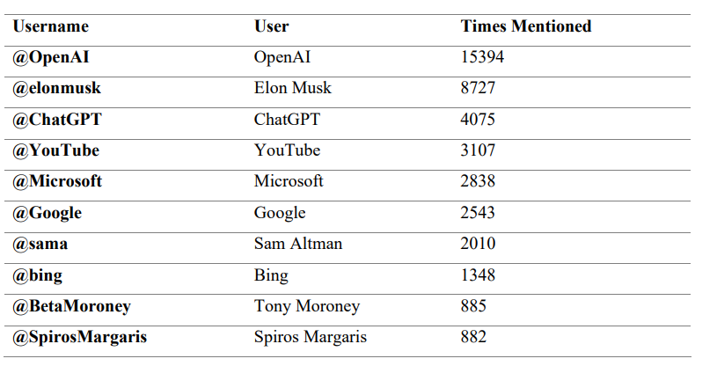

##### **Table 2: Hashtags used most often within the dataset**

